Home Learning
Year Group: 4 Week Beginning: 4th May 2020
Reading | - Read for 20 minutes daily  (Record in reading record books)
English | - Find https://www.youtube.com/watch?v=q9VfGbDezuc or you can type ‘Journey’ by Aaron Becker on You tube to find the story.  Watch this clip of the book, “Journey” by Aaron Becker from 57 sec to 2mins 12 secs.  - Can you continue the story in the first person? (using I, me) What did you see on your journey? How did you feel as you moved towards the castle? Can you describe it? Did you speak to the guards?  - Please write this in your purple exercise books and email us. Remember to use your writing targets. How many can you use today?  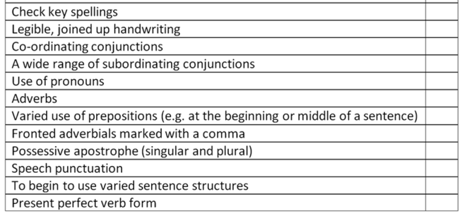
Maths | 1) IXL Time (Use your blue book for workings out if it helps you with your calculations)  - T 1-15  - Purple mash - Time Conversions  - Time Clock faces  - Years and Months  - Complete ‘Maths frame times table check’ and record your result in the blue homework book  (Pupil Log in is in your reading record books)
Spelling | 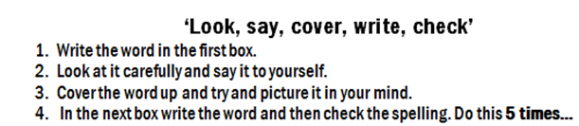  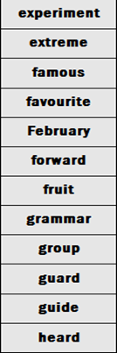
Punctuation and Grammar | Complete on Purple mash - Positive emotions  -Avoiding nice  (Pupil Log in is in your reading record books)
IPC/Science | Go on to  www.purplemash.com  Use your login to complete any 2Dos that have been set by your teacher  Remember to save work as it is completed  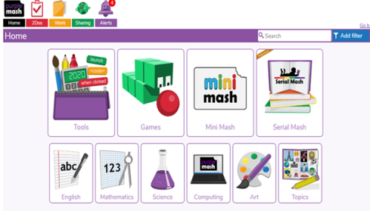  - History and PE (A separate document)  - My Ambition  - DIY Game Magazine

German | 