Learning at Home

YEAR 5

Wednesday 25th November - Wednesday 2nd December 2020
Reading | Read for at least 30 minutes daily. Selecting books from a range of fiction, non-fiction and poetry.  Use your log in details for Bug Club and remember to complete the comprehension questions.  Username: Childs first name  Password Teal (followed by a number)  School Code: AHX7  Find 4 words the meaning of which you are unsure of, using a dictionary and thesaurus (this can be found online also) search for their definitions, antonyms and synonyms.  In the resources you will find a copy of the next part of our Big Reading book ‘The Terrible Thing That Happened To Barnaby Brocket’. Read through this and then have a go at the activities below.  Task 1 – Can you write the next paragraph in the book, focusing on who the new character might be and what he will do. Remember to refer to the text for ideas.  Task 2 – Can you create a map of one of the places in the story you have read so far. How much detail can you include without referring back to the text? As you don’t have a copy of the whole text, do your best to illustrate details you can recall and use your imagination and inference skills to add in even further details. You could choose from settings such as: The Graveling Academy for unwanted children, Ethel and Marjorie’s coffee farm, Barnaby’s house, Vincente’s Art Gallery or Captain Hoeseason’s Ship.  Task 3 – Can you create a setting description to go with your illustrated map. Try to include a range of English success criteria and inferential detail.
English | Year 5 have been reading the Matchbox Diaries  This week we will be planning and writing a piece of Tension writing  https://youtu.be/_kpdlXU-nP0  RESOURCES  Refer to the Year 5 Home Learning page for PPTs and additional support.  Once completed email to the Year 5 Teachers
Maths | This week we are learning about Multiples, Factors and Prime Numbers  IXL  Number sense A1-19  Recap or complete (Additional learning)  Addition B1-9  Subtraction C1-7  Maths Frame    MULTIPLES  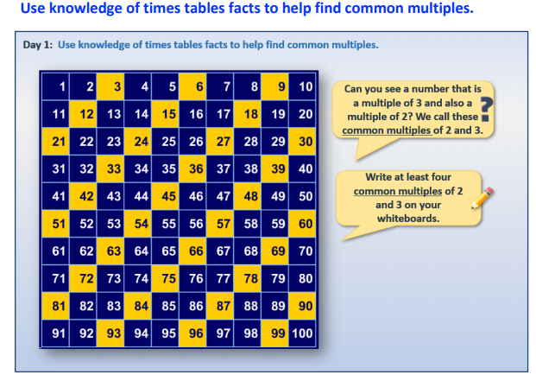  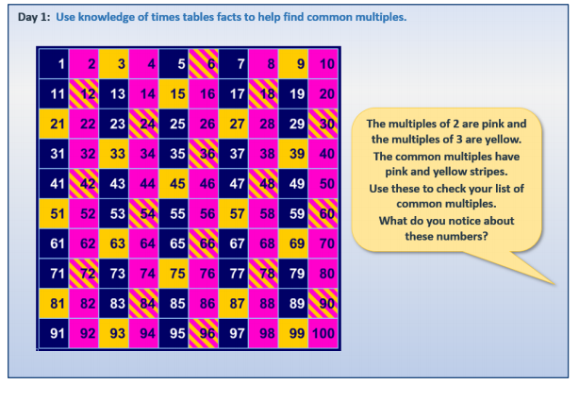  Can you find the common factors of 4 and 8?  Can you find the common multiples of 6 and 9?  Can you explain how to find the common multiples of a number?  Which of these multiples of 2 are also multiples of 7?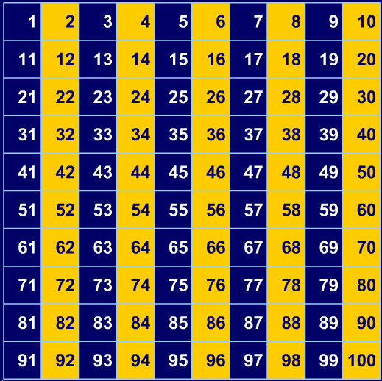  Write common multiples of 2, 3 and 4 up to 40.  Write common multiples of 3, 4 and 5 up to 40.  Which set has more numbers?  FACTORS  Refer to the Website  PRIME NUMBERS  Refer to the website  EXTRA RESOURCES  These are available on the Year 5 Home Leaning page which included PPT and worksheets.
Spellings | Practise the Year 5 spelling rules task 41 and 42 on:  https://spellingframe.co.uk/spelling-rule/5/Year-5-and-6  Practise the Year 5/6 Spelling list in your Reading Journals - Look up the tricky words and put them into sentences.
Topic  (History/  Geography) | Task 1 - Can you understand more about Singapore and why it has developed into such a significant global island?  You can display your research as a Power Point presentation or a poster.  FURTHER RESOURCES are on the website including useful links  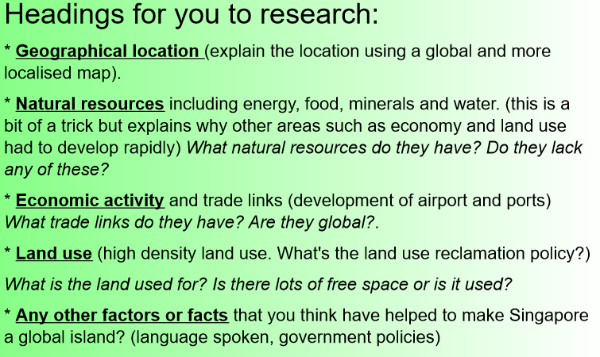  Task 2 – Use the island comparison sheet to compare and contrast Singapore with another island city. If you would like to complete this task more in depth you may use the questions from the compare/contrast sheet to create a PowerPoint presentation, video presentation or informative poster.
Topic  (Art) | Andy Warhol  Research the art of printing in the style of Andy Warhol.  Write instructions on how to block print. Can you find a creative way to present your instructions?  Can you create a Warhol inspired island artwork (you could use repeated images).  You might even want to have a go at using the link below to create your own homemade frame, which can be customised, to display your artwork.  https://www.instructables.com/Cardboard-Picture-Frame-2/
Topic  (Science) | Watch the videos below which explain day and night:  http://www.bbc.co.uk/learningzone/clips/day-and-night-on-earth/1874.html (if the link does not work, Google ‘BBC class clips Day and Night’)  http://www.bbc.co.uk/learningzone/clips/how-does-the-earths-rotation-createday-and-night/2173.html (if the link does not work, Google ‘BBC class clips Earth’s rotation day and night)  https://www.bing.com/videos/search?q=night+and+day+explained+for+ks2&&view=detail&mid=44C656FD5283E9BE54C944C656FD5283E9BE54C9&&FORM=VRDGAR  https://www.bing.com/videos/search?q=night+and+day+explained+for+ks2&&view=detail&mid=048E0ED55096639BA462048E0ED55096639BA462&&FORM=VDRVRV  https://www.bing.com/videos/search?q=night+and+day+explained+for+ks2&&view=detail&mid=802980EBA833586B75F4802980EBA833586B75F4&&FORM=VDRVRV (this video is Australian so please bear this in mind when she refers to our side of the planet)  Task 1 – After watching the videos above please either complete the fill in the gap’s activity describing how day and night occur or use the ‘Day and Night’ writing template to explain in your own words.  Task 2 – If you can use some props from around your home to demonstrate your explanation practically. You can take a picture of this or even create a short video clip.  Task 3 – Look at the Shadow PowerPoint and see if you can have a go at some of the activities. If you don’t have chalk available can you take some photos of your shadows or create some sketches of them. If you don’t have foil you could use an everyday object from around your house instead.
German | Children should practice the learned German vocabulary in Linguascope. To access these resources, please follow the steps below:  1. CONNECT: www.Linguascope.com  2. LOG IN: valley1 Password: 20twenty​

