Spring Term Homework Menu – WW2: The Home Front
(Please choose 3 of the options below to complete this half term and 3 to complete after the February holiday)
History | Geography | The Arts | Science | Experience
 | 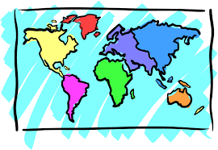 |  | 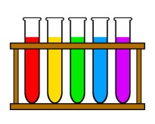 | 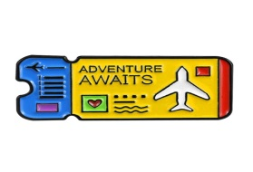
Research the Home Guard.  What was their purpose?  Why was the Home Guard formed?  How were people recruited?  When were they operational?  What else can you tell us about the Home Guard?  Present this in a way that you believe will deliver your information most effectively. | Find or draw two maps and clearly explain how they show the ways in which Europe changed between WWI and the end of WWII as a result of these wars.  e.g. Empires, names of countries, borders, division of countries… | Write a song (or poem) or compose a piece of music inspired by musical artists from WWII.  Consider the purpose of this piece. Is it to boost morale, or explain life at war?  e.g. Vera Lynne & Glenn Miller | How did the roles of women in science and technology change in WWII and why?  How has this impacted on the roles women have today?  Present this in a way that you believe will deliver your information most effectively. | Visit the Imperial War Museum in London.  Write a leaflet to help guide a visitor around the museum.  Or  Write a review of the museum to explain how successful it was in deepening your WWII understanding.
Cook a simple meal. | RE | Computing | DT | When completing homework, we encourage you to be creative in your presentation, in order to deliver and share a piece of work which you are proud of.  We would like this homework to be submitted by the final Thursday of each term so that we can come together as a class and share.
 | 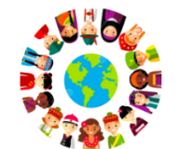
 | Research the Jewish holiday of Purim (which is celebrated March 9th and 10th this year). Create a fact-file which outlines key points about this festival.  Remember the 5Ws. | Create a digital presentation (e.g. PowerPoint, podcast or Spark) about the enigma code and the work that took place at Bletchley Park. Explain how this impacted and contributed to the advances made during WWII. | Draw, annotate and compare two contrasting uniforms from WWII. You could choose different uniforms based on  -Country  -Type of force (e.g. Army/Navy)  -Rank

For subjects where research is necessary, children can choose how they wish to present their learning, enabling them to produce a piece of work they feel proud of.

