Spring Term Homework Menu Year 5
Please bring in the two pieces for this half-term between the 5th – 7th February ready for our sharing event on Thursday 8th February 2024
For next half term, please bring in the 3 pieces between 25th – 27th March ready for our sharing event on Thursday 28th March 2024
History | Geography | The Arts | Science | Experience
Industrial Revolution  Write a diary entry for a child that worked during the industrial revolution.  Think about the hours worked, the way they were treated, how work conditions could be improved.  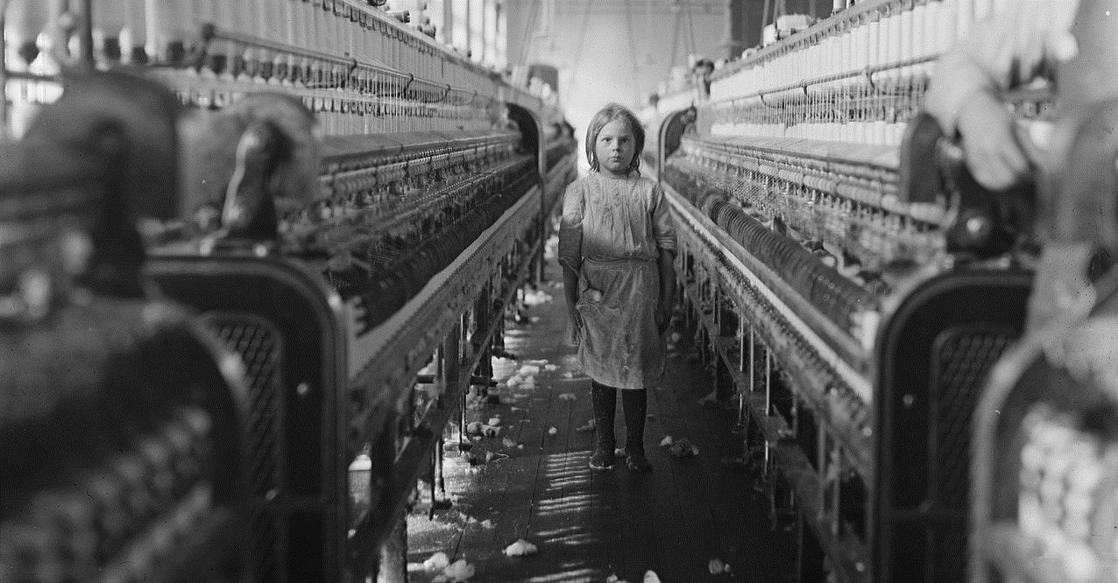 | What are the Wonders of North & South America?  Think of the human and physical features  Create a collage of your findings  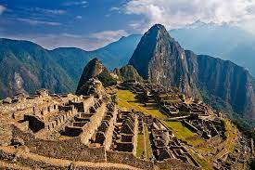 | Using the Wonders of North and South America as inspiration- Create your own Wonder  Use a variety of materials to draw, paint, sculpt or sketch.  Don’t forget to name your Wonder! | Have you ever helped to make a cup of tea? Do you know how a tea bag works?  Find the best material to make a tea bag. Do you think it will be kitchen roll? Maybe newspaper could work. What about a thin fabric?  Here’s one way to find out Cut out a square of kitchen roll. Put a teaspoonful of tea leaves in the middle. Gather up the corners with a clothes peg to make a bag. Half fill a clear beaker with water from the hot tap. (Ask for an Adult’s help) Holding the peg, dunk the tea bag up and down in the water for one minute. Try other papers and fabrics to see which type makes the best tea bag (lets the flavour and colour out, and keeps the tea leaves in).  Take some pictures and write an evaluation of your investigation | Visit the local Library or one of the larger libraries in London  Explore the different areas of the Library.  What part of this visit was your favourite?  What would you recommend to do?  How would you rate your experience?
Curriculum Drivers | RE | Computing | DT
 |  |  |  | 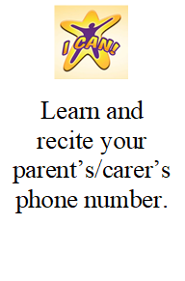
Focus: Our Place in History  Does Bromley have Significant figures and/or events that happened?  Write a fact file about Bromley | Write a story that teaches us how to behave towards other people | Design a poster that encourages our local community to use the library as a useful and exciting learning tool.  Use Purple Mash | Can you build a model of a bridge?  There are many different designs of bridges, each serves a particular purpose. Designs of bridges vary depending on the function of the brdige, the nature of the ground underneath, where the brdige is constructed and anchored, the material used to make it and money available to build it.  Use the internet, and non fiction books to find out the different structures (the libraby visit may be useful too!)

For subjects where research is necessary, children can choose how they wish to present their learning, enabling them to produce a piece of work they feel proud of.

