So let’s start with 10 times table
The 10 times table is the easiest times table there is and requires no understanding of how the times tables work at all.
To multiply any number by 10, move the digit to the next place value and add a place holder.
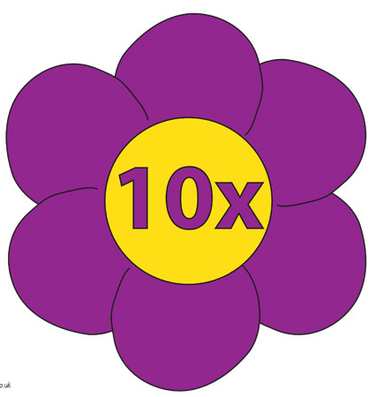
Take a look at the ten times table below. Can you see that a zero has been added in the ones place value? It has been highlighted in bold.
1 X 10 = 10
2 X 10 = 20
3 X 10 = 30
4 X 10 = 40
5 X 10 = 50
6 X 10 = 60
7 X 10 = 70
8 X 10 = 80
9 X 10 = 90
10 X 10 =100
11 X 10 =110
12 X 10 =120
If someone asks, “What is 9 X 10”? In your mind picture the number 9 then move the digit to the next place value and add a place holder: 9 0 the answer is 90.
This works with any number: 16 X 10 = 160 92 X 10 = 920 357 X 10 = 3570

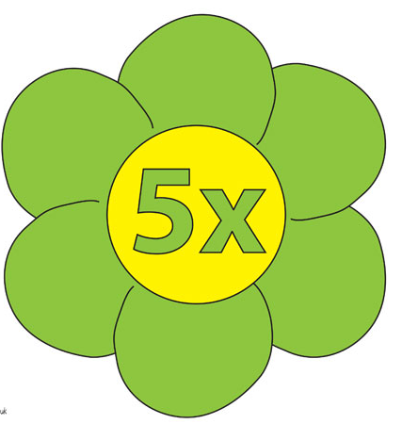
Now let’s move on with the 5 times table
1 X 5 = 5’
2 X 5 = 10
3 X 5 = 15
4 X 5 = 20
5 X 5 = 25
6 X 5 = 30
7 X 5 = 35
8 X 5 = 40
9 X 5 = 45
10 X 5 =50
11 X 5 =55
12 X 5 =60

Counting up in 5’s is fairly straight forward, as every time we get bigger by 5 (starting at 5) the next number will be a ‘10’
To get the ‘10’ bigger by 5, take the zero off the 10 and replace it with a 5, and so on as shown below:

This is fine if we want to count out a number of 5p coins, but what if some asks “What is 8 X 5”?
Luckily we already now our 10 times table and to find the answer we simply multiply by 10 and halve the result (this is because 5 is half of 10)
Let’s see it work:
8 X 10 = 80
Half of 80 = 40
Therefore 8 X 5 =40

The odd numbers are a little more difficult but not by much. If the question were, “What is 9 X 5”?
9 X 10 = 90
Half of 90 = 45
So 9 X 5 = 45
If you understand this move on to the 2’s, if not, read on and I’ll explain how we split the 90 in half.

The closest we can get to splitting 90 in half using 10’s is 50 + 40
The difference between 50 and 40 is 10
If we take the ten off of the 50 we have 40 - 40 and the spare - 10
If we divide this spare 10 in half (so we can share it out to both 40’s) we get two 5’s
Add the 5’s to each of the 40’s and we get 45
So half of 90 = 45

Did you know that multiplying gives the same answer forwards as backwards? 1 X 2 is the same answer as 2 X 1. It’s the same when multiplying any numbers 11 X 6 is the same as 6 X 11. Try to remember this it will be useful later on.

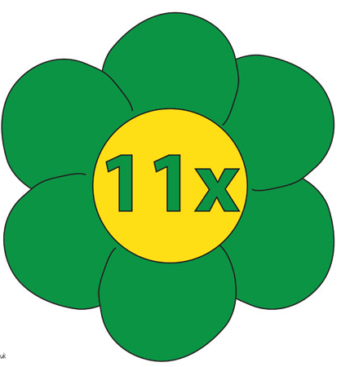
And now another easy one, the 11 times table
1 X 11 = 11
2 X 11 = 22
3 X 11 = 33
4 X 11 = 44
5 X 11 = 55
6 X 11 = 66
7 X 11 = 77
8 X 11 = 88
9 X 11 = 99

Up to 9 the 11 times table is really easy because the answer is in the question. “What is 8 X 11”?
Simple 88, I thought of the number 8 and placed another 8 next to it in my head.
Let's do the last three:
10 x 11= 110
We know that 10 X 11 is the same as 11 X 10
We also know that when we multiply by ten, we move the digit to the next place value and add a place holder.
So when we multiply 11 X 10 we get 110 which is the same answer for 10 X 11
11 X 11 = 121
Split this calculation into two 10 X 11 = 110 and 1 X 11 = 11 then add the two together = 121
12 X 11 = 132
Again, split this calculation into two 10 X 11 = 110 and 2 X 11 = 22 then add the two together = 132

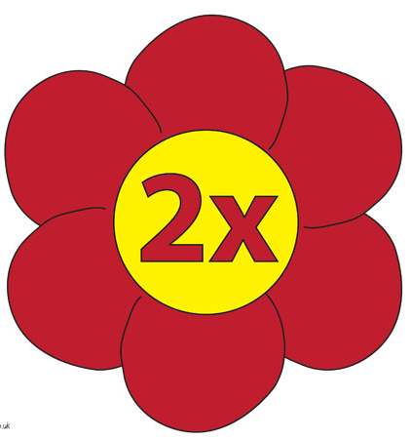
The 2 times table
For the twos you will need to learn a bit about how times tables work:
1 X 2 = 2
2 X 2 = 4
3 X 2 = 6
4 X 2 = 8
5 X 2 = 10
6 X 2 = 12
7 X 2 = 14
8 X 2 = 16
9 X 2 = 18
10 X 2 = 20
11 X 2 = 22
12 X 2 = 24
Here’s how it works:
Whenever we multiply a number, the answer gets bigger by whatever the multiplier is.
In the 2 times table the multiplying number is 2 so each answer gets bigger by 2 starting with 2.
On a number line it looks like this in bold below:
1 2 3 4 5 6 7 8 9 10 11 12 13 14 15 16 17 18 19 20 21 22 23 24
Can you see that each number gets bigger by 2? If not you will need to understand this basic idea before you do any more times tables.
Did you know that multiplying by two is also known as doubling? When we multiply by two we are adding that number to itself, like this:
2 X 2 is the same as 2 + 2 or two lots of 2.
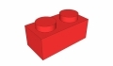
The single brick above has 2 knobbles on the top (1 X 2 = 2)
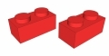
With 2 bricks we have 4 knobbles (2 X 2 = 4) That's how all of the times tables work but with different numbers of knobbles.
You should know four of the 2 times tables already shown below
1 X 2 = 2
5 X 2 = 10
10 X 2 = 20
11 X 2 = 22

Let’s try to fill in the gaps:
2 X 2 = 4 (this is the same as 2+2)
3 X 2 = 6 (this is the same as 3+3)
4 X 2 = 8 (this is the same as 4+4)

A break for Partitioning
When we get numbers that are too big for our head, we can partition them (or split them) into parts that are smaller and easier to think about.
Below I’ve split 6 into 5 and 1 (because 5 + 1 =6)
To do the calculation 6 X 2 in my head I simply think of two lots of 5 and two lots of 1 and stack them above each other like this:
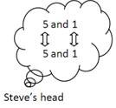

Now add the two 5’s together and the two 1’s
Then you have 10 and 2
Add these together and you get the answer 6 X 2 = 12
This will also work with 7, 8 and 9 times 2.
7 X 2 = 14 (split 7 into 5 and 2 and add them together as with the 6 above)
8 X 2 = 16 (split 8 into 5 and)
9 X 2 = 18 (split 9 into 5 and 4)
12 X 2 = 24 (stack two 12’s on top of each other and add them together)

4 times table
Here it is:
You will already know 5 of the four times tables.
1 X 4 = 4
2 X 4 = 8 (because 2 x 4 is the same as 4 x 2)
5 X 4 = 20 (half of 10 x 4)
10 X 4 = 40 (4 with a zero added to the end 40)
11 X 4 = 44 (4 lots of 1’s stacked on top of each other)

To do the rest of 4 times table, simply double the answers of the 2 times table
Here’s how it works
3 X 4 = 12 (imagine the calculation was 3 X 2. We know 3 X 2 = 6 and that double 6 is 12)
4 X 4 = 16 (imagine the calculation was 4 X 2. We know 4 X 2 = 8 and that double 8 is 16)

6 X 4 = 24 (You don’t have to use the doubling method for this, you can work out 5 X 4 and 1 X 4 and add the answers together to get 6 X 4 = 24)
7 X 4 = 28 (Use either the doubling method or work out 5 X 4 and add another 2 lots of 4 to get 7 X 4 = 28)
8 X 4 = 32

There are 3 different methods for this one:
You could double 8 X 2 = 16 but this is tricky mental maths as you will have to spilt the two 16’s into 10, 5 and 1.
It may look like this in your head:
10 and 5 and 1
10 and 5 and 1

10 and 5 and 2
10 and 5

10 and 10 and 2
10

20 and 10 and
20 + 10 + 2 =
32
It’s a lot of work for just one number
I would work back from 10 X 4 = 40
We know that as above 10 x 4 = 40
And we know that we are looking for 8 X 4 so we have gone past the number we are looking for (8) by 2
2 lots of 4 = 8 (because we have gone over by this amount, we need to take it off of the 40)
40 – 8 = 32
9 X 4 = 36
This a great trick that you will learn more about with the 9 times table, but because 9 X 4 is the same as 4 X 9 we’ll pretend it’s a nine times table calculation and take a look at it here.

Hold your hands out in front of you (back or front doesn’t matter)
Pull down the fourth finger of the left hand (because 4 is what we are looking for)
Count the number of fingers to the left of the held down finger, the tens = 3
Count the number of fingers to the right of the held down finger, the ones = 6
The answer is 36.
This works with the whole of the 9 times table up to 10. We’ll look at 9’s after 4’s
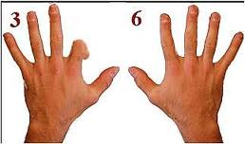

12 X 4 = 48
This is done by splitting 12 X 4 into two separate calculations: 10 x 4 and 2 X 4. Once we have the answers to these two calculations we add the answers together like so:

First place the answer to 10 X 4 in your head = 40
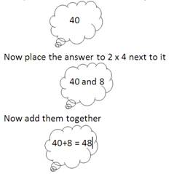

This is how we will tackle the 12 times table as well.

9 times table
1 X 9 = 9
2 X 9 = 18
3 X 9 = 27
4 X 9 = 36
5 X 9 = 45
6 X 9 = 54
7 X 9 = 63
8 X 9 = 72
9 X 9 = 81
10 X 9 = 90
11 X 9 = 99
12 X 9 = 108

As mentioned above you can use your fingers to work out your 9’s.
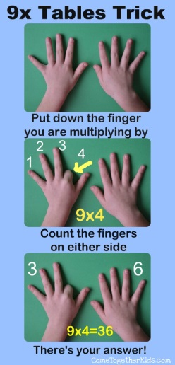
Another great method is to multiply by ten and then takeaway the number you are multiplying by:
1 X 9 = 9 (1 X 10 = 10 and then 10 – 1 = 9)
2 X 9 = 18 (2 X 10 = 20 and then 20 – 2 = 18)
3 X 9 = 27 (3 X 10 = 30 and then 30 – 3 = 27)
4 X 9 = 36 (4 X 10 = 40 and then 40 – 4 = 36)
5 X 9 = 45 (5 X 10 = 50 and then 50 – 5= 45)
6 X 9 = 54 (6 X 10 = 60 and then 60 – 6 = 54)
7 X 9 = 63 (7 X 10 = 70 and then 70 – 7 = 63)
8 X 9 = 72 (8 X 10 = 80 and then 80 – 8= 72)
9 X 9 = 81 (9 X 10 = 90 and then 90 – 9 = 81)
10 X 9 = 90 (10 X 10 = 100 and then 100 – 10 = 90)
11 X 9 = 99 (11 X 10 = 110 and then 110 – 11 = 99)
12 X 9 = 108 (12 X 10 = 120 and then 120 – 12 = 108)

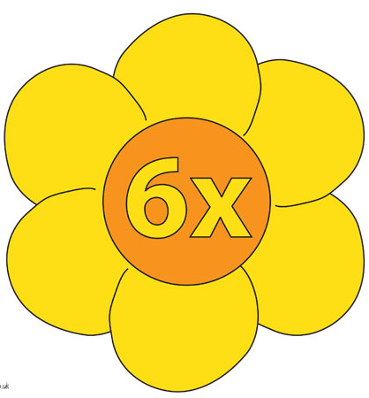
6 times table
1 X 6 = 6
2 X 6 = 12
3 X 6 = 18
4 X 6 = 24
5 X 6 = 30
6 X 6 = 36
7 X 6 = 42
8 X 6 = 48
9 X 6 = 54
10 X 6 = 60
11 X 6 = 66
12 X 6 = 72

There’s a great trick for the even numbered 6’s up to 8 X 6.

Let’s start with 2 X 6.
First the calculation 2 X 6 = 12
Split the 2 in half and you will have two lots of 1’s (1 and 1) Place one of the 1’s in front on the 2 (12) and throw the other 1 away (picture of a bin with a 1 in it).

The next even sum is 4 X 6 = 24
Split the 4 in half and you will have two lots of 2’s (2 and 2)
Place one of the 2’s in front on the 4 (24) and throw the other 2 away (picture of a bin with a 2 in it).

Here is the same idea again with the next even calculation 6 X 6 = 36 only this time I’ve written it out differently
6 x 6 = ?
3 + 3 X 6 = ?

Now for the trick but don’t look for any maths!

Get rid of one of the 3’s and put the other one in front of the 6 = 36

Again with 8 X 6 = 48
8 x 6 = ?
4 + 4 X 6 = ?
Now for the trick again...
Get rid of one of the 4’s and put the other one in front of the 8 = 48
So when you need the answer to any ‘even’ 6 times table, the answer is in the question.
Click HERE to download or view the video on an apple mobile device

We are now left with the odd 6’s
3 X 6 = 18 (2 X 6 = 12 and then add another 6 in your head = 18)
5 X 6 = 30 (10 X 6 = 60 and then ÷2 = 30)
7 X 6 = 42 (add another 6 to 6 X 6)
9 X 6 = 54 (10 x 6 = 60, 60 – 6 = 54 check out the nine times table for how this works)
11 x 6 = 66 (take a look at the 11 times table for this)
The last one is 12 X 6 = 72 (as with all the 12’s, multiply by ten and then add double the multiplier which in this case the multiplier is 6 so add double of this which is 12.

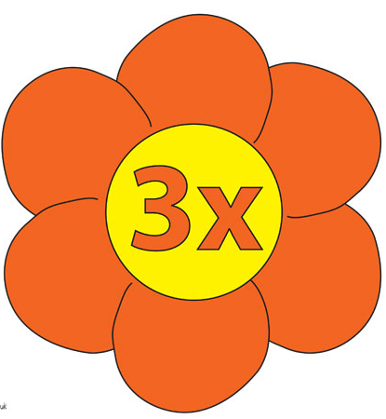
3 times table
1 X 3 = 3
2 X 3 = 6
3 X 3 = 9
4 X 3 = 12
5 X 3 = 15 (10 X 3 and then divide by 2)
6 X 3 = 18
7 X 3 = 21
8 X 3 = 24
9 X 3 = 27
10 X3 = 30 (add a zero to the 3)
11 X 3 = 33
12 X 3 = 36 (10 x 3 and then add 6)

Apart from those indicated above, you can either multiply by 2 and then add 3 to the answer, or spend a lot more time in learning the 6 times table and half the answers for the 6 times table to get the answers for the 3 times table.

12 times table
1 X 12 = 12
2 X 12 = 24
3 X 12 = 36
4 X 12 = 48
5 X 12 = 60
6 X 12 = 72
7 X 12 = 84
8 X 12 = 96
9 X 12 = 108
10 X 12 = 120
11 X 12 = 132
12 X 12 = 144

The simple rule that you can apply to all of the 12’s is to partition the calcualtion into 10's and 2's then add the answers together.

1 X 12 = 12 (1 X 10 and then add 2)
2 X 12 = 24 (2 X 10 and then add 4)
3 X 12 = 36 (3 X 10 and then add 6)
4 X 12 = 48 (4 X 10 and then add 8)
5 X 12 = 60 (5 X 10 and then add 10)
6 X 12 = 72 (6 X 10 and then add 12)
7 X 12 = 84 (7 X 10 and then add 14)
8 X 12 = 96 (8 X 10 and then add 16)
9 X 12 = 108 (9 X 10 and then add 18)
10 X 12 = 120 (10 X 10 and then add 20)
11 X 12 = 132 (11 X 10 and then add 22)
12 X 12 = 144(12 X 10 and then add 24)

It may be easier to understand like this:
8 X 12 = ?
8 X 10 = 80
8 X 2 = 16
16 + 80 = 96
8 X 12 = 96

8 times table
The thing that makes 8’s easier than 7’s is that 8 is an even number.
1 X 8 = 8
2 X 8 = 16
3 X 8 = 24
4 X 8 = 32
5 X 8 = 40
6 X 8 = 48
7 X 8 = 56
8 X 8 = 64
9 X 8 = 72
10 X 8 = 80
11 X 8 = 88
12 X 8 = 96

First the easy ones
1 X 8 = 8
2 X 8 = 16 (double eight. Use partitioning if necessary 5 and 3 + 5 and 3))
4 X 8 = 32 (take eight away from 5 X 8 = 40)
5 X 8 = 40 (this is half of 10 X 80 = 80)
6 X 8 = 48 (add 8 to 5 X 8 = 40)
7 X 8 = 56 (what is 7 X 8? 56 =78 or 5678)
9 X 8 = 72 (take 8 away from 10 X 8 = 80 or use your fingers)
10 X 8 = 80 (move the 8 a place value and add a place holder)
11 X 8 = 88
12 X 8 = 96 (add two lots of 8 to 10 X 8)

The harder ones
3 X 8 = 24
8 X 8 = 64
.
Try this for something silly for 8 X 8.
The number the 8 looks like a monkeys face and two monkey were characters in a children’s programme called 64 zoo lane so 88 (or two monkeys) =64 (zoo lane)

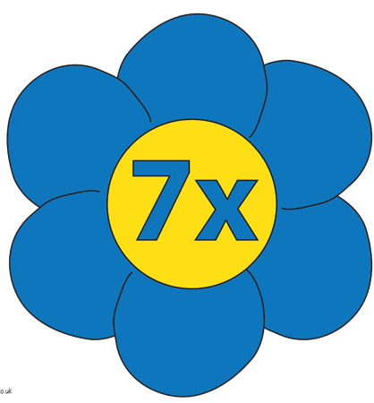
The 7 times table
1 X 7= 7 (easy)
2 X 7 = 14 (partition the 7 into two lots of 5 and 2 and add them together)
3 X 7 = 21 (You could try to remember that when looking for 3 X 7 that 2+1
make 3 and 21 is the answer)
4 X 7 = 28 (this one is easy if you can remember 3 X 7 as you just need to add 7 to 21)
5 X 7 = 35 (half of 10 X 7 =70)
6 X 7 = 42 (this is double 3 X 7 = 21)
7 X 7 = 49 (Do your best to try and remember this one)
8 X 7 = 56 (Do this one backwards 7 X 8 and remember the 5678 rule)
9 X 7 = 63 (10 X 7 and the take away 7)
10 X 7 = 70 (add the zero onto the end of the 7)
11 X 7 = 77 (easy, look at the 11 times table)
12 X 7 = 84 (10 X 7 = 7 and the and 14 or two lots of 7)
Also, like the 12's the 7 times table can be partitioned into two separate calculations, in this case 5's and 2's. For example:
8 X 7 = ?
8 X 5 = 40
8 X 2 = 16
40 + 16 = 56
This will work for all of the 7 times table
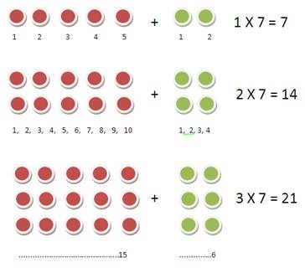

- http://www.topmarks.co.uk/maths-games/7-11-years/times-tables
- http://www.topmarks.co.uk/maths-games/5-7-years/times-tables
- http://www.topmarks.co.uk/maths-games/hit-the-button
- http://resources.woodlands-junior.kent.sch.uk/maths/timestable/interactive.htm
- http://resources.woodlands-junior.kent.sch.uk/maths/timestable/
- http://www.crickweb.co.uk/ks2numeracy-multiplication.html
- http://www.maths-games.org/times-tables-games.html
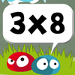

https://itunes.apple.com/gb/app/math-times-tables-free-fun/id789858896?mt=8
https://itunes.apple.com/gb/app/10-minutes-a-day-times-tables/id775904110?mt=8

https://itunes.apple.com/gb/app/times-tables-game-multiplication/id651220703?mt=8

