What’s going on with Brexit?
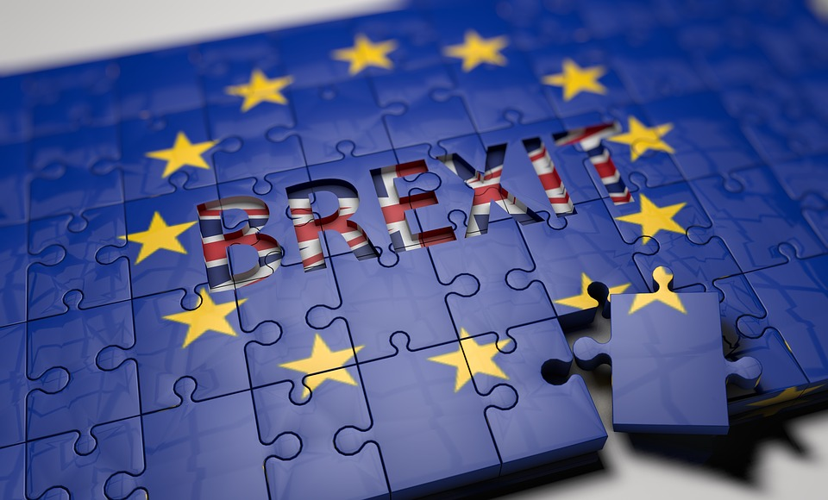
History

Thursday 23rd June, 2016 is a date few are
likely to forget. This is when the British
voting public took part in an historic
referendum. The issue they were voting on
was whether or not Britain should leave the
European Union (EU). More than 30 million
people took to the poll stations to cast their
vote, either in favour of Leave or Remain. While the turnout was relatively high at 71.8% of eligible voters, the margin of victory was narrow: the winning side was Leave, with 51.9% of the vote.

The concept of Britain leaving the EU was given the name ‘Brexit’, in a cunning mix of the words ‘British’ and ‘exit’. There had been a lot of pressure on the Prime Minister at the time, David Cameron, from the right-wing political party UKIP, who were gaining popularity with their policy of taking the UK out of the EU if elected. Dissatisfaction with the UK’s perceived lack of power had been brewing like a thunderstorm for some time, and David Cameron therefore decided to call the referendum if the Conservatives were re-elected, which they were in 2015.

Why did people vote for Brexit?

The reasons that people voted to leave the EU are manifold. Some popularly-cited reasons include: taking back control of the UK from Brussels; making it harder for people from other countries to immigrate to the UK; to remove power from unelected bureaucrats, and to register their protest at the government. Some people thought that being out of the EU would be better for the UK’s economy in the long term.

Why did people vote against Brexit?

The 48.1% of voters who opted to remain in the EU did so for numerous reasons. Some popularly-cited reasons include: feeling a sense of belonging with the other countries in Europe; wanting to protect their freedom of travel and human rights; believing that immigration was good for the country, and wanting to maintain the UK’s position of influence in Europe. Some people thought that being in the EU would be better for the UK’s economy in the long term.

So what’s happening now?

The date has been set for the UK’s departure from the EU: 11pm on March 29th, 2019. Negotiations are ongoing and there’s a lot to discuss, but the three 'separation issues' have been agreed upon: the rights of EU citizens in the UK and UK citizens in the EU; the 'divorce bill' (how much the UK pays the EU), and arrangements for the Northern Ireland border. Talks are currently focusing on future relations between the UK and the EU, including trade after Brexit.

The 3.2 million EU citizens currently living the UK will most likely be guaranteed the right to stay in the country. However, immigration is likely to be made more difficult for people wishing to migrate to the UK after Brexit. It is hoped that people wishing to travel between the UK and Europe on short breaks will not need visas.

Questions

Challenging (3-4)

1. Name FOUR facts about Brexit that are mentioned in the first paragraph of the article.

2. Give ONE reason that the Brexit referendum was called.

3. Write out the sentence which contains a simile.

4. Highlight all the statistics which have been used in the article.

More Challenging (5-6)

1. Write out TWO sentences from this article which show the writer’s opinion.

2. Give TWO reasons that the Brexit referendum was called.

3. Write out the TWO words used in the article which both mean ‘many’.

4. Write out the sentence which contains a simile. What effect does this simile create?

Mega Challenging (7+)

1. Who are the ‘unelected bureaucrats’ mentioned in the article?

2. Looking at the last sentence of paragraphs 3 and 4, what do you infer?

3. Write out the sentence which uses the passive voice in this article.

4.. Write a sentence which summarizes your own opinion on Brexit. Your sentence should include a semi-colon.

