NCFE Level 2 Diploma in Sport (601/3038/6)

Unit 04 –Anatomy and Physiology for Exercise
R/505/9959

Student Name: ______________________
Student Candidate Number: ____________

Assessor Name: ______________________
Assessor Signature: ______________________

Unit 4
Anatomy and Physiology for Exercise R/505/9959

  - – Describe the structure and function of the skeletal system. (pass only)
Task: label the skeletal system.
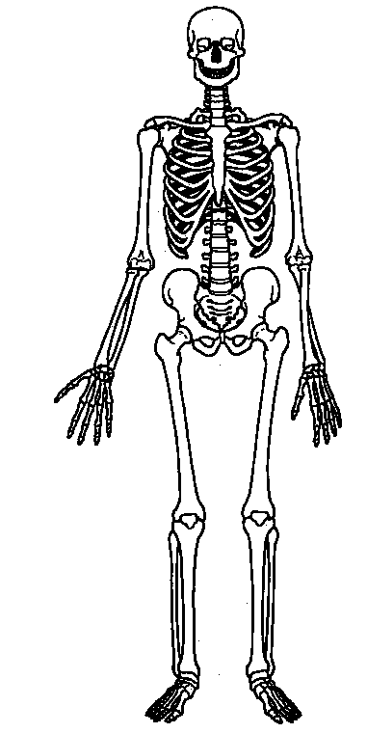

Label the functions of the skeletal system with a definition.

S…….. …………………………………………………………………….

S……. ……………………………………………………………………..

P……. ………………………………………………………………………..

M…… …………………………………………………………………........

B……. C……. P………

…………………………………………………………………........

Answer the following:

- How many bones are in the body? ……………………………………………

- Tendons join …………………………………………….. to bone.

- Ligaments join …………………………………………… to bone.

Task: using the back of your sheet and the following descriptions, draw and label the structure of a long bone.

Spongy Bone medullary cavity
Epiphysis Diaphysis
Endosteum Periosteum
Articular Cartilage Epiphyseal line

1.2– Describe the different types of joints and the movements allowed at each. Pass = found, Merit = movement, Distinction = example
TYPE OF JOINT | ILLUSTRATION | FOUND | MOVEMENT | SPORTING EXAMPLE

2.1 Identify the major muscles of the body. (Pass Only)
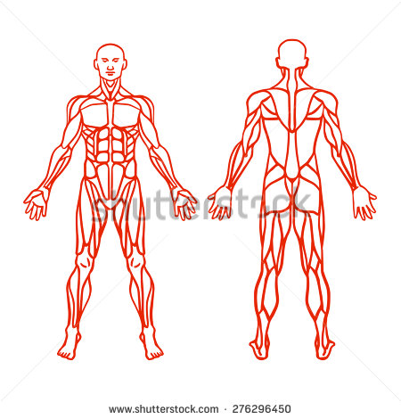
Label the major muscle groups.

2.2 Describe the different types of muscle and muscle movement. Pass Only

There are 3 types of muscle tissue, they are:

Muscle Movement, complete the table.

Muscle | Movement | Diagram
Bicep | Flexion

3.1 Describe the function and structure of the cardiovascular system. (Pass)
Label the Heart:

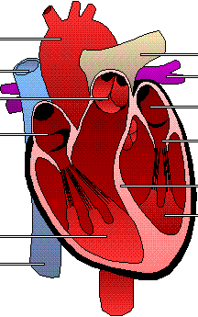

What are the following:
Heart Rate:
Stroke Volume:
Cardiac Output:

Task: for a merit, describe the following functions for the missing definitions:

AORTA –

VENA CAVA –

PULMONARY VEIN –

PULMONARY ARTERY – takes deoxygenated blood from the heart to the lungs

SEMILUNAR VALVES –

SEPTUM - partition that separates the right and left sides of the heart.

VENTRICLE –

ATRIUM - One of the two upper chambers of the heart.

ATRIOVENTICULAR VALVE - either of two heart valves through which blood flows from the atria to the ventricles; prevents return of blood to the atrium

Activity:
Take part in exercise, record your resting heart rate, and heart rate immediately after exercise.
RHR=
MHR =
Briefly explain what happens to your heart rate while exercising. For a distinction, show a comprehensive description.
……………………………………………………………………………………………………………………………………………………………………………………………………………………………………………………………………………………………………………………………………………………………………………………………………………………………………………………………………………………………………………………………………………………………………………………………………………………………………

4.1 Describe the function and structure of the respiratory system. (Pass)
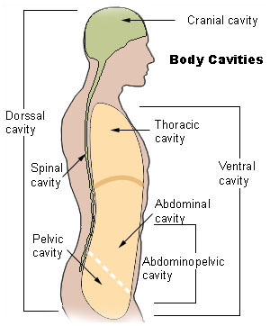
The Respiratory System

The function/s of the RESPIRATORY SYSTEM is:

The respiratory system is found in the thoracic cavity (chest) of your body. The thoracic cavity consists of the ribcage at the side and diaphragm (curved sheet of muscle across the bottom).
The respiratory system comprises of many different structures and parts that all have a role in the process of breathing.

Label the parts of the respiratory system on the diagram below. The parts to label are listed In the table that follow.

For a merit, use the websites below (and your teacher) to find out the function of the structures of the respiratory system.
http://www.nb.lung.ca/_images/flash/respiratory.swf
https://www.lung.ca/children/grades7_12/respiratory/respiratory_system.html
http://www.lungusa.org/site/c.dvLUK9O0E/b.22576/k.7FFF/Human_Respiratory_System.htm
http://library.thinkquest.org/5777/resp1.htm
http://www.betterhealth.vic.gov.au/bhcv2/bhcarticles.nsf/pages/Respiratory_system?OpenDocument
Structure | Function
Nasal cavity
Pharynx
Epiglottis
Larynx
Trachea
Pleura
Lungs (right and left)
Bronchi
Bronchioles
Alveoli
Ribs
Diaphragm

For a distinction, use what you have learned and the websites below to answer the following questions. http://kidshealth.org/PageManager.jsp?dn=bbch&article_set=10657&lic=245&cat_id=46

1. List the path air takes as it enters your respiratory system.

2. You have two lungs, but they are not the same size. Which lung is biggest? Why?

3. What structure protects your lungs? How many do you have? What sorts of things do these structures protect your lungs from?

4. When breathing in, does your chest get bigger or smaller? When you breathe out does your chest, get bigger or smaller? Why?

5. What is the name of the tiniest tubes you have inside your lungs? How many of these tubes do you have in each lung? How thick is each of these tubes?

6. What is the name of the tiny air sacs at the bottom of each bronchiole? How many of these tiny air sacs do you have? What space would these cover if you stretched them all out?

7. What type of blood vessel surrounds the alveoli?

8. When participating in sport, how and why is the respiratory system affected? (Before, during and after)

5.1 Describe the role and function of the nervous system.
In your own words, describe the role and functions of the nervous system (for a pass). To gain a merit include some links to sport and exercise. For a distinction use evidence to link the connection with sport and exercise with a comprehensive description.
You may use the internet to gain information and help explain your answer alongside textbooks. (Do not copy and paste)

……………………………………………………………………………………………………………………………………………………………………………………………………………………………………………………………………………………………………………………………………………………………………………………………………………………………………………………………………………………………………………………………………………………………………………………………………………………………………
……………………………………………………………………………………………………………………………………………………………………………………………………………………………………………………………………………………………………………………………………………………………………………………………………………………………………………………………………………………………………………………………………………………………………………………………………………………………………
……………………………………………………………………………………………………………………………………………………………………………………………………………………………………………………………………………………………………………………………………………………………………………………………………………………………………………………………………………………………………………………………………………………………………………………………………………………………………
……………………………………………………………………………………………………………………………………………………………………………………………………………………………………………………………………………………………………………………………………………………………………………………………………………………………………………………………………………………………………………………………………………………………………………………………………………………………………
……………………………………………………………………………………………………………………………………………………………………………………………………………………………………………………………………………………………………………………………………………………………………………………………………………………………………………………………………………………………………………………………………………………………………………………………………………………………………
5.2 Describe the principles of muscle contraction. (Pass only)

Muscle Contraction
Concentric
Concentric contractions take place when the agonist muscle _____________ and the antagonist muscle ____________.
3 types of muscle contraction
Eccentric
Eccentric contractions take place when the agonist muscle ______________ and the antagonist muscle ____________.

Isometric
Isometric contractions take place there is a pushing or pulling force but both of the muscle in the antagonistic pair stay the _______ ___________.

Key Terms, define.
Muscle Contraction –

Antagonistic Pair –

Agonist –

Antagonist –

Label the antagonist and agonist muscle pairs.

Movement | Antagonist | Agonist
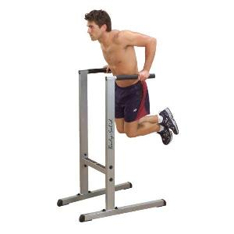
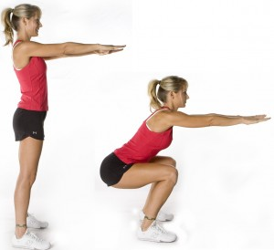
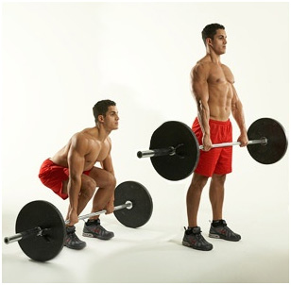
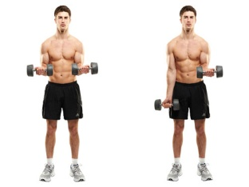
Your own example here:

5.3 Describe the all or non-law/motor unit recruitment. (Pass only)
Independent research activity, find the answers to the following:
What is meant by the all or non-law of the action potential?
……………………………………………………………………………………………………………………………………………………………………………………………………………………………………………………………………………………………………………………………………………………………………………………………………………………………………………………………………………………………………………………………………………………………………………………………………………………………………

Why do we say that the action potential is an all or none process?

……………………………………………………………………………………………………………………………………………………………………………………………………………………………………………………………………………………………………………………………………………………………………………………………………………………………………………………………………………………………………………………………………………………………………………………………………………………………………

What is propagation in nerves?

……………………………………………………………………………………………………………………………………………………………………………………………………………………………………………………………………………………………………………………………………………………………………………………………………………………………………………………………………………………………………………………………………………………………………………………………………………………………………

What is meant by all or none response?

……………………………………………………………………………………………………………………………………………………………………………………………………………………………………………………………………………………………………………………………………………………………………………………………………………………………………………………………………………………………………………………………………………………………………………………………………………………………………

5.4 Describe how exercise can enhance neuromuscular connections and improve motor fitness. (Pass) for a merit, demonstrate a critical understanding and for a distinction, be thorough with your answer.
Match the correct statements with their titles.

Physiological adaptations to high intensity short duration training types.
Fibre size |  | Effective integration of multiple body segments to create explosive movements or lift heavy loads requires more neuromuscular involvement than any other training; hence strength, power, speed and hypertrophy training are the best types of training to improve the neuromuscular systems resistance to fatigue.
Fast – twitch fibre behaviour |  | The timing of contractions becomes more co-ordinated, especially with power, speed and strength training, in order to meet the force generation required to move loads.
Nerve–muscle connections |  | Muscle size increases with hypertrophy training and to a lesser degree strength training. This is due to an increase in the number and thickness of actin and myosin filaments, an increase in myofibrils and an increase in sarcoplasm (fluid within the muscle cell).
Timing of neural stimulus |  | The ability to summate (fire a lot of impulses in target muscles all at once) is improved with strength and power training because they require maximum activation of target muscles to create maximum force.
Summation of motor units |  | Strength, hypertrophy, power and speed training modalities all focus on contractions from fast twitch fibres, thus these training types improve the specific fast twitch function being trained, whether that is strength, speed, power, size or a combination.
Neuromuscular fatigue |  | Increased recruitment of additional motor units, which respond in a simultaneous fashion to improve force production. There is an increased activation of synergistic muscles to assist force production for strength, power, speed and hypertrophy. Neural pathways linking to target muscles become more efficient at transmitting the message (stimulus).

Physiological adaptation to longer duration training types.

Capillarisation |  | Muscles and liver increase their ability to store carbohydrate and fat so it can be used for ATP production more readily.
Substrate storage |  | Mitochondria as you may remember from the energy system section are the aerobic powerhouse of the muscle cell. The number of mitochondria increases with aerobic exercise enabling more aerobic metabolism to take place. This means the muscle can create more ATP aerobically and results in less lactate being produced during workouts below anaerobic/lactate threshold.
Slow–twitch fibre behaviour |  | The number of capillaries in the muscle increase. This enables more O₂ to be delivered to working muscles and more CO₂ to be absorbed back into the blood thus improving endurance performance.
Mitochondria |  | As the duration of training lengthens slow twitch (endurance) fibres become increasingly dominant. Aerobic fitness, anaerobic fitness and muscular endurance training all improve the function of slow twitch fibres.
ACTIVITY | MUSCLE FIBRE
100m sprint
300m race
Throwing a javelin
Kicking a penalty in rugby
10k Cycle race
A handspring vault in gymnastics
1500m swim

Label the diagram.

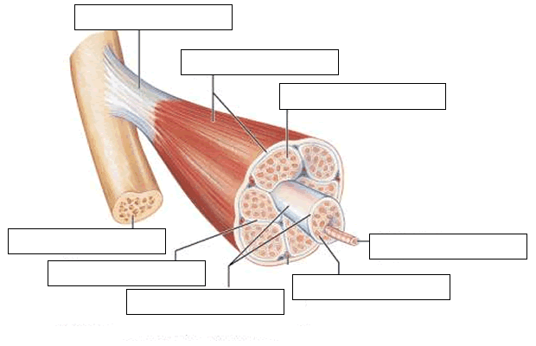
For a merit, using the definition below summarise how exercise and training can enhance a neuromuscular connection and improve motor fitness.

“A neuromuscular junction (or myoneural junction) is a chemical synapse formed by the contact between a motor neuron and a muscle fiber.^{[1]} It is at the neuromuscular junction that a motor neuron is able to transmit a signal to the muscle fiber, causing muscle contraction.”

…………………………………………………………………………………………………………………………………………………………………………………………………………………………………………………………………………………………………………………………………………………………………………………………………………………………………………………………………………………………………………………………………………………………………………………………………………………………………………………………………………………………………………

6.1 Describe how carbohydrates, fats and proteins are used in the
production of energy/adenosine triphosphate. For a merit include how this benefits participants in sport and exercise.
Attached to this unit is an information booklet, independently read through the information highlighting key areas, and then answer the following.

Carbohydrates
Functions:

Sources:

Proteins
Functions:

Sources:

Lipids (Fats)
Functions:

Sources:

You Are What You Eat: Carbohydrates

1. Describe the pathway and the enzymes involved in the digestion of carbohydrates.

2. Describe the advantage of having indigestible carbohydrates in the digestive system.

3. The liver is one destination for digested monosaccharides. Describe how the liver utilizes monosaccharides.

4. Describe two ways that simple sugars are either incorporated or utilized within cells.

You Are What You Eat: Protein

1. Describe the pathway and the enzymes involved in the digestion of proteins.

2. Describe how the liver uses amino acids.

3. Describe how amino acids are incorporated or utilized within cells.

4. If certain amino acids were removed from the diet and other amino acids could not be trans-formed into those amino acids, how might the resulting deficit disrupt an organism or a cell?

You Are What You Eat: Lipids

1. Describe the pathway and the enzymes involved in the digestion of lipids.

2. Describe the pathway of lipids between the digestive system and the bloodstream.

3. Besides long-term energy storage, what other functions do lipids serve in organisms and in cells?

4. How might a deficit or over-accumulation of fats be detrimental to organism?

6.2 Explain the use of the 3 energy systems during aerobic and anaerobic exercise. (Pass)
Activity, Fill in the missing words.

Two kinds of cell respiration go on in your muscle …………………...
…………………. RESPIRATION
&
ANAEROBIC ………………………
Your ………………………. usually get their energy from AEROBIC respiration.
glucose + oxygen = ......................+ carbon dioxide+water

Our muscles sometimes need ……………………… amounts of energy very quickly, e.g when ……………………………., therefore ANAEROBIC respiration takes over.

…………………… = ENERGY + lactic acid

Glucose has to be ……………………… down for it to be used by the muscles.
The glucose which has been stored (from food) in the muscles and liver as glycogen is broken down and …………………… and pyruvic acid is formed.
When there is oxygen, the pyruvic acid is changed into carbon dioxide and water.
Without enough, ………………………… the pyruvic acid changes into lactic acid.

respiration, Oxygen, muscles, aerobic, large, sprinting, fibres, glucose, broken, ATP, energy

Energy systems used during exercise – ANAEROBIC
The CP system

The ATP that is broken down by the muscle …………………………………. can be reformed in the presence of ……………………………….. phosphate (CP) which is also ………………………….. in muscles.
If there is enough ……………… then muscle contractions can take place even though there is no oxygen.

This …………………………………… system is used by sprinters and ………………………. It is used whenever a large effort is needed for a short ……………………………….. CP stores are used up in about 5-10 ………………………………………..

Sporting examples:

Contracting, throwers, creatine, time, stored, anaerobic, seconds, CP.

Energy systems used during exercise – ANAEROBIC
The Lactic Acid System

Pyruvic acid …………………………….. into lactic acid that collects in the muscles that are …………………………………. as well as overflowing to the ………………………..
………………………… Acid makes muscle contractions difficult and causes ……………………………….
If there is, too much the muscles …………………………. work at all.
Athletes who work as hard as possible for up to 2 …………………………………… use this anaerobic ……………………………………..
After this, the body goes into oxygen ………………………………..

Sporting examples:
1.
2.
3.

debt, working, won’t, bloodstream, Lactic, changes, tiredness, system, minutes.

Energy systems used during exercise – AEROBIC
The Aerobic System
If there is enough oxygen and glucose ……………………………., then you can continue to work on a less …………………………………. exercise almost continuously. This time the pyruvic …………………………. is turned immediately into ……………………………… dioxide and …………………………… because there is enough …………………………………. available.
This aerobic system is important during …………………………… activities.

Sporting examples:
1.
2.
3.

Although some …………………………………….. use one system, more than the other many depend on …………………… or more when taking part in sports.

Oxygen, Available, water, longer, acid, explosive, carbon, sportspeople, 2.

Activity: for a merit, choose a team game and show where the different systems are used, for different tasks during a match.

……………………………………………………………………………………………………………………………………………………………………………………………………………………………………………………………………………………………………………………………………………………………………………………………………………………………………………………………………………………………………………………………………………………………………………………………………………………………………
……………………………………………………………………………………………………………………………………………………………………………………………………………………………………………………

Complete the Quiz below.

1) Which organ pumps oxygen and nutrients to the tissues of the body?

A The lungs
B The kidneys
C The liver
D The heart

2)The lower chambers of the heart are known as:

A Atria
B Ventricles
C Capillaries
D Vena Cavae
3) The aorta transports:

A Oxygenated blood to the heart
B De-oxygenated blood to the heart
C Oxygenated blood away from the heart
D De-oxygenated blood away from the heart

4) Which organ is responsible for taking oxygen into the body?

A The heart
B The kidneys
C The spleen
D The lungs

5) Which of the following can be found stored in bones?

A Vitamins
B Minerals
C Glycogen
D Oxygen

6) Which type of joint is the most common?

A Fibrous
B Synovial
C Fused
D Cartilaginous

7) Which of the following types of movement is possible at a pivot joint?

A Flexion
B Abduction
C Adduction
D Rotation

8) Which of the following muscles would be the prime mover during knee flexion?

A Soleus
B Hamstrings
C Quadriceps
D Gluteals

9) Slow twitch muscle fibres:

A Are employed in high intensity activities
B Use the CP (creatine phosphate) energy system
C Are employed in low intensity activity
D Have a poorer blood supply than other muscle fibres

10) What is a motor unit?

A A muscle fibre which surrounds a myofibril
B A subcomponent of sensory nerves
C A motor neuron and all the fibres it innervates
D A receptor located in the muscle

11) The heart is positioned behind the sternum and:

A Far right of centre
B Far left of centre
C Just left of centre
D Just right of centre

12) Which structure attaches bone to bone?

A Ligaments
B Cartilage
C Tendons
D Joints

13) Which structure of the skeleton enables the potential for movement?

A Joints
B Bones
C Cartilage
D Bone marrow

14) What is a characteristic of fast twitch muscle fibres?

A Poor blood supply
B Aerobic fibres
C Red in colour
D Slower to contract

15) Fat is burned in the presence of oxygen during?

A Anaerobic sprint training
B Heavy resistance training
C Aerobic endurance training
D 400 metre racing

