Unit Assessment & Feedback
Learner Name
Qualification
Unit Title | Beliefs and Values
Unit Number |  | Level
Tutor/Assessor |  | Date

Feedback from Assessor to Learner

Comments from Learner

Have all assessment criteria for the unit been met? | Yes |  | No
If no, please detail action required and target dates for completion. Please initial and date once these have been completed.
Any further actions? | By when? |  | Completed?

Learner Signature |  | Date
Tutor/Assessor Signature |  | Date
IQA Signature (if sampled) |  | Date

Learner Evidence Record

Learner Name
Qualification
Unit Title | Beliefs and Values
Unit Number |  | Level |  | Credit Value
Tutor/Assessor

AC | Assessment Criteria | Page No.

I confirm that the work I have submitted is all my own work
Learner Signature |  | Date
Tutor/Assessor Signature |  | Date
IQA Signature (if sampled) |  | Date
EQA Signature (if sampled) |  | Date

BELIEFS AND VALUES

Unit Level: 1
Unit Credit Value: 1
GLH: 8
Unique Reference Number: L/503/0962

This Unit has 3 Learning outcomes.
LEARNING OUTCOMES | ASSESSMENT CRITERIA | Date Started | Date completed
The Learner will: | The Learner can:
- Understand what it meant by “beliefs”. | - State what is meant by “beliefs”.  - Identify own beliefs.  - Give examples of the beliefs of other people /groups.
- Understand what is meant by “values”. | - state what is meant by “values”.  - Identify values commonly held by a specific group of people.  - Identify own values  - Give examples of the values held by other people/groups.
- Understand how values and beliefs can influence attitudes, opinions and behaviour. | - State how values and beliefs may influence own attitudes, opinion and behaviour in a given situation.  - State how the values and beliefs of a given group have influenced their attitude/opinions and behaviour.
Beliefs and Values
NOCN
Level 1
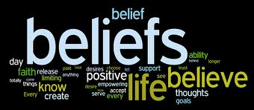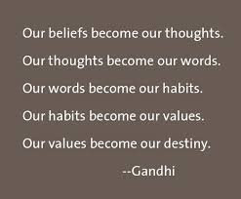

1. The Learner will understand what is meant by ‘beliefs’.

  - State what is meant by ‘beliefs’.
  - Identify own beliefs.

____________________________________________________________________________________________________________________________________________________________________________________________________________________________________________________________________________________________________________________________________________________________________________________________________________________________________________________________________________________________________________________________________________________________________________________________________________________________________________________________________________________

____________________________________________________________________________________________________________________________________________________________________________________________________________________________________________________________________________________________________________________________________________________________________________________________________________________________________________________________________________________________________________________________________________________________________________________________________________________________________________________________________________________
1.3 Give examples of the beliefs of other people/groups

5 main religions | God | Roughly how many follow the religion | Place or worship | Summary of beliefs
Christianity

Beliefs and Values
NOCN
Level 1
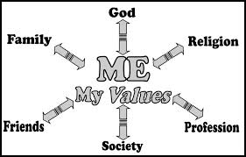

2. The Learner will understand what is meant by ‘values’.

2.1 State what is meant by ‘values’.

____________________________________________________________________________________________________________________________________________________________________________________________________________________________________________________________________________________________________________________________________________________________________________________________________________________________________________________________________________________________________________________________________________________________________________________________________________________________________________________________________________________

____________________________________________________________________________________________________________________________________________________________________________________________________________________________________________________________________________________________________________________________________________________________________________________________________________________________________________________________________________________________________________________________________________________________________________________________________________________________________________________________________________________
Beliefs and Values
NOCN
Level 1

2. The Learner will understand what is meant by ‘values’.

2.2 Identify values commonly held by a specific group of people.

____________________________________________________________________________________________________________________________________________________________________________________________________________________________________________________________________________________________________________________________________________________________________________________________________________________________________________________________________________________________________________________________________________________________________________________________________________________________________________________________________________________

________________________________________________________________________________________________________________________________________________________________________________________________________________________________________________________________________________________________________________________________________________________________________________________________________________________________________________________________________________________________________________________________________________
Beliefs and Values
NOCN
Level 1
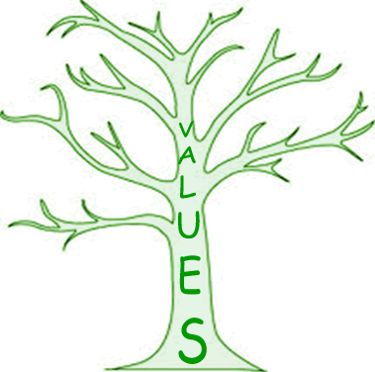

2. The Learner will understand what is meant by ‘values’.

2.3 Identify own values.

____________________________________________________________________________________________________________________________________________________________________________________________________________________________________________________________________________________________________________________________________________________________________________________________________________________________________________________________________________________________________________________________________________________________________________________________________________________________________________________________________________________

____________________________________________________________________________________________________________________________________________________________________________________________________________________________________________________________________________________________________________________________________________________________________________________________________________________________________________________________________________________________________________________________________________________________________________________________________________________________________________________________________________________

2.4 Give examples of the values held by other people or groups
Task- Choose 2 of the five main religions and research the values that the people who follow these religions commonly have.
Religion 1:
Values within this religion:

Religion 2:
Values within this religion:

3.1- State how own values and beliefs have influenced your attitude/opinion and behaviour in one of the following situations:
- Your education
- Gay marriage
- Drinking alcohol
- Taking drugs
You should talk about:
- What your beliefs and values are.
- How they have influenced your attitude/opinion of your chosen situation.
- How they have influenced your behaviour in your chosen situation.

Beliefs and Values
NOCN
Level 1
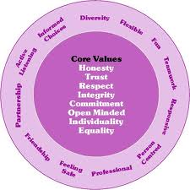

3. The Learner will understand how values and beliefs can influence attitudes, opinion and behaviour.

3.2. State how the values and beliefs of a given group have influenced attitudes/opinion and behaviour.

____________________________________________________________________________________________________________________________________________________________________________________________________________________________________________________________________________________________________________________________________________________________________________________________________________________________________________________________________________________________________________________________________________________________________________________________________________________________________________________________________________________

____________________________________________________________________________________________________________________________________________________________________________________________________________________________________________________________________________________________________________________________________________________________________________________________________________________________________________________________________________________________________________________________________________________________________________________________________________________________________________________________________________________

