**Bandits:**

* Plain black harlem trousers
* Plain black t-shirt
* Red sash
* Red fezz

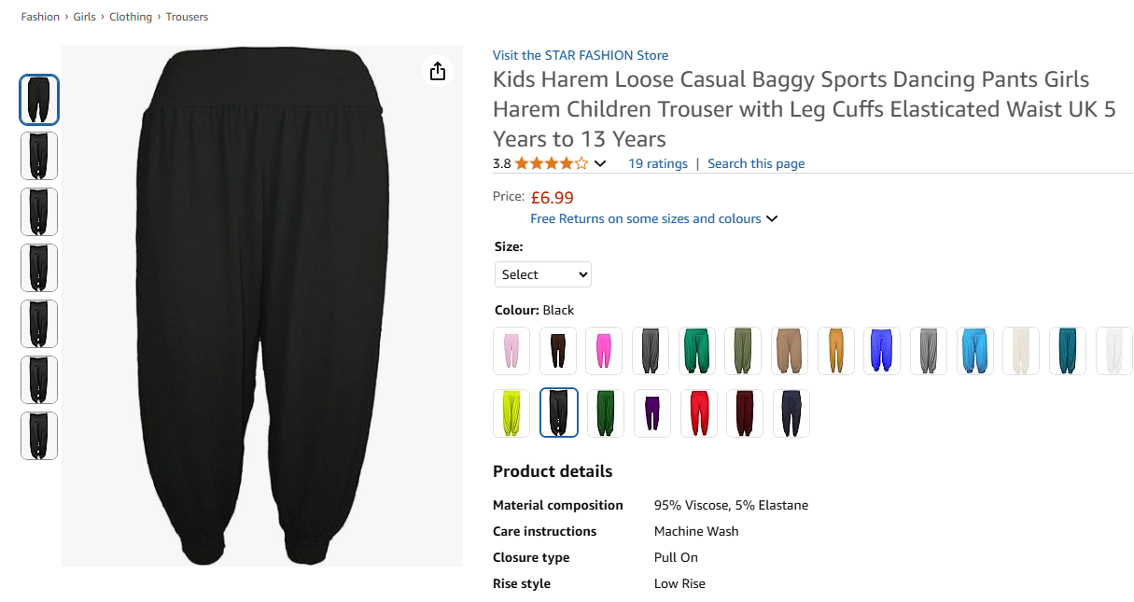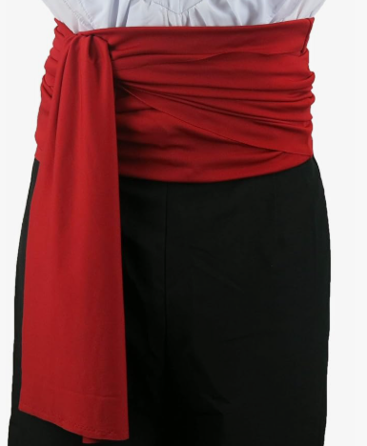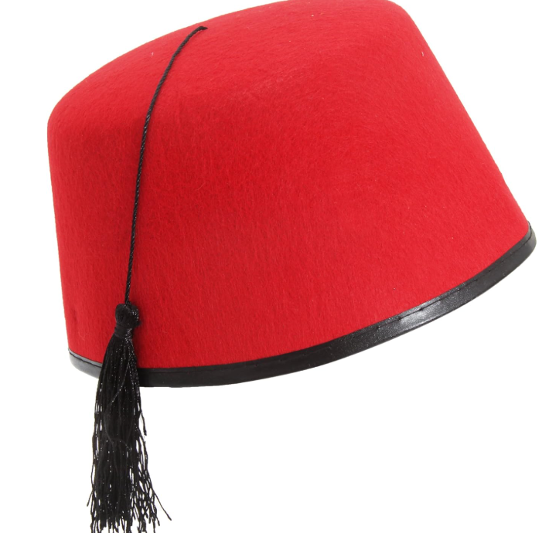

**Dusty, Musty, Handy and Sandy:**

* Stripy beige/black t-shirt
* Pale (white/beige) harlem trousers
* A pair of black braces

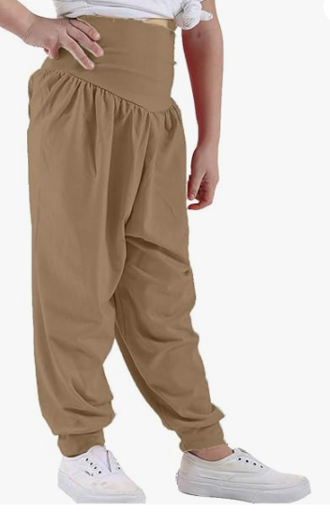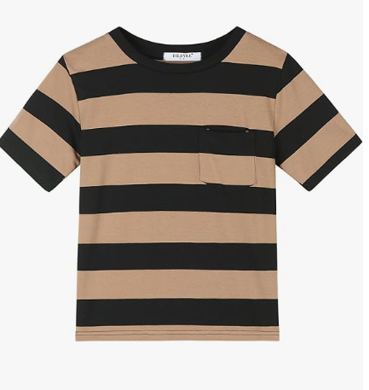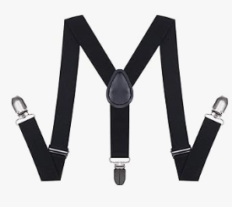

**Bongo and Bongette**

* Black harlem trousers
* Red and black stripy tshirt
* Red sash
* Red fezz

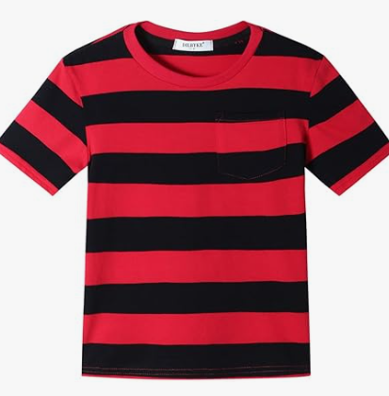

**Sultan:**

* Harlem trousers
* Fancy waistcoat
* Gold turban
* Plastic jewellery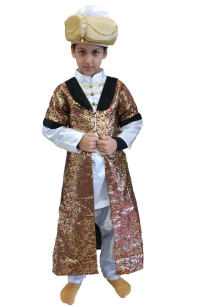

**Grand Vizier and Lady Vizier :**

**Colour theme – black and red**

* Long black dress or harlem pants
* Red cloak
* Staff
* Red and black head piece (if possible)

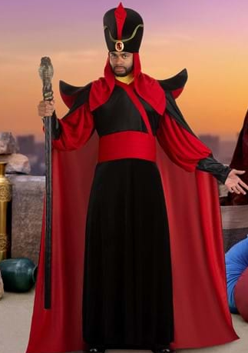

**Genie:**

* Colour theme –purple

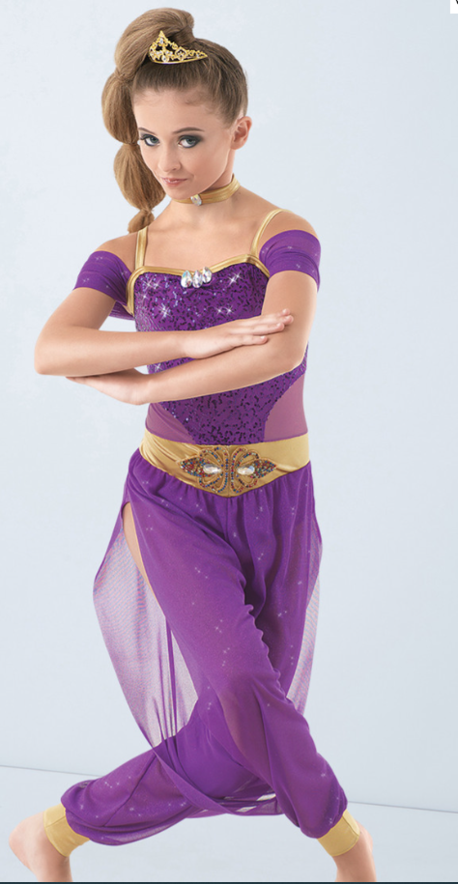

**Alakazam:**

* All white if possible – can be like base costume (harem pants/top) or even a suit – he needs to stand out from the rest of the cast!!

**Princess Satsuma:**

**Colour theme – turquoise**

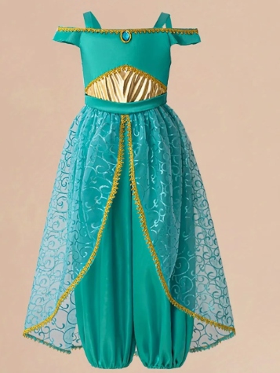

**Citizens:**

* **Black Harlem trousers**
* **Black tshirt**
* **waistcoat (bright colours)**

**Flossy and bossy Baba:**

* Bright coloured harlem pants and tshirt
* Shawl
* Bright coloured headscarf
* White Apron 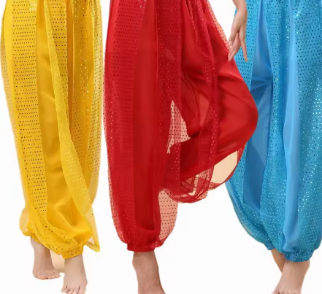

**Ali Baba:**

* Colour theme purple
* Waistcoat 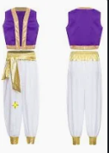 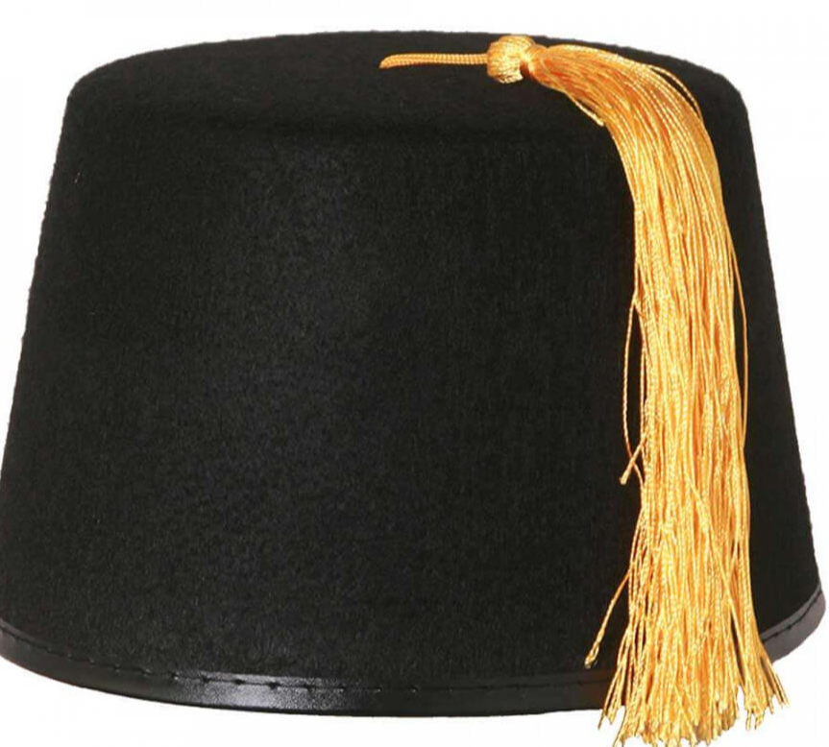

**Guards:**

* Black harlem trousers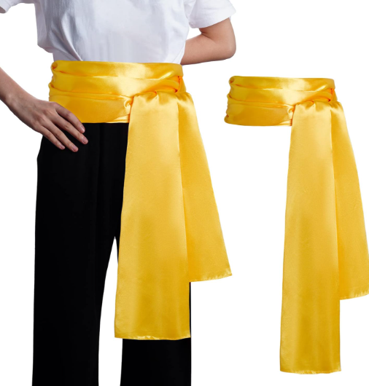
* Black tshirt
* Gold sash

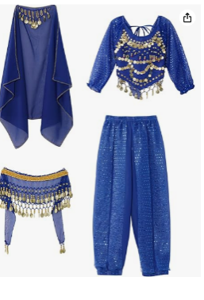**Handmaidens – Tabioca, Semolina, Figgy**

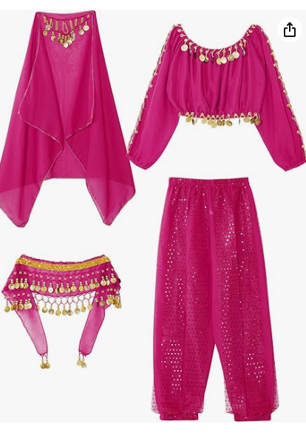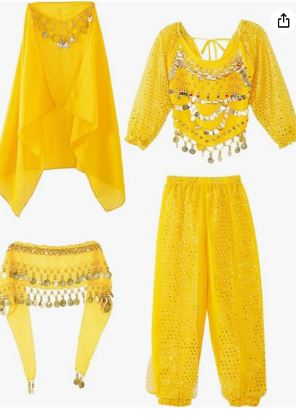

**Sheiks:**

* 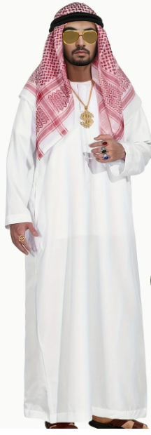
* White tunic or white harlem trousers and tshirt
* Red head scarf
* Black headband
* Sunglasses
* Plastic gold jewellery

Market sellers

Harlem trousers, colourful top, head scarf or hat

