# Pupil premium strategy statement

## This statement details our school’s use of pupil premium (and recovery premium for the 2021 to 2022 academic year) funding to help improve the attainment of our disadvantaged pupils.

## It outlines our pupil premium strategy, how we intend to spend the funding in this academic year and the effect that last year’s spending of pupil premium had within our school.

## School overview

|  |  |
| --- | --- |
| Detail | Data |
| School name | Walmsley CE Primary |
| Number of pupils in school | 355 |
| Proportion (%) of pupil premium eligible pupils | 8.45% |
| Academic year/years that our current pupil premium strategy plan covers **(3 year plans are recommended)** | 2022-2025 |
| Date this statement was published | Feb 2022 |
| Date on which it will be reviewed | Sept 2023 |
| Statement authorised by | Debra Carr |
| Pupil premium lead | Alastair Catterall |
| Governor Lead |  |

**Funding overview**

|  |  |
| --- | --- |
| **Detail** | **Amount** |
| Pupil premium funding allocation this academic year | £52245 |
| Recovery premium funding allocation this academic year | £2248 |
| Pupil premium funding carried forward from previous years (enter £0 if not applicable) | £0 |
| **Total budget for this academic year**  If your school is an academy in a trust that pools this funding, state the amount available to your school this academic year | £54493 |

# Part A: Pupil premium strategy plan

## Statement of intent

|  |
| --- |
| At Walmsley, we aim to ensure that all pupils, irrespective of their background or the challenges they face, make good progress and feel successful in their journey through school. We strive to enable the children to feel safe with a focus on their well-being.Our pupil premium strategy supports disadvantaged pupils to achieve and have a full role in school life.  Quality first teaching is at the heart of our approach, focusing on areas in which disadvantaged pupils require the most support. We target individual and group support through School Led Tutoring for pupils whose education has been affected, including non-disadvantaged pupils. We, as a school wish to develop learners who have dreams and aspirations and understand their own role in determining their future destiny. As a school we are charged with preparing children for their next step in life but what we aim to do as a school is prepare children with the skill set to succeed in the future and create the future whatever that may look like –resilience, adaptability, creative thinking, no ceiling on their learning or what they can achieve.  Our approach will be responsive to common challenges and individual needs based upon assessments and professional dialogue with teachers, not assumptions about the impact of disadvantage. The approaches we have adopted complement each other to help pupils excel. To ensure they are effective we will:   * ensure disadvantaged pupils are challenged in the work that they’re set * act early to intervene at the point need is identified * adopt a whole school approach in which all staff take responsibility for disadvantaged pupils’ outcomes and raise expectations of what they can achieve |

## Challenges

This details the key challenges to achievement that we have identified among our disadvantaged pupils.

|  |  |
| --- | --- |
| Challenge number | Detail of challenge |
| 1 | Ensure the well-being of all staff and children, particularly disadvantaged children is supported through this period of school disruption. Addressing issues around emotional well-being which have been exacerbated due to the pandemic. |
| 2 | Ensure that attendance levels remain high across schools and disadvantaged children and families are supported to maintain high attendance levels in-line with their peers. |
| 3 | Ensure disadvantaged children are monitored and supported to achieve expected and higher levels of progress and attainment. |
| 4 | Ensure that timetabling is effective in providing time for support activities. Ensure that extra staff are available to facilitate this extra support. |
| 5 | Ensure all disadvantaged children have access to all wider opportunities and encouraged to take part. Engaging families facing challenging circumstances. |

## Intended outcomes

This explains the outcomes we are aiming for **by the end of our current strategy plan**, and how we will measure whether they have been achieved.

|  |  |
| --- | --- |
| Intended outcome | Success criteria |
| To achieve and sustain improved well-being for all our pupils including that of the disadvantaged | Sustained high levels of well-being demonstrated by student voice, student and parent surveys, and staff observations. |
| To ensure that attendance levels return to high levels pre-pandemic and that disadvantaged children are in-line with their peers. | The overall absence rate for all pupils is being no more than 96% and disadvantaged children are in-line with their peers. |
| To ensure that disadvantaged children are monitored and suitable support is given through quality first teaching to achieve expected and higher levels of progress. | That disadvantaged children have achieved expected or higher levels of progress and/or attainment and that pandemic disruption has had as little impact as possible. |
| To provide suitable additional support activities to pick up any gaps in education not addressed in quality first teaching | Children, particularly disadvantaged, have had gaps addressed in catch-up programmes to ensure that pandemic disruption has had as little impact as possible. |
| To encourage disadvantaged children to have full access to wider school life removing barriers for families in challenging circumstances. | Disadvantaged children have had full access to all activities available in school and identified barriers which have been removed. |

## Activity in this academic year

This details how we intend to spend our pupil premium (and recovery premium funding) **this academic year** to address the challenges listed above.

### Teaching (for example, CPD, recruitment and retention)

Budgeted cost: £8516.96

|  |  |  |
| --- | --- | --- |
| Activity | Evidence that supports this approach | Challenge number(s) addressed |
| Well Being of staff | Having a proactive approach to well-being of staff has been strong over pandemic. School focussed on its core mission to remove pressures off staff. Staff report positive effect on their well-being reported via staff voice. | 1 |
| Subject leadership  Mark Mullin ECM | Continued development of our subject leadership training has support teachers to have a greater understanding of their role. | 3 |
| Subject leadership  Deep Dive CPD | Extra training to support teachers understating of Deep Dive in their subject area. | 3 |

**Targeted academic support (for example, tutoring, one-to-one support structured interventions)**

Budgeted cost: £ 43019.83

|  |  |  |
| --- | --- | --- |
| Activity | Evidence that supports this approach | Challenge number(s) addressed |
| Nuffield Early Language Intervention | Assessed Reception children in order to support language development.  All EYFS and Key Stage 1 staff fully trained. | 3 |
| Ensure disadvantaged children have access to high quality fiction and non-fiction to facilitate a love of reading | Purchase of high quality fiction and non-fiction. Timetabling of opportunities for reading for pleasure. Access to quality books which can be taken home. Quality texts has enhanced children’s engagement with reading. | 3 |
| Mastering Number Programme | All EYFS and Key Stage 1 staff have accessed training and embedding elements into their practice. | 3 |
| Additional TA support and small group interventions to improve Math and English skills. | Small group interventions in English and Maths to fill gaps in knowledge and help children close the gap. Approach supported progress in previous years | 4 |
| One-to-one and small group support in English and Mathematics. | Additional staff employed to support children on a one-to-one basis or in small groups. Approach supported progress in previous years. | 4 |
| KS1 Phonics intervention | Small group interventions to accelerate children’s progress in phonics where low attainment is a barrier. Approach supported progress in previous years | 4 |
| KS2 Reading intervention | One to one interventions using Toe-by-Toe to enable children to accelerate their rates of progress. Approach supported progress in previous years | 4 |

**Wider strategies (for example, related to attendance, behaviour, wellbeing)**

Budgeted cost: £16206.75

|  |  |  |
| --- | --- | --- |
| Activity | Evidence that supports this approach | Challenge number(s) addressed |
| Accessing Wider school life. | Support families to ensure that all children access all aspects of school life: residential trips, educational trips and other enrichment activities. | 5&6 |
| Monitoring of attendance | Monitoring of attendance and punctuality under 90%. Supports our high levels of attendance | 2 |
| Aspire Behaviour Support | Aspire Behaviour support to work alongside teachers to provide strategies to support children with emotional and behavioural support. Children supported well within school and liaison with home strong.  To work with children and families to help develop structures and strategies to support behaviour. | 1 |
| Well-being of all stakeholders, particular focus on disadvantaged children and their families. | Healthy Relationships – programme delivered to Years 5 & 6 from Fort Alice.  Bright Leaders programme for Year 6  Transition programme on Kooth ages 11-26 for Year 6.  Qwell access for parents and staff for mental health support.  Growing and Changing programme delivered by Healthy Families Practitioner. | 1 |

**Total budgeted cost: £ 67743.54**

# Part B: Review of outcomes in the previous academic year

## Pupil premium strategy outcomes

This details the impact that our pupil premium activity had on pupils in the 2021 to 2022 academic year.

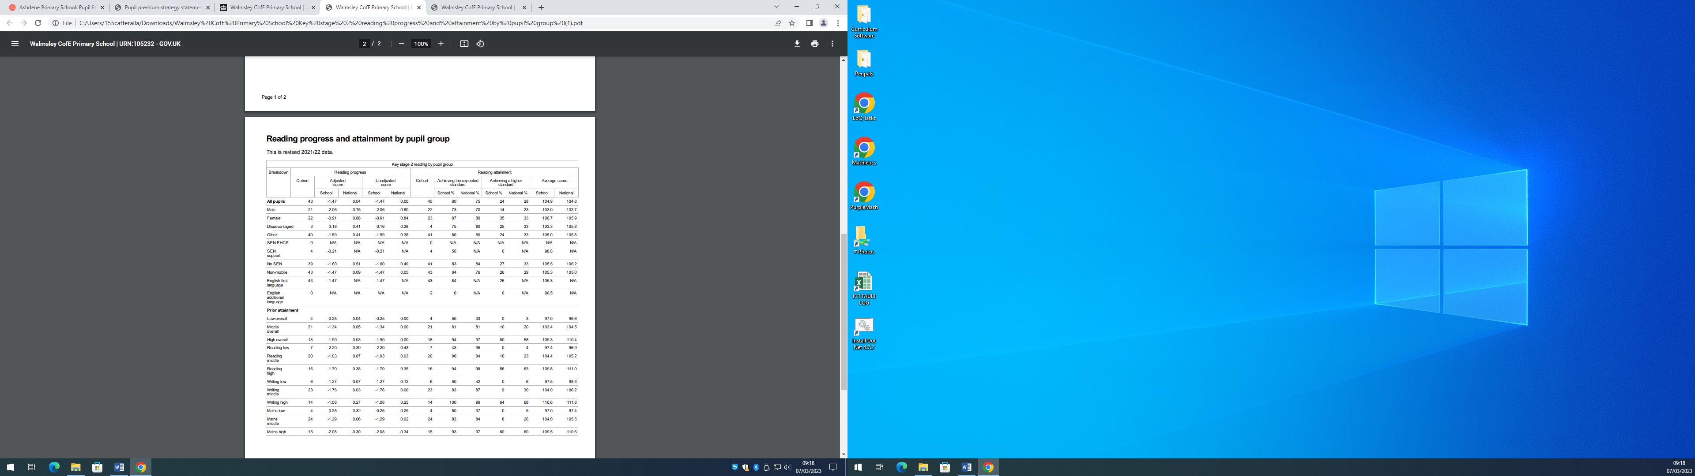

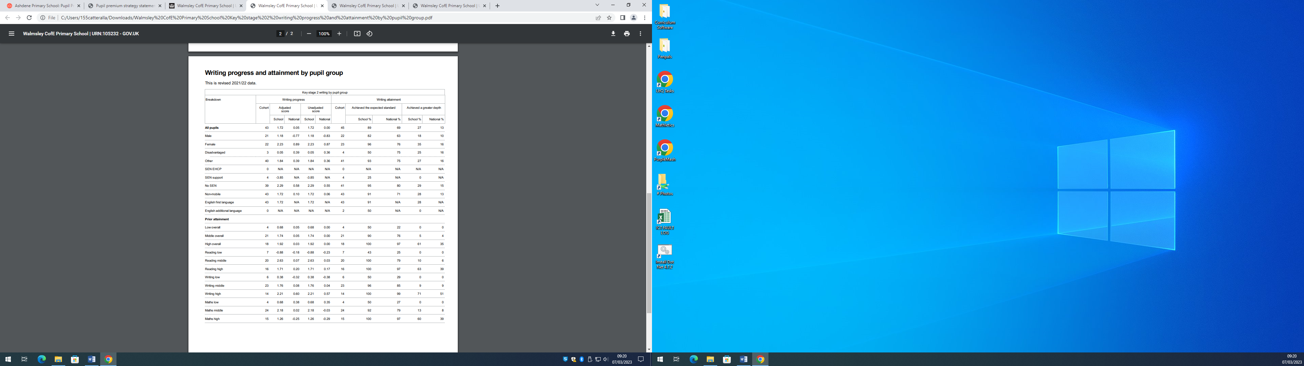

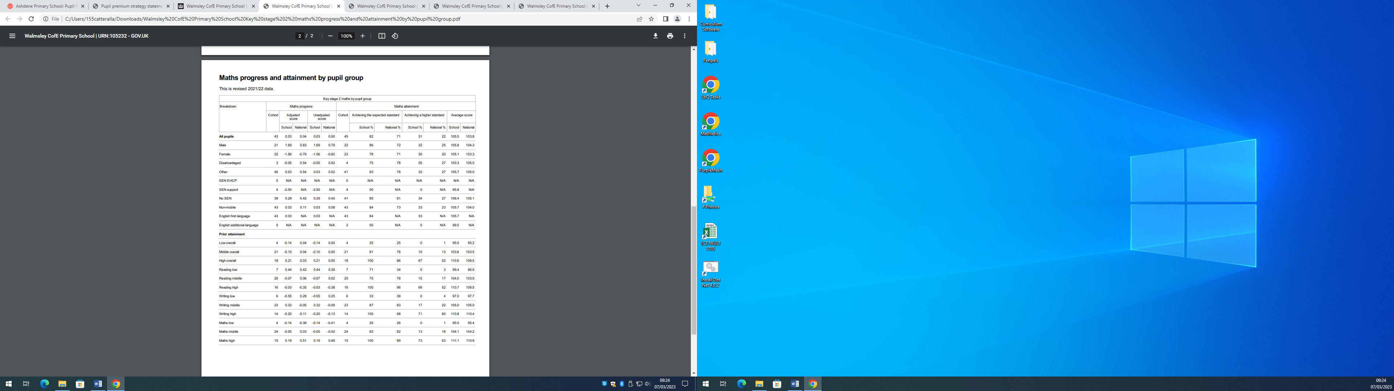

## Externally provided programmes

*Please include the names of any non-DfE programmes that you purchased in the previous academic year. This will help the Department for Education identify which ones are popular in England*

|  |  |
| --- | --- |
| Programme | Provider |
| Nuffield Early Language Intervention | Nuffield Education Foundation |
| Mastering Number Programme | NCETM & MATHSHUBS |

# Further information

|  |  |  |  |
| --- | --- | --- | --- |
| |  | | --- | | **Additional activity**  Our pupil premium strategy will be supplemented by additional activity that is not being funded by pupil premium or recovery premium. This will include:   * utilising a [DfE grant to train a senior mental health lead](https://www.gov.uk/guidance/senior-mental-health-lead-training). The training we have selected will focus on the training needs identified through the online tool: to develop our understanding of our pupils’ needs, give pupils a voice in how we address wellbeing, and support more effective collaboration with parents. * establishing a team to support the mental health and well-being of staff and children consisting of the head teacher, PSHE lead, SENDco, KS 2 lead, EYFS and KS 1 well-being leads to offer a wrap-around approach across school. * offering a wide range of high-quality extracurricular activities to boost wellbeing, behaviour, attendance, and aspiration. Activities will focus on building life skills such as confidence, resilience, and socialising. Disadvantaged pupils will be encouraged and supported to participate.   **Planning, implementation, and evaluation**  In planning our new pupil premium strategy, we evaluated why activity undertaken in previous years had not had the degree of impact that we had expected.  We triangulated evidence from multiple sources of data including assessments, engagement in class book scrutiny, pupil voice, and in particular teachers in order to identify the challenges being faced by our children and in particular our disadvantaged children. We also compared our progress and achievement against local and national data.  We are constantly reviewing the impact of the pandemic for all pupils and in particular our disadvantaged children.  **Three Year Plan.**  We will keep our approach under constant review in order to ensure that the actions and support we have in place for the duration of our three-year approach ensure better outcomes for our children. If necessary we will continue to supplement our above plans as funding changes over the time of this plan. | | | |
| 2022-2023 | 2023-2024 | 2024-2025 |
| £5,288 | £1,817 | £478 |