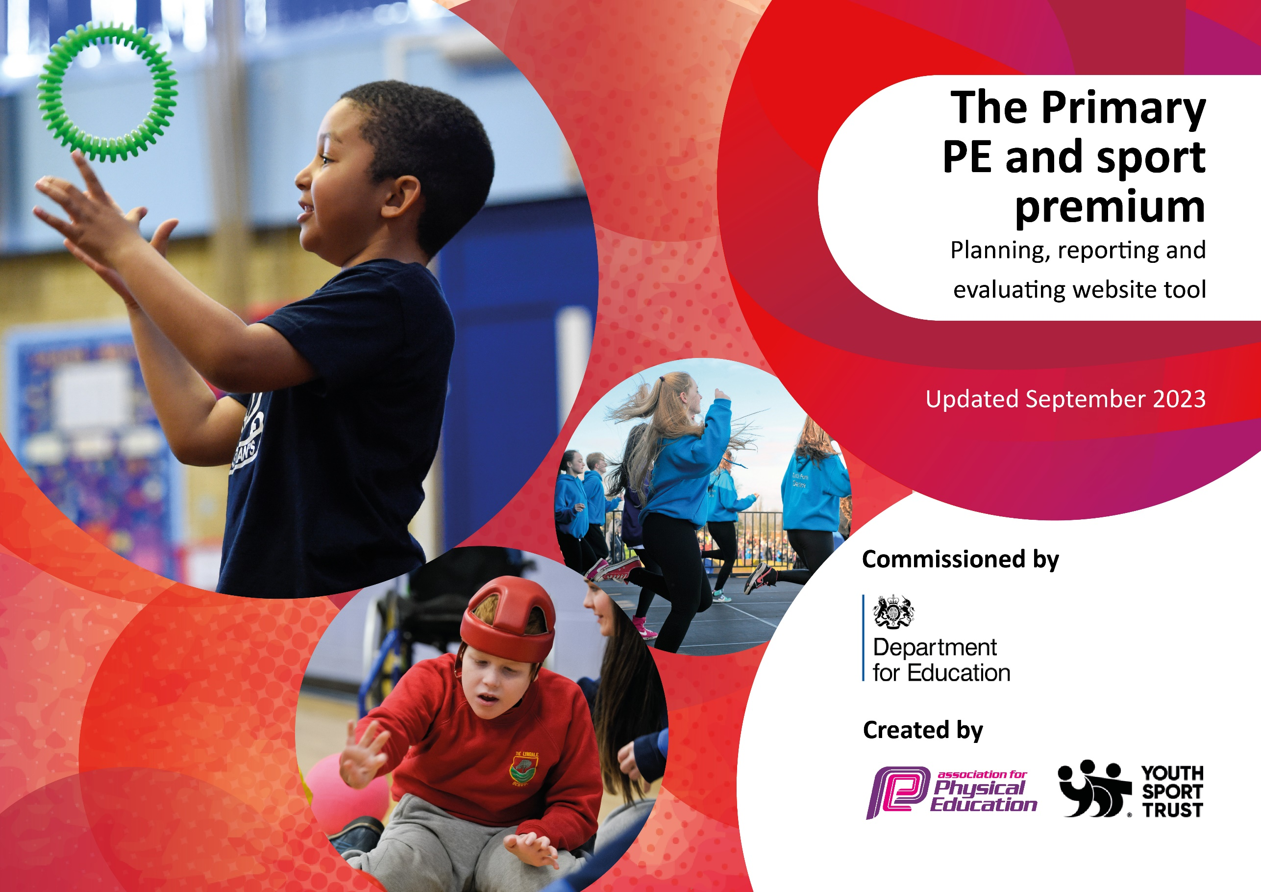

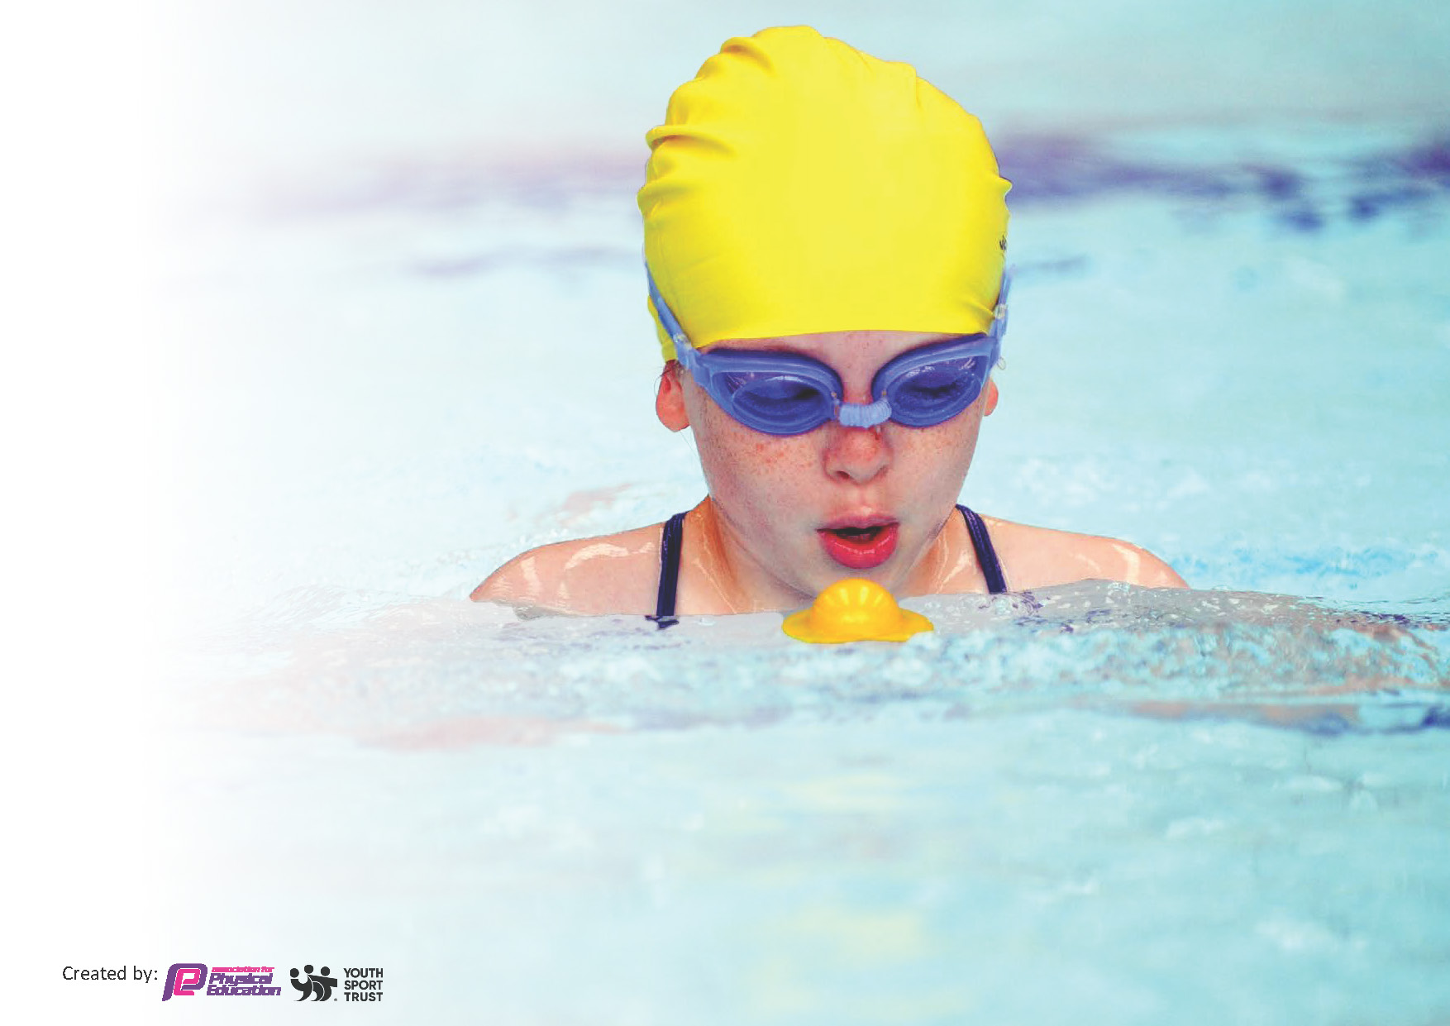
This template can be used for multiple purposes:
by:
- It enables schools to effectively plan their use of the Primary PE and sport premium
- It helps schools to meet the requirements (as set out in guidance) to publish information on their Primary PE and sport premium
- It will be an effective document to support Ofsted inspections enabling schools to evidence progress in Physical Education (PE) and evidence swimming attainment, which forms part of the PE National Curriculum. We would recommend schools consider
the Intent, Implementation and Impact of any spend, as examined within the Education Inspection Framework.

It is important that your grant is used effectively and based on school need.

Schools must use the funding to make additional and sustainable
improvements to the quality of the PE, School Sport and Physical Activity (PESSPA)
they offer. This means that you should use the Primary PE and sport premium to:

- Build capacity and capability within the school to ensure that improvements made now will benefit pupils joining the school in future years
- Develop or add to the PESSPA activities that your school already offers.

The Primary PE and sport premium should not be used to fund capital spend projects; the school’s core budget should fund these. Further detail on capital expenditure can be found in the updated Primary PE and sport premium guidance.

The Primary PE and sport premium guidance, outlines 5 key priorities that funding should be used towards. It is not

necessary that spending has to meet all the key priorities, you should select the priorities that you aim to use any funding towards.

Although completing this template is not a requirement for schools, schools are required to publish details of how they spend this funding. Schools must also outline what the impact this funding has had on pupils’ PE and sport participation and attainment and how any spending will be sustainable in the future. All funding must be spent by 31st July 2024.

The Department for Education has worked closely with the Association for Physical Education (afPE) and the Youth Sport Trust (YST) to develop this template and encourages schools to use it. This template is an effective way of meeting the reporting requirements of the Primary PE and sport premium.
Review of last year’s spend and key achievements (2022/2023)

We recommend you start by reflecting on the impact of current provision and reviewing your previous spend.

Activity/Action | Impact | Comments
To maintain high quality PE teaching and learning throughout the whole school through the deployment of dance and sport specialists.  Funda and Miss Katie have delivered lessons and supported staff through CPD to ensure staff have the skills and confidence to teach their own PE lessons.  To develop the KS1 playground and increase the amount of physical activity taking place outside PE lessons.  To release staff to enable a range of groups access external competitions.  To provide specific training for staff on tennis and cricket during the spring/summer term through Tom Luke Tennis.  To purchase bikes and trikes for the refreshed EYFS outdoor space. | Staff confidence to deliver PE has grown and all classes have benefitted from experienced coaches delivering their lessons.  Children in Reception, Y1 and Y2 now have their own trim trail to complement that in the KS2 playground. There has been an increase in the amount of activity children are taking part in at playtime and lunchtime.  Teams across Y2-6 have taken part in football, cricket, rounders, netball ad swimming including the Y5/6 girls football team representing the North West at Elland Road.  All staff supported and co-lead the sessions with Tom Luke enabling their confidence to grow and for children to benefit from high levels of staffing within the sessions.  Motor skills and physical activity are improved for the children in reception. | Staff will be teaching a lot more of their own PE moving forwards.  Further development of the KS2 playground is now needed as wilst they have a trail, for the number of children their access is still limited.  The ability to partake in these activities is really important and will be prioritised again next year.  This will not be a requirement moving forwards and will not be continued.  Impact not yet seen as order was delayed by manufacturer. Further investment required during the coming academic year.

Key priorities and Planning
This planning template will allow schools to accurately plan their spending.

Action – what are you planning to do | Who does this action impact? | Key indicator to meet | Impacts and how sustainability will be achieved? | Cost linked to the action
Develop the KS2 playground space to encourage increased activity through ActiveAll boards | All KS2 pupils | Key indicator 2 -The engagement of all pupils in regular physical activity – the Chief Medical Officer guidelines recommend that all children and young people aged 5 to 18 engage in at least 60 minutes of physical activity per day, of which 30 minutes should be in school.  Key indicator 4: Broader experience of a range of sports and activities offered to all pupils. | More pupils meeting their daily physical activity goal, more pupils encouraged to take part in PE and Sport Activities. | £8000 costs for the procurement and installation of the boards.

Purchase of PE Hub scheme of work | All teaching staff and the pupils that they teach | Key Indicator 1: Increased confidence, knowledge, and skills of all staff in teaching PE and sport. | Primary teachers more confident to deliver effective PE supporting pupils to undertake extra activities inside and outside of school, and as a result improved % of pupil’s attainment in PE. | £500 for access to PE hub.
Purchase of balancebikes, scooters, helmets, resources and training | Pupils in reception and KS1 | Key indicator 2 -The engagement of all pupils in regular physical activity  Key indicator 4: Broader experience of a range of sports and activities offered to all pupils. | Pupils able to further enhance their skills following balanceability training and become more active throughout the day. | £3589.80
To enter school competitions as they are offered on the Bolton School Games website. Increased participation in competitive sports.  Purchase membership to Bolton School Games | An increased range of children across KS1 and KS2 | Key indicator 5: Increased participation in competitive sport. | More pupils will be given opportunities to take part in external events across a wider range of sports. | £1000  £100
Year 6 wellbeing team to support lunchtime staff by organizing sport activities for KS1 and KS2.  Training provided by EdStart for the team delivering | Opportunities available for all pupils. | Key indicator 2 -The engagement of all pupils in regular physical activity | Lunch time clubs will help children achieve the desired 60 minutes of physical activity per day | £500 for training  £500 for resources
Ensure children have access to age appropriate active travel training in order to encourage them to walk or cycle to school safely by providing balanceability and bikeability training. | Reception – balanceability  Year 6 - bikeability | Key indicator 4: Broader experience of a range of sports and activities offered to all pupils. | Y6 pupils learn how to ride their bike safely on the road. | £200 towards helmet and bike hire
To ensure that equipment is updated to provide the best experiences for children to participate in a range of activities, both curricular and extra-curricular. Update PE equipment which becomes old and damaged to ensure it provides sustainability for purpose and activity. | All pupils across school | Key indicator 4: Broader experience of a range of sports and activities offered to all pupils. | Children have access to high quality equipment to facilitate progress and enjoyment within PE, allowing the enhancement of skills in a broad range of sports. | £1500 towards equipment replacement
To enhance the woodland offer through access to forest school trained staff and through the procurement of resources to support delivery | All pupils across school | Key indicator 4: Broader experience of a range of sports and activities offered to all pupils. | These sessions will focus on developing the confidence, social interaction and wellbeing of pupils | £4200 for delivery and resources

Key achievements 2023-2024
This template will be completed at the end of the academic year and will showcase the key achievements schools have made with their Primary PE and sport premium spending.

Activity/Action | Impact | Comments
Purchase of balance bikes, scooters, helmets, resources and training | All children in Reception have been supported in developing their core strength and gross motor skills through the use of the newly purchased balance bikes and pedal bikes.  The EYFS lead who also teaches in Reception has been trained on the use of the equipment and has supported the rest of the team in the effective use of the equipment.  In addition, children in KS1 have also started to further develop their skills by progression on to the newly purchased scooters for use at playtimes and other free times. | We have seen a really positive impact from the use of the equipment.  The next steps for this are to purchase storage for the equipment on the playground and to further enhance the offer to enable more children to actively engage.
To enter school competitions as they are offered on the Bolton School Games website. Increased participation in competitive sports.  Purchase membership to Bolton School Games | We have increased the number of children and range of sports we have participated in this year. We have seen a broad range of children representing school in cross country, football, dodgeball, rounders, cricket, gymnastics, snowboarding and athletics.  We have become less reliant on parent support with transport and have ensured groups are supported by members of familiar school staff.  A broader range of children have responded positively to the opportunities that they have been given.  Sport premium money has been used to support with staffing cover costs and transport costs. | Children have been encouraged to adopt greater resilience when taking part in sporting events.  During the next academic year, we aim to further enhance the competitive sport offer and aim to increase the number of children able to actively engage in the events.
Purchase of PE Hub scheme of work | A higher percentage of teachers have been teaching their own PE lessons this year. The scheme has enabled a consistent approach to be taken across school. The detail provided supports staff CPD and children are familiar with the format of the lessons.  Knowledge, skill progression and the range of sports being taught has increased. | The new PE Hub portal has been purchased for the new academic year to further support teacher assessment and to provide the most up to date planning and teaching materials available.
To enhance the woodland offer through access to forest school trained staff and through the procurement of resources to support delivery | Hedgehogs Woodland sessions were initially planned for one term but due to the impact of the sessions, a decision was made to increase these to termly. Children, staff and parent helpers all report the positive impact that the sessions had on children’s gross motor skills, confidence, and resilience. | Due to the success of the sessions, a decision has been made to extend these into the next academic year.
To ensure that equipment is updated to provide the best experiences for children to participate in a range of activities, both curricular and extra-curricular. Update PE equipment which becomes old and damaged to ensure it provides sustainability for purpose and activity. | New resources have been purchased this year both to replace old and damaged equipment but also to complement the PE Hub curriculum and the increased range of sports delivered. | Although there will be ongoing refresh requirements for PE equipment, there should be no further new sport requirements in order to deliver the intended curriculum.

Swimming Data
Meeting National Curriculum requirements for swimming and water safety.
Priority should always be given to ensuring that pupils can perform safe self-rescue even if they do not fully meet the first two requirements of the National Curriculum programme of study

Question | Stats: | Further context  Relative to local challenges
What percentage of your current Year 6 cohort can swim competently, confidently and proficiently over a distance of at least 25 metres? | 96% | 46/48 pupils  2/48 were non swimmers at the start of the sessions.
What percentage of your current Year 6 cohort can use a range of strokes effectively [for example, front crawl, backstroke, and breaststroke]? | 92% | 44/48

What percentage of your current Year 6 cohort are able to perform safe self-rescue in different water-based situations? | 92% | 44/48
If your schools swimming data is below national expectation, you can choose to use the Primary PE and sport premium to provide additional top-up sessions for those pupils that did not meet National Curriculum  requirements after the completion of core lessons. Have you done this? | No | N/A
Have you provided CPD to improve the knowledge and confidence of staff to be able to teach swimming and water safety? | No | Swimming teaching is provided by the local swimming pool.

Signed off by:

Head Teacher: | Joanna Atherton
Subject Leader or the individual responsible for the Primary PE and sport premium: | Matt McGlashan
Governor: | (Name and Role)
Date: | 20/8/23

