Chronological understanding | Cause and consequence | Continuity and change | Similarity and difference | Significance | Interpretations | Evidence and enquiry | Substantive knowledge

Substantive Knowledge
Coal can be burnt to provide heat.  Coal is found underground.  A steam engine uses coal to move.  Coal miners worked 12 hours a day.  Coal miners were 6 days a week  Coal miners were helped by horses who pulled the coal up. | People use to milk cows by hand.  Horses were used to plough the fields.  They didn’t have tractors to help with the work.
Teachers wrote on blackboards and used chalk.  They hit children with a ruler if they were late.  Teachers taught drills in PE. | Nurses didn’t wear masks or gloves.  Nurses had uniforms.  Nurses were only women.
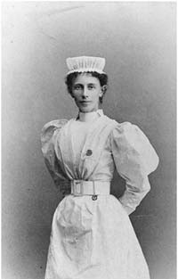
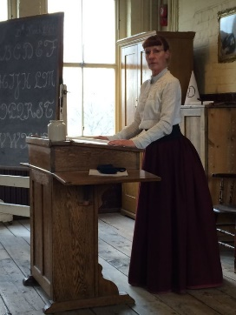
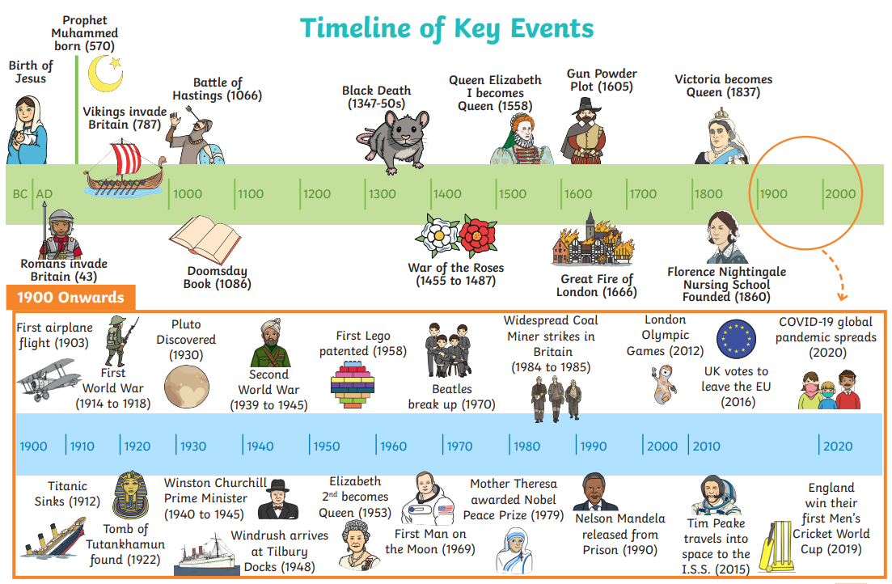

Hurrier | Children who moved carts of coal through tunnels.
Breaker boy | Sorted coal from rock.
Plough | A plough is pulled across the ground by a human or animal. When pulled across the ground, the plough lifts up dirt and makes two lines of dirt behind it.
Mines | The process or industry of obtaining coal or other minerals from a mine.

