Chronological understanding | Cause and consequence | Continuity and change | Similarity and difference | Significance | Interpretations | Evidence and enquiry | Substantive knowledge

Substantive Knowledge
Laurence Stephen Lowry was born in Stretford, Manchester in 1887.  He was a painter.  He painted the working class people.  His paintings show industries and factories.  He painted people and drew them as ‘matchstick men.’ | Going to the match painting by LS Lowry – shows fans arriving for Bolton Wanderers game at their former home of Burden Park.  It was painted in 1953
LS Lowry was appointed the official artist for the Coronation of Queen Elizabeth II in 1953  Coming from the Mill Painting shows the industrial revolution - link with jobs from the past | Bolton Wanders was founded in 1874 by pupils in Christ Church School on Blackburn Street  Wanderers is the name comes from the fact that they often changed grounds.  In 1922 Bolton Wanders won the FA cup  1895 they moved to Burden Park  1997 they moved to their current stadium

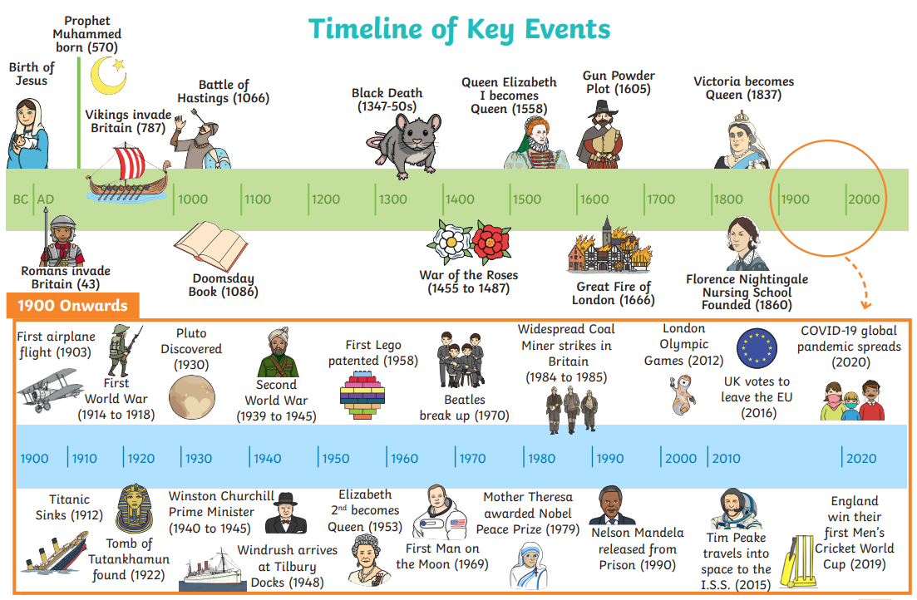
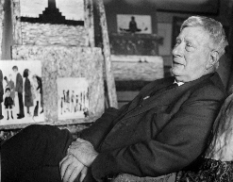

Coronation | The ceremony of crowning a sovereign or a sovereign's consort.
Working class | The social group consisting primarily of people who are employed in unskilled or semi-skilled manual or industrial work.
Mill | A factory fitted with machinery for a particular manufacturing process.
Industrial revolution | The Industrial Revolution was a time when the manufacturing of goods moved from small shops and homes to large factories.

