Chronological understanding | Cause and consequence | Continuity and change | Similarity and difference | Significance | Interpretations | Evidence and enquiry | Substantive knowledge

Substantive Knowledge
Eagley Mills are in Bolton  The first mill was built in 1780 by William Longshaw  Bridge Mill was textile mill.  Bridge mill stopped production in 1972 | Eagley Mills are located next to the River Irwell  The River Irwell – Eagley Brook was a power source for the Mill.  The River Irwell was used to transport materials and goods to and from the Mills.
People spinning in their homes were not able to provide enough yarn for the weavers and so new machines were invented to produce more. These machines required large buildings to house them and a workforce in one place. | 1760-1840 - At this time in the United Kingdom lots of mills were being built as it was the Industrial Revolution.  Demand for clothes was growing due to a growing population.  More mills were built at Eagley Mills to cope with the growing demands.
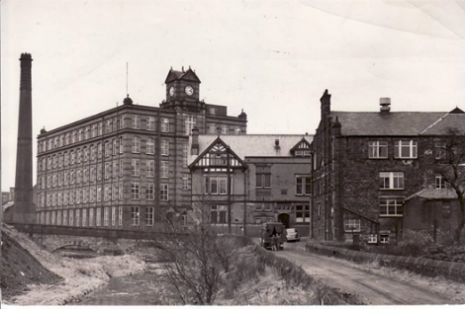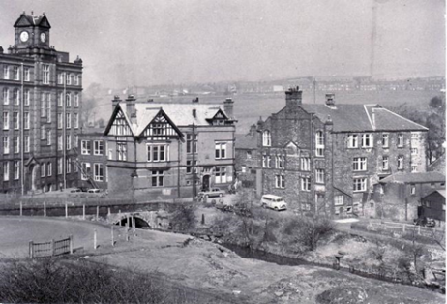
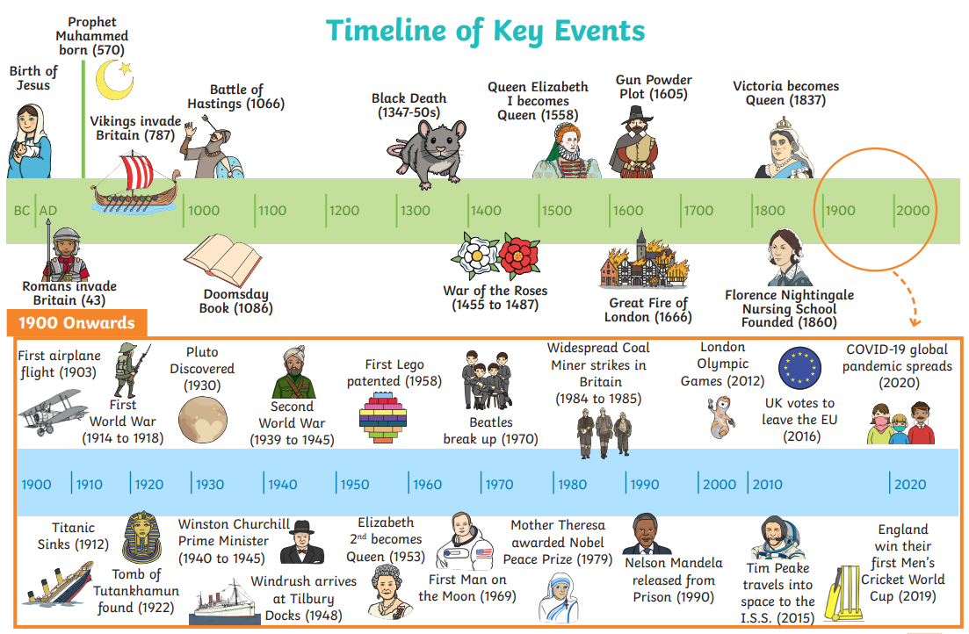
Key Vocabulary
Workhouse | A place where you live and worked if you were poor.
Eagerly Brooke | The water way where Eagerly mill was built so the water could run the machinery.
Arthur Gregg | The manager of Eagerly mill
scavengers | Young children who worked in Eagerly mill.
Spinning Jenny/Wheel | The spinning jenny was essentially an adaptation of the spinning wheel. It was used to spin the cotton.

