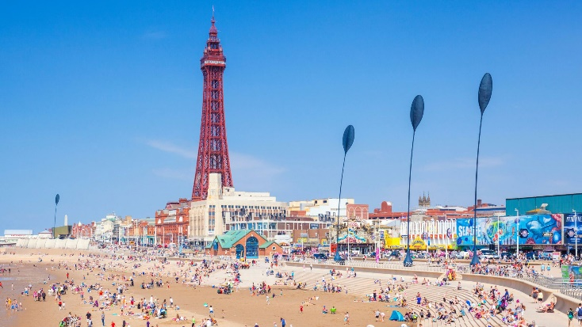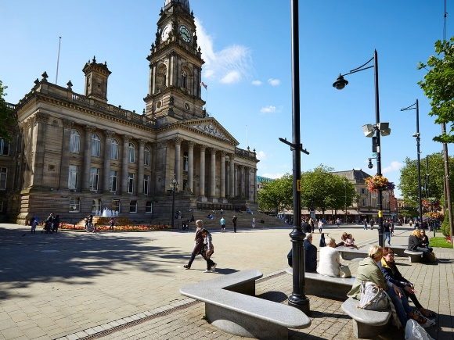

KEY VOCABULARY

Blackpool – Beach – Resort – Tower – Sea – Arcade – Ice cream – Donkey – Illuminations – Promenade – Pier

Bolton – Town – Shopping Centre – Mills – Egerton – Reservoirs – Hills – Fields

**Year 2 – Our Local Area – The North West**

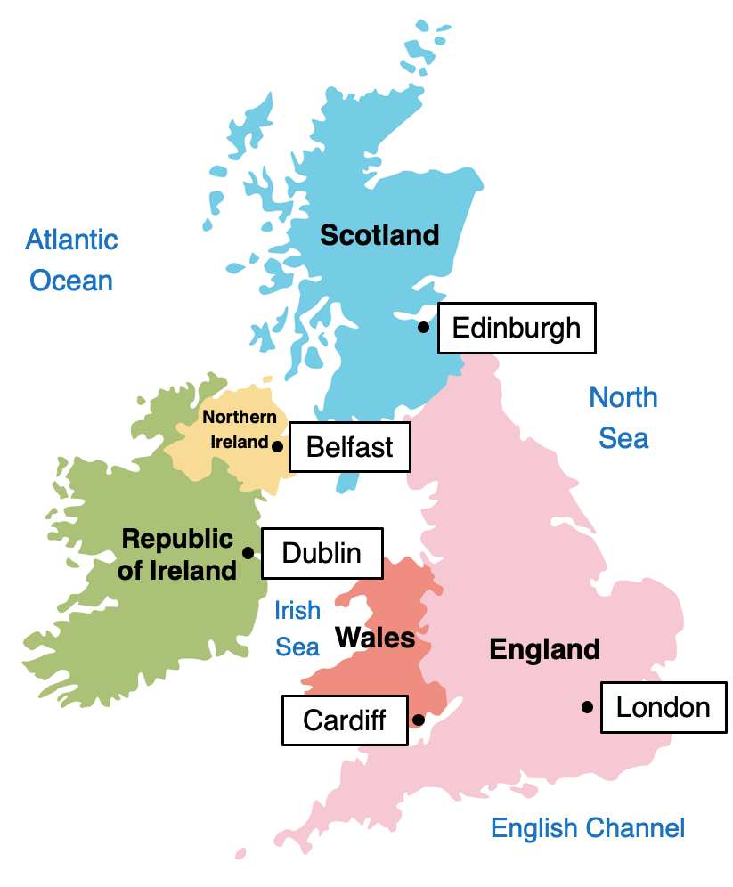

Blackpool

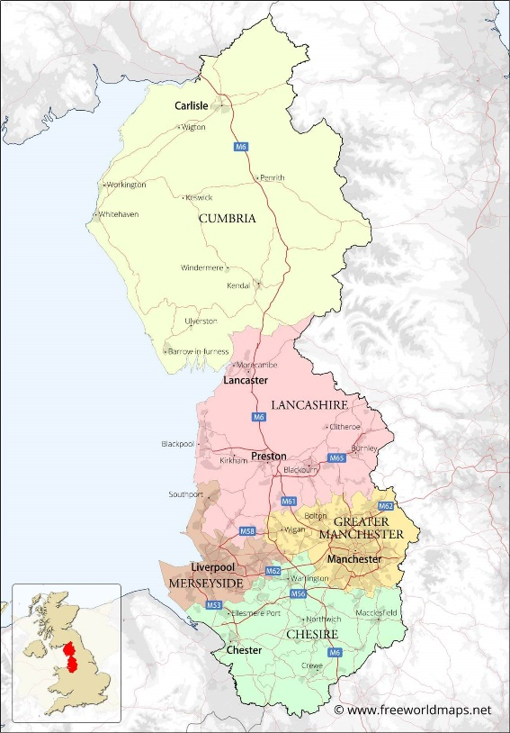

Bolton