Chronological understanding | Cause and consequence | Continuity and change | Similarity and difference | Significance | Interpretations | Evidence and enquiry | Substantive knowledge

Substantive Knowledge
She was queen from 1837-1901.  She was queen for 63 years.  When she was queen it was called the Victorian Era. | Laws were made so all children could go to school.  Queen Victoria increased the wages for the working class people.  Towns and cities got piped water, gas and electricity.  Rails meant people could travel.  Seaside holidays became popular.
Poor children  - Didn’t have good food to eat.  - Worked long hours.  - Didn’t go to school.  - Lived in damp, filthy conditions.  - Had lots of illness and diseases.  Rich children-  - Ate good food.  - Were clean and wore nice clothes.  - Didn’t go to work.  - Went on holidays.  - Had toys.  - Went to school.  Girls were educated at home. | She spoke English, German and Hindustani.  She ruled over Australia, New Zealand, Canada, South Africa and India.  She wanted democracy for her people- a system of government by the whole population or all the eligible members of a state, typically through elected representatives.  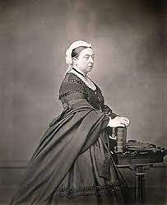  She had 9 children.  She had 40 grandchildren.
