Chronological understanding | Cause and consequence | Continuity and change | Similarity and difference | Significance | Interpretations | Evidence and enquiry | Substantive knowledge

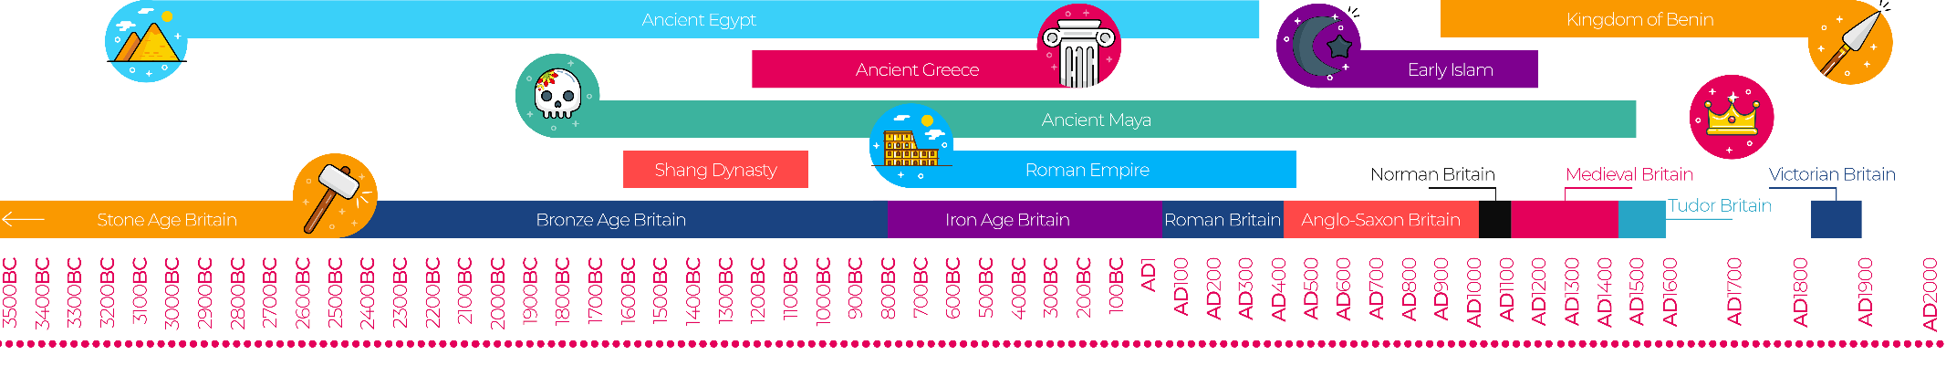
Ancient Civilisations Substantive Knowledge
Iron Age - 1200BC-600BC  Stone Age This era was 2.6 million years ago. Ended in 3300BC.  Bronze Age 3300BC-1200BC | Ancient means the past and no longer exists.  Civilization means a society and way of life.  All these ancient civilizations were built around a river.  Ancient Egyptians 3100-332 BC.  It is modern day Egypt.  It was built near the River Nile.
Indus Valley -3300-1500 BC.  It is where Pakistan is now.  Built near the River Indus- They used the river to wash, drink and for their farming. | Ancient Sumer- 3100-539 BC.  It is where Iran is today.  It was built between the River Tigris and Euphrates.

