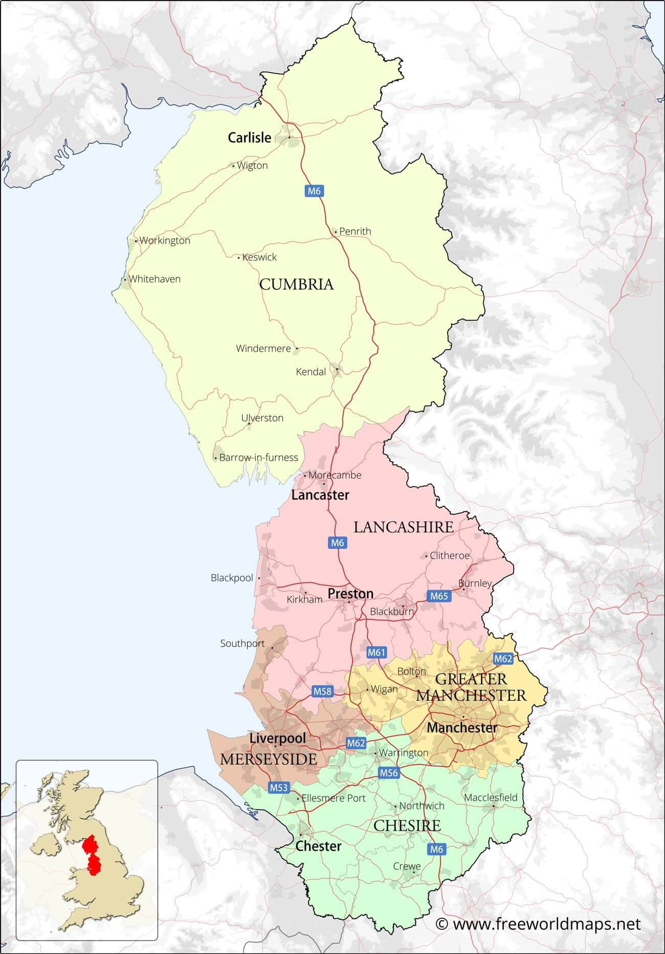

Port – Liverpool

Market town – Clitheroe

Resort – Southport

Industrial city – Manchester

Residential village - Windermere

**Urban areas –** space is used for towns and cities.

**Rural areas –** space is mostly countryside and farmland.

Settlements have different functions:

**Ports** – for transporting goods

**Market towns** – when local farmers sell goods

**Resorts** – for people to go on holiday

**Industrial** – where materials are made into goods

**Residential** – a place where people will live but will travel to work somewhere else

There are different types of settlements:

**Hamlet** – a very small settlement with just a group of houses.

**Village** – has houses, a primary school, a few shops, a Post Office and a village hall.

**Town** – is larger than a village, with lots of houses, primary and secondary schools and sometimes railway stations and shopping centres.

**City** – is the largest type of settlement with lots of buildings and people, hospitals, sports facilities, universities, shops, offices, many houses and a cathedral.

**Year 3 - Settlements**