Chronological understanding | Cause and consequence | Continuity and change | Similarity and difference | Significance | Interpretations | Evidence and enquiry | Substantive knowledge

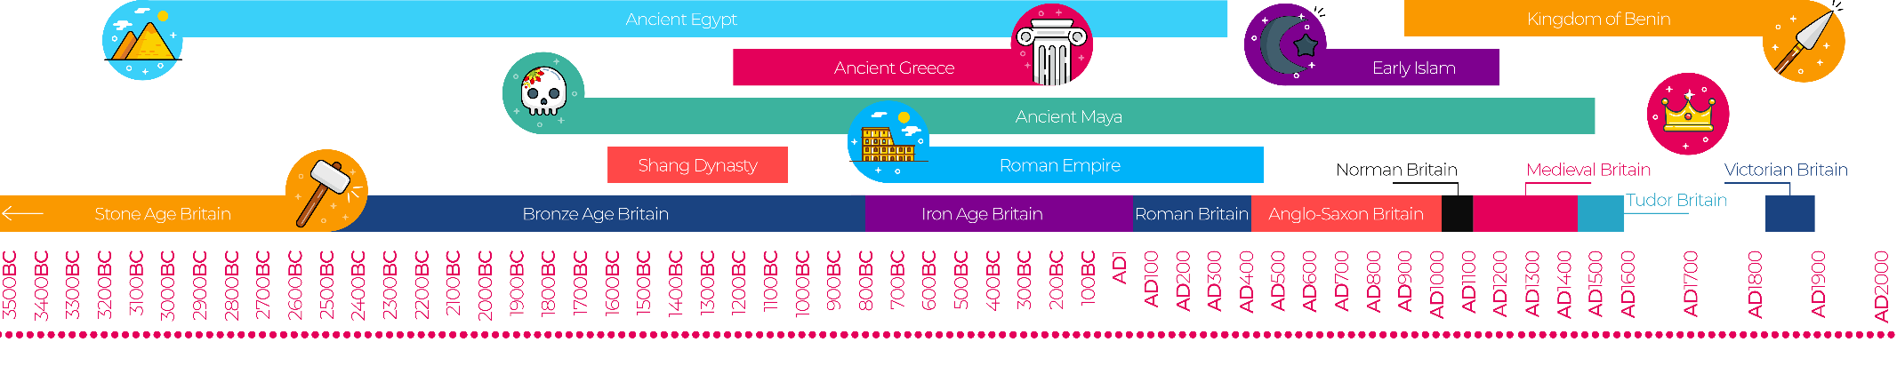
Stone Age- Iron Age Substantive Knowledge
Bronze age- a prehistoric period that followed the Stone Age when weapons and tools were made of bronze rather than stone  Iron age- a prehistoric period that followed the Bronze Age, when weapons and tools came to be made of iron. | Stone Age humans hunted large mammals, including woolly mammoths, giant bison and deer.  They used stone tools to cut, pound, and crush  Men were in charge of hunting large mammals, seafood, and birds.  Women were in charge of gathering grains, seeds, nuts, fruits, roots, eggs, grubs, small animals, and insects.
Skara Brae is in Scotland.  It was built between 3000BCE and 2500BCE.  It was found In 1850 after a storm blew away the earth on top of it | Stonehenge- Found in England is a huge man-made circle of standing stones, built 5,000 years ago.  A legend from the 12th century claimed giants placed the monument on a mountain in Ireland, before a wizard named Merlin magically moved the stone circle to England.
