Chronological understanding | Cause and consequence | Continuity and change | Similarity and difference | Significance | Interpretations | Evidence and enquiry | Substantive knowledge

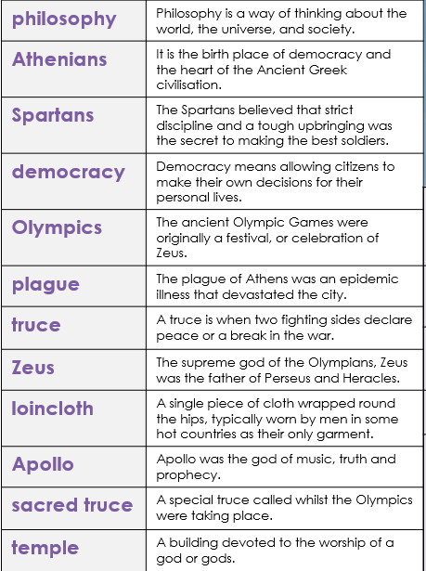
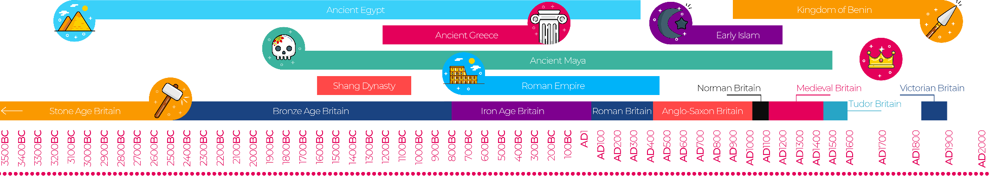
Ancient Greece Substantive Knowledge
Sparta was an ancient city state.  Athens was an ancient city state.  In Sparta- all men were soldiers, women had rights, the streets were dirty, they focused on military skills and the army was the most important thing.  In Athens- they had democracy, education was important, they encouraged theatre and the arts, the city was clean and woman stayed at home. | The Ancient Greeks had different Gods for different parts of their lives.  The Ancient Greeks made offering to their Gods and prayed in temples to them.
490 BC was the Battle of Marathon  The Greek army beat the Persians during the Battle of Marathon. | The Romans conquered Ancient Greece in 146BC.  The Romans were influenced by the Ancient Greeks.

