Chronological understanding | Cause and consequence | Continuity and change | Similarity and difference | Significance | Interpretations | Evidence and enquiry | Substantive knowledge

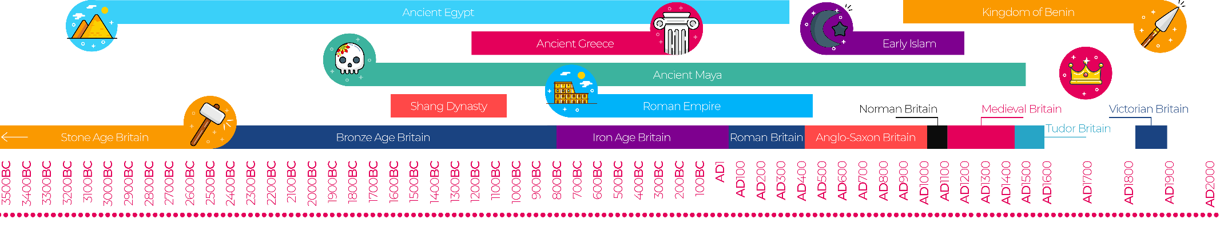
Pretoria Pit Disaster Substantive Knowledge
The Pretoria Pit disaster was a mining accident in December 1910, in Westhoughton.  An underground explosion occurred at the Hulton Colliery Bank Pit No. 3, known as the Pretoria Pit. A total of 344 men and boys lost their lives. | Coal can be burnt to provide heat.  Coal is found underground.  A steam engine uses coal to move.  Coal miners worked 12 hours a day.  Coal miners were 6 days a week
At 7:50am, there was an explosion in the Plodder Mine, which was thought to have been caused by an accumulation of gas from a roof collapse the previous day.  The official death total was 344 but only 343 bodies were recovered.  Men with breathing apparatus were given charge of getting the bodies out of the mine; their job was hazardous as the roofs were unsafe and the supports unstable. | Thirteen of the 344 bodies recovered from the Pretoria explosion could not be identified, so a tomb was made in Westhoughton Cemetery to contain them.  There is a memorial to the victims in Westhoughton cemetery.
Mining | The process or industry of obtaining coal or other minerals from a mine.
Miner | a person who works in a mine.
Collier | Someone who works with coal, usually the getter
Ventilation | System of getting fresh air into the mine and removing stale air.
Shaft | Vertical tunnel which leads from the surface to the underground roadways.

