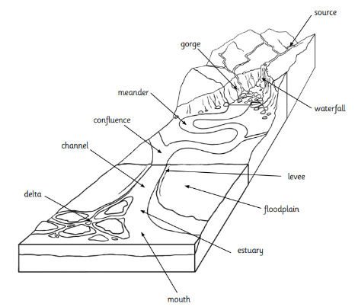
Rivers
Year 4 – Rivers & Mountains
Estuary – where a river meets the sea.
Flooding – the overflow of water onto land that is usually dry.
Floodplain – an area of flat land around a river that is covered when the river floods.
Gorge – a deep narrow valley with steep sides, usually where a river passes through.
Meander – a winding curve or bend in a river.
Mouth – the end of a river where it flows into another body of water such as the sea or a lake.
Rapids – part of a river where the water moves very fast, often over rocks.
Sediment – bits of rock and soil that are carried along by a river and deposited when the river slows down.
Source – the start of a river.
Spring – a point where water flows out of the ground.
Stream – a small river.
Valley – a long area of lower land, often between hills and created by rivers.
Waterfall – where the water from a river or stream flows over a steep drop, often landing in a plunge pool below.
- A moving body of water.
- Begin when rain falls on high ground and flow downhill.
- They flow and bend (meander) as they cross the land and go around hills/rocks.
- They flow until they reach another body of water.
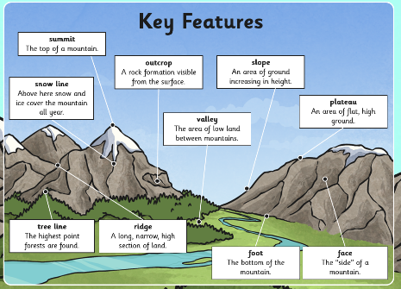
- As they flow, they erode the land.
- Over a long period of time rivers create valleys, or gorges and canyons.
Rivers are an important part of the water cycle. They are responsible for transferring water to oceans.
- Mountains:
- Areas of land that are much higher than the land surrounding them.
- They are often found together in a group called a mountain range.
- Mountain ranges are created by sections of Earth pushing together and forcing the ground up where
they meet.
- Mountains can also be ancient volcanoes.
Summit – The top of a mountain. Foot – The bottom of the mountain.
Face – The side of a mountain. Valley – The area of low land between mountains.
Slope – An area of ground increasing in height. Plateau - An area of flat, high ground.
Ridge – A long, narrow, high section of land.
Base – the bottom of a mountain.

