Chronological understanding | Cause and consequence | Continuity and change | Similarity and difference | Significance | Interpretations | Evidence and enquiry | Substantive knowledge

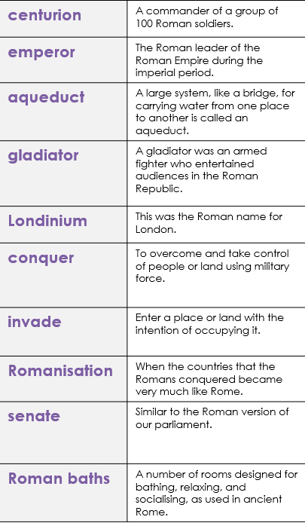
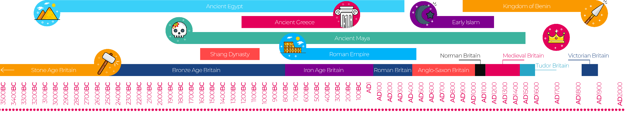
Romans Substantive Knowledge
Rome was founded in 753 BC.  Rome is in Italy on the continent of Europe. | Caesar wrote, "The Britons have a huge number of cattle, they use gold coins or iron bars as their money, and produce tin and iron."
One of the main reasons that the Roman Empire was able to expand so greatly was the power of its army.  A legionary was the central soldier in the army. They were adult, male, Roman citizens who had signed up to fight and train full time. A person usually served for 25 years and were paid a regular wage from the imperial government.  An auxiliary, on the other hand, was not a Roman citizen. They were people from other cultures and societies that were not yet considered to be fully Roman. However, they could still sign up to join the army, but they were only paid one third of the same wage as a citizen legionary. | Romans built roads, aqueducts to supply their towns with water and also built sewer systems to take away dirty water.  Hadrian’s Wall is considered Britain’s most impressive and most important Roman monument.  Chester Roman Amphitheatre is a large theatre which was used for training soldiers and for public entertainment like gladiator contests, animal fights and combat sports.

