Chronological understanding | Cause and consequence | Continuity and change | Similarity and difference | Significance | Interpretations | Evidence and enquiry | Substantive knowledge

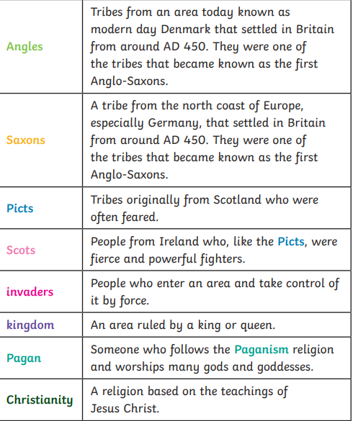
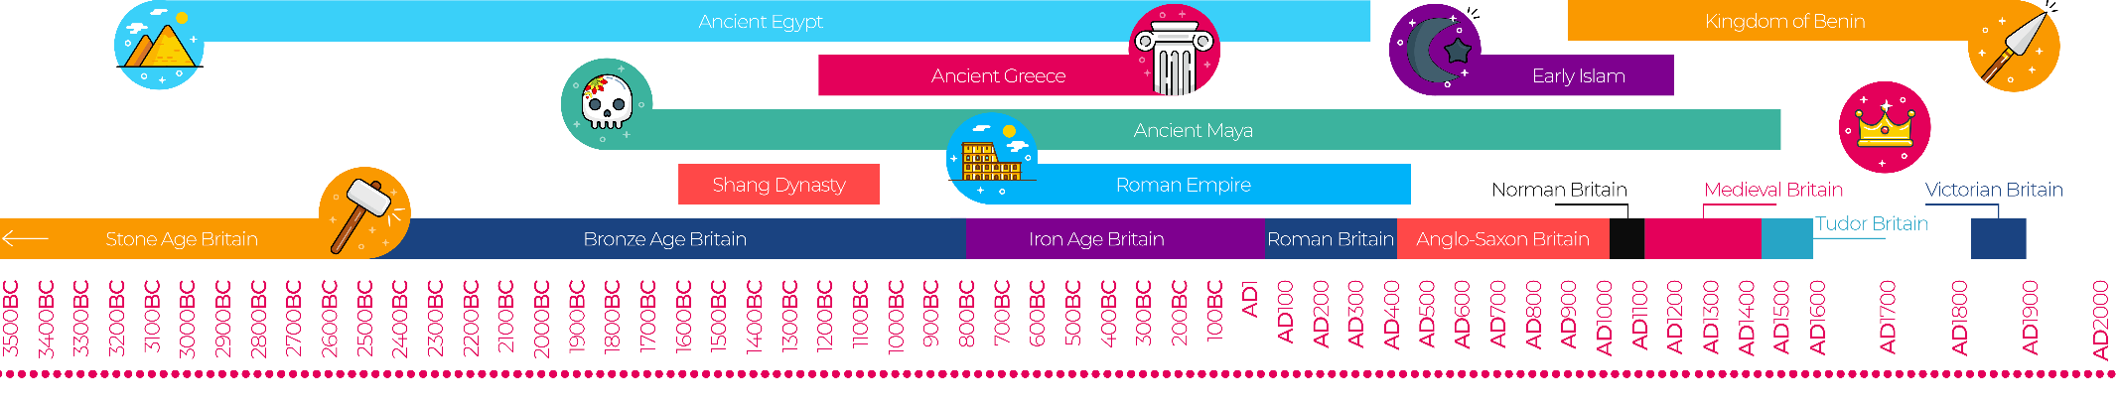
Britain’s settlement by Anglo Saxons and Scots Substantive Knowledge
The Romans left Britain in AD410.  The Scots were a tribe that came from Ireland.  They fought the Romans for many years. | The Saxons were from Germany and Scandinavia .They settled in Britain between 410-1066.  There were 3 main tribes Angles, Saxons and Jutes.  They wanted to come to Britain because their land was flooded and it was difficult to grow crops.  They split Britain into 7 Kingdoms.  •Mercia ,Northumbria, East Anglia, Essex, Sussex, Wessex, Kent
The Scots settled in Dal Raita  They were good at sailing and traded items like wine, salt and glass. They were farmers and hunters. | Anglo-Saxons became Christians.  People would worship a number of gods and goddesses, each responsible for their own area of expertise. Anglo-Saxon pagans also believed in going to the afterlife  Sutton Hoo is a site with lots of Anglo-Saxon artefacts.

