Chronological understanding | Cause and consequence | Continuity and change | Similarity and difference | Significance | Interpretations | Evidence and enquiry | Substantive knowledge

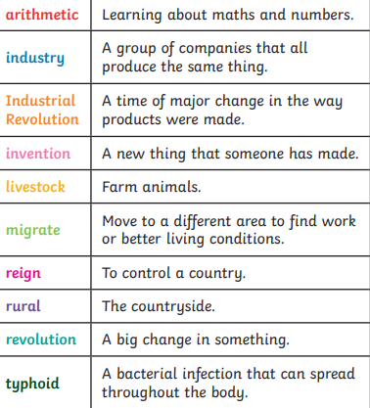
Local history study –Industrial Revolution Substantive Knowledge
The Victorian Era is named after Queen Victoria who was the queen from 1837-1901.  She was the longest reigning monarch in British history at the time.  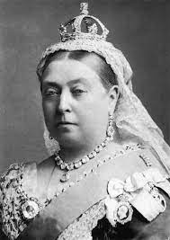  She died at 81 years old.  She was an empress and ruled South Africa, India, Australia, Canada and Jamaica.  She was married to Prince Albert.  They had 9 children. | Inventions at the time also helped make life easier. The Victorians were greatly impressed by the developing science and technology found in such discoveries as the steam-powered engine and telephone.  As a result, railways helped make travel easier; telephones made long-distance communication better; improved sanitation techniques turned filthy streets into clean roads, and incandescent glass mantles brightened everyone's lives.
People started using coal for fuel instead of wood or peat. Coal gave out more heat and allowed better quality iron and steel to be made.  The spinning jenny and power loom allowed the textile industries to grow.  The steam locomotive and railways meant that travel was quicker and people, raw materials and goods could be transported more easily. | Eagley Mills are in Bolton built in 1780 by William Longshaw . Bridge Mill was textile mill that stopped production in 1972  Eagley Mills are located next to the River Irwell  From which Eagley Brook was a power source for the Mill.  The River Irwell was used to transport materials and goods to and from the Mills.
Samuel Crompton – developed the spinning Mule – was from Bolton – 1753- 1827
The spinning mule helped to revolutionize the cotton industry.

