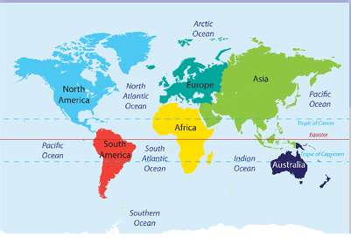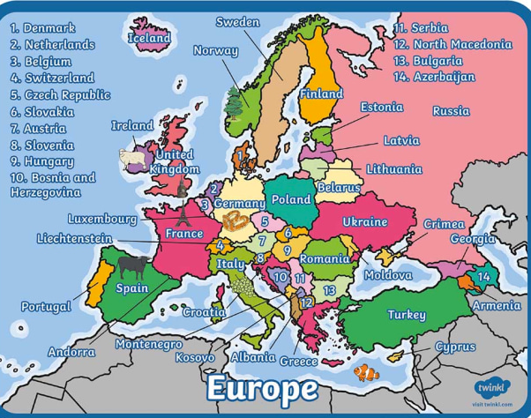

**Year 5 – Trade Links**

**Key Vocab / Knowledge**

**Trade** – buying and selling things.

**Import** – buying things for the UK from abroad.

**Export** – sending and selling goods to other countries from the UK.

**Global Supply Chain** – International supply chain of people and activities that go into creating and offering goods or services.

**Food Miles** - the distance certain foods have to travel from grower to consumer

* U.S.A – North America, capital is Washington DC
* China – Asia, capital is Beijing
* Germany – Europe, capital is Berlin
* The Netherlands – Europe, capital is Amsterdam
* France – Europe, capital city is Paris
* U.K – Europe, capital city is London

Top 5 import/export categories with our 5 trade partners:

* electrical machinery
* Mechanical machinery
* Medicinal and pharmaceutical products
* Oil
* Road vehicles

