Chronological understanding | Cause and consequence | Continuity and change | Similarity and difference | Significance | Interpretations | Evidence and enquiry | Substantive knowledge

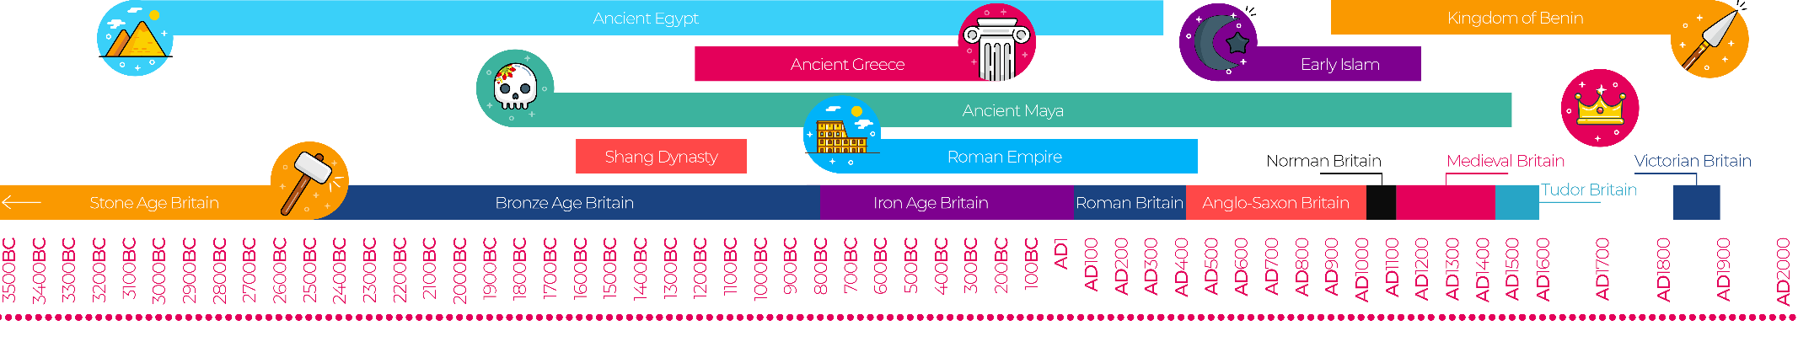
Viking and Anglo-Saxon struggle for the Kingdom of England to the time of Edward the confessor Substantive Knowledge
The Vikings were in Britain- 789- 1066.  Vikings came from Norway, Sweden and Denmark. | King- ruled the people  Jarls (nobles)- had people working for them  Karls- were farmers or craftsmen  Thralls- were slaves that could buy their freedom
Alfred the Great was King of Wessex and the Vikings tried to attack.  He was King of Wessex from 871-899 CE.  He made a deal with the Vikings called Danegeld but they made a surprise attack.  Alfred finally won the battle and gave the Vikings land to have as their own. | The Vikings brought together the Kingdoms of Britain mainly Wessex and Mercia to become one Kingdom with one ruler/King.  There would only be three Kingdoms that would avoid being captured by the Danes- Northumbria, Mercia and Wessex.  Wessex was the most powerful Kingdom.
Edward promised the throne to Harold Hardrada-Viking.

Stanford Bridge- battle. Vikings lost- Harold battled William of Normandy.

Harold lost the Battle of Hastings.- William became King of England.
The Battle of Hastings in 1066.
