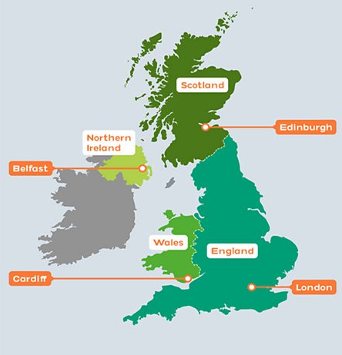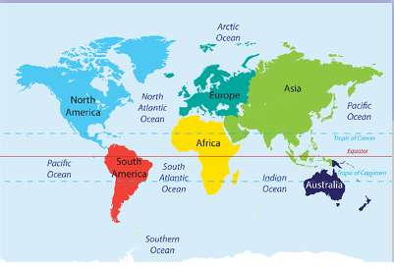

**Year 6 – London**

**Key Vocab / Knowledge**

Capital city

South West England – London / North West England – Bolton

Heathrow Airport / Manchester Airport

Population – London 2,500,000 Bolton 300,000

Area – London 1,600 square KM Bolton 140 square KM

Green Space

London – Hyde Park, Regents Park, St Jame’s Park, Hampstead Heath, Richmond Park, Kew Gardens

Bolton – Moses Gate, Moss Bank Park, Jumbles Reservoir, Queen’s Park

