Chronological understanding | Cause and consequence | Continuity and change | Similarity and difference | Significance | Interpretations | Evidence and enquiry | Substantive knowledge
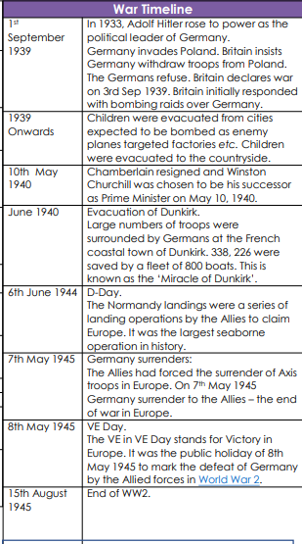
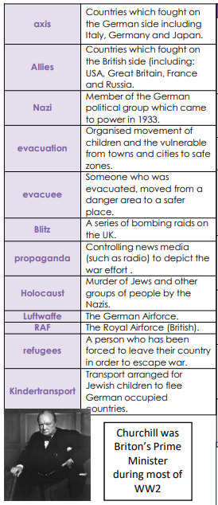
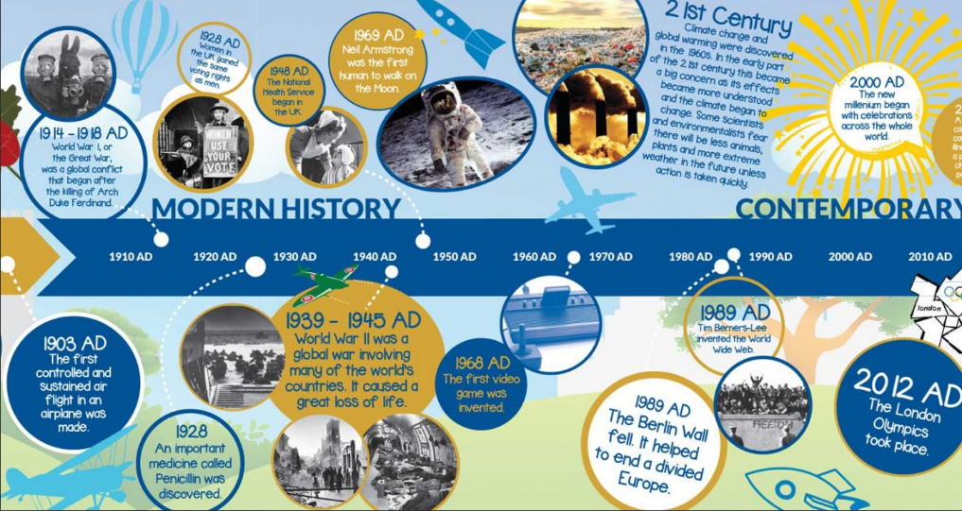
A Period of Study Beyond 1066 - World War 2 Substantive Knowledge
Germany was blamed and punished by Britain, France and America for WW1.  Germany had to pay huge fines in 1920s which angered them.  Britain and France allow Hitler to take over Austria and Czechoslovakia in the hope that it would avoid war breaking out.  Britain and France declared war on Germany in 1939 after it declared war on Poland. | Battle of Britain took place July to October 1940.  Operation Sealion was Hitler’s plan to invade Britain by sea – he first needed to destroy the RAF.  3000 men from Luftwaffe invaded but Germany failed to control the skies therefore invasion was impossible.  Churchill delivered a speech to the nation on 20/8/40 to express thanks to the airmen.
The Blitz took place between 1940 and 1941  From 7th September 1940 bombing took place for 56/57 nights.  Significant damage was caused to houses and significant buildings including St Paul’s Cathedral in London.  Air raid shelters were developed with locations such as London Underground being used to keep people safe.  40 000 civilians died in the Luftwaffe bombings | Children in Britain in WW2  The government evacuation scheme was launched on 1/9/39. Over the first 3 days, 1.5 million children were evacuated.  Most evacuees moved from cities to rural locations in the UK. A small number of children were evacuated as far as Canada, Australia, New Zealand and South Africa.

