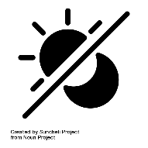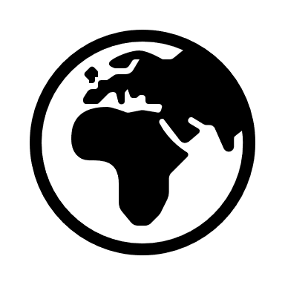

Creation:the act of God creating the world and everyone in it and everything that has been created by God

World: the planet and everything and everyone in it

Belief: trust or confidence in something

Thank: to express gratefulness for something

Harvest: to gather in crops and a Christian celebration

God: the all loving and all powerful being that Christians believe created the world and everything in it

Believe: to accept that something is true

Bible: the holy book for Christians, comprising the Old Testament and the New Testament

Genesis: the first book of Moses for Jewish people and the first book of the Old Testament for Christians

Praise: to show and express gratitude and thanks to God

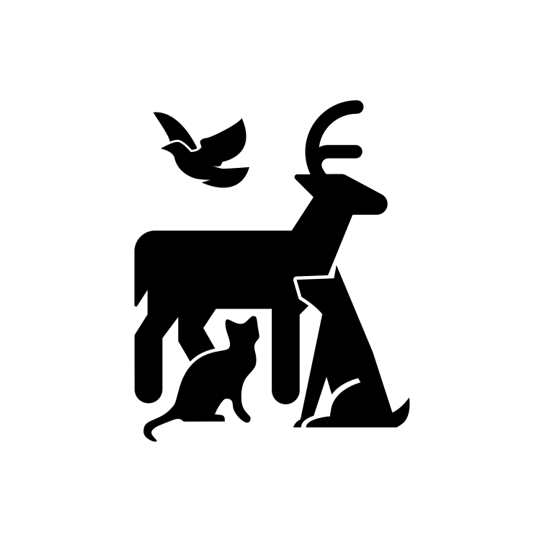

**God’s Creation**

The first book of the **Bible** is the book of **Genesis** which in Chapters 1 and 2 tells Christians the story of how **God** created the world and everyone in it. This is known as the Story of **Creation.**

The story tells Christians how God made the world in six days and then on the seventh day he rested. Although some Christians may disagree with the events of Creation, they all **believe** that God is responsible for creating everything in some way.

Christians have a very strongly held **belief** that they should look after everything that God has created, and they should **thank** him for the world and everything in it.

Although Christians can thank God, pray to him and worship him at any time, the festival of **Harvest** is a key time in the Christian year when they **praise** him for Creation. This is a time when Christians can thank God for all he has made and for all they have been given. Christians will be singing songs about God as creator and about all he has given people.

Important information

So how does it all work?

Wonderful words

Year One – Knowledge Organiser

Who do Christians say made the world?

Year One  
**Knowledge  
Organiser**

UNIT  
**7**



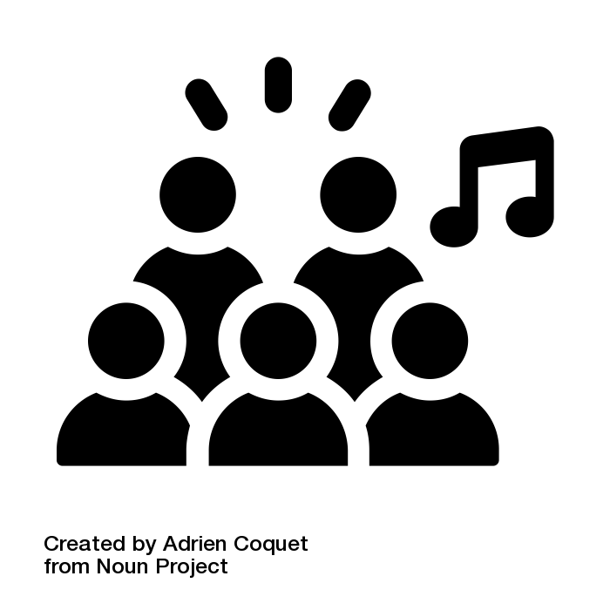

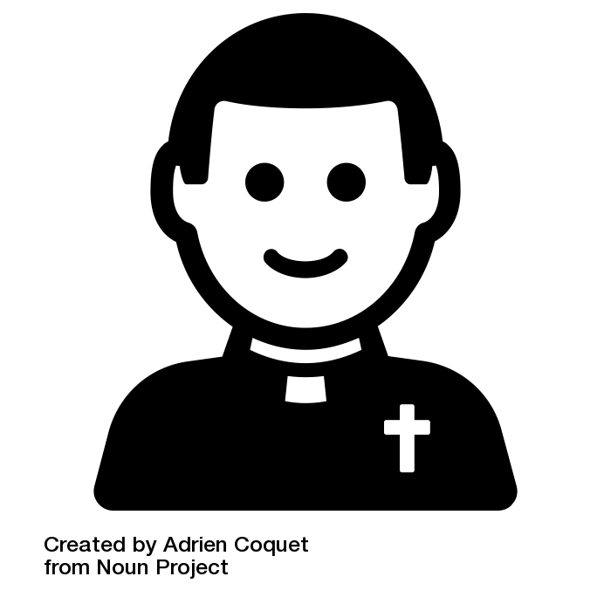

**Christians say thank you to God**

All icons are used free of charge from Noun Project.  
Individual artist credit is given on the following slide.