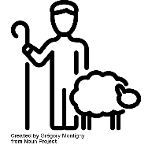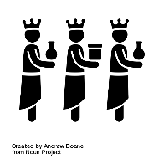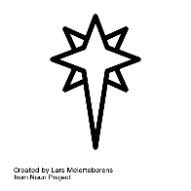

**NATIVITY**

**ADVENT**

Christmas is a very important **celebration** around the world as a **religious** celebration for Christians and also as a **secular** celebration for many people who are not Christian.

At Christmas people remember the **birth** of **Jesus** in a manger in Bethlehem. Christians use the weeks before Christmas known as **advent** to prepare for the celebration of God becoming human in Jesus. Christians believe that Christmas is a time to remember how Jesus came to earth as both God and human and they call this belief the **incarnation.**

Advent is a time when people will use advent calendars, wreaths, and candles to remember the days leading up to the birth of Jesus.

The story of the birth of Jesus is celebrated in many ways including through cards, Nativity plays and church services. Christians remember **Mary** and **Jospeh** and the events of the story, including Jesus being born in a manger as there was no room anywhere else and how the first visitors to see him were the **shepherds.**

The shepherds were the first people to visit Jesus in the manger and this shows how Jesus was born for everyone, rich and poor alike.

Incarnation:‘in the flesh’; Christians believe Jesus is God ‘in the flesh’, or God incarnate

Jesus: The second person of the Trinity or the Son; God in the flesh

Mary: the mother of Jesus

Joseph: the husband of Mary

Shepherds: the first people to visit Jesus after he was born

Advent: the four Sundays leading up to Christmas

Secular: anything that is not connected with religion or religious worldviews

Religious: believing in a religion

Birth: the arrival of a baby into the world

Celebration: an enjoyable activity held to remember something

So how does it all work?

Important information

Wonderful words

Year One – Knowledge Organiser

Year One  
**Knowledge  
Organiser**

Why does Christmas matter to Christians?

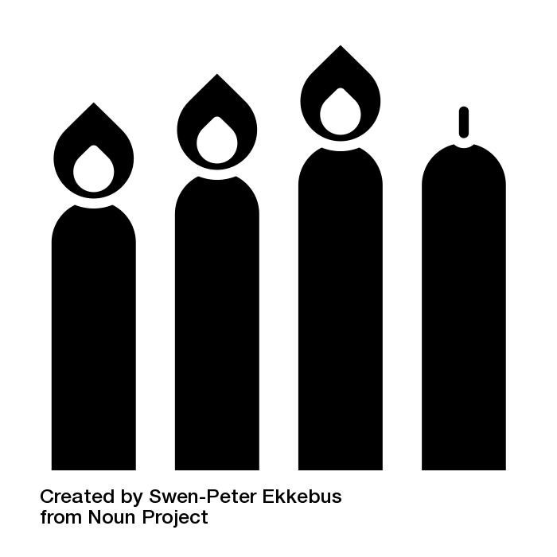

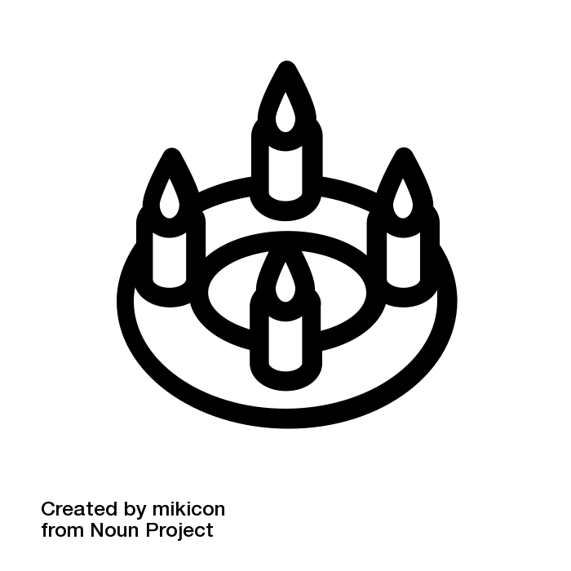

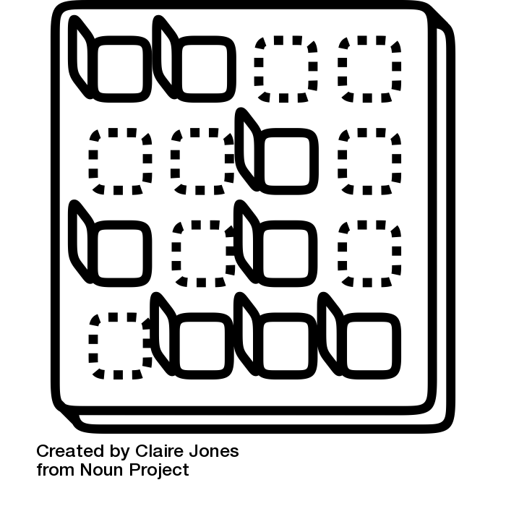

All icons are used free of charge from Noun Project.  
Individual artist credit is given on the following slide.

UNIT  
**8**