**At home and at the synagogue**

**Jewish** people have many items in their homes which help them show that they follow the Jewish faith.

This may include a **mezuzah** box which contains the **Shema**, a very important prayer from the **Torah** which tells Jews about their relationship with **God.** The mezuzah box can be seen on doorposts in Jewish homes and Jewish people will touch it as a reminder of their faith.

Sometimes there will be a **Star of David** on a mezuzah box or somewhere else in a Jewish home to show people that the home is a Jewish home. You can also find a Star of David in a **synagogue** to show it is a Jewish place of worship.

Some Jewish people will also keep **Shabbat** when they will not work or travel and will have a special meal to remember the day God rested when he had created the world. Many Jewish people will also go to the synagogueto show what an incredibly important day it is.

Jewish people will also have celebrations and festivals throughout the year to remember specific events and important times. One of those is the festival of **Chanukah** which helps Jewish people remember when there was only enough oil to keep the temple menorah lit for one day but it stayed alight for eight days. Some of these stories are in the **Torah** such as the story of David and Goliath.

Synagogue:the Jewish place of worship, sometimes called a shul

Torah: the Jewish holy book made up of the five books of Law.

Jewish: relating to the religion of Judaism.

Mezuzah: a small scroll with words from the Torah written on it and contained in a smack rectangular mezuzah box

Shabbat: a day of rest for Jewish people, the seventh day of the week

Shema: A Jewish prayer

God: all powerful being who Jewish people believe created the world

Chanukah: a Jewish festival that remembers the winning back of the Second Temple and the miracle of the tiny amount of oil.

Dreidel: a four-sided spinning top played during the festival of Chanukah

Star of David: the recognized symbol of Judaism

Important information

So how does it all work?

Wonderful words

Who is Jewish and how do they live?

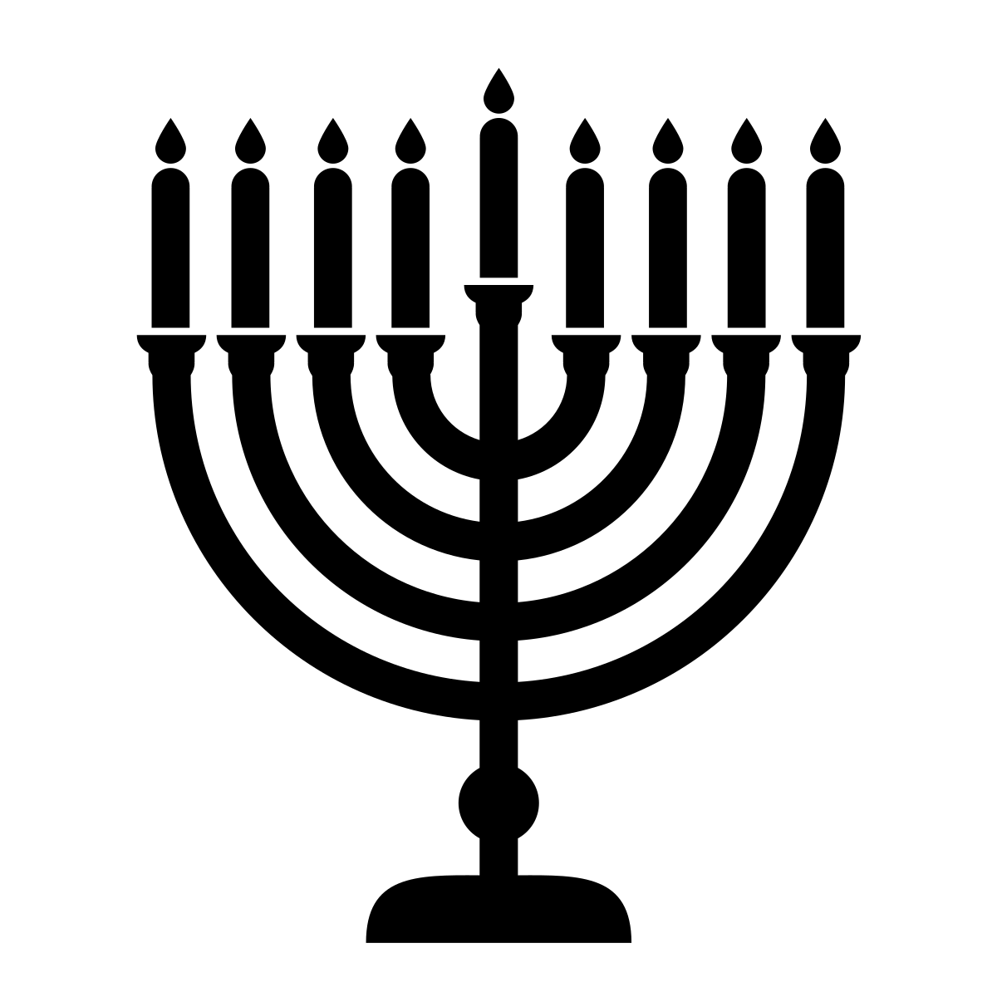

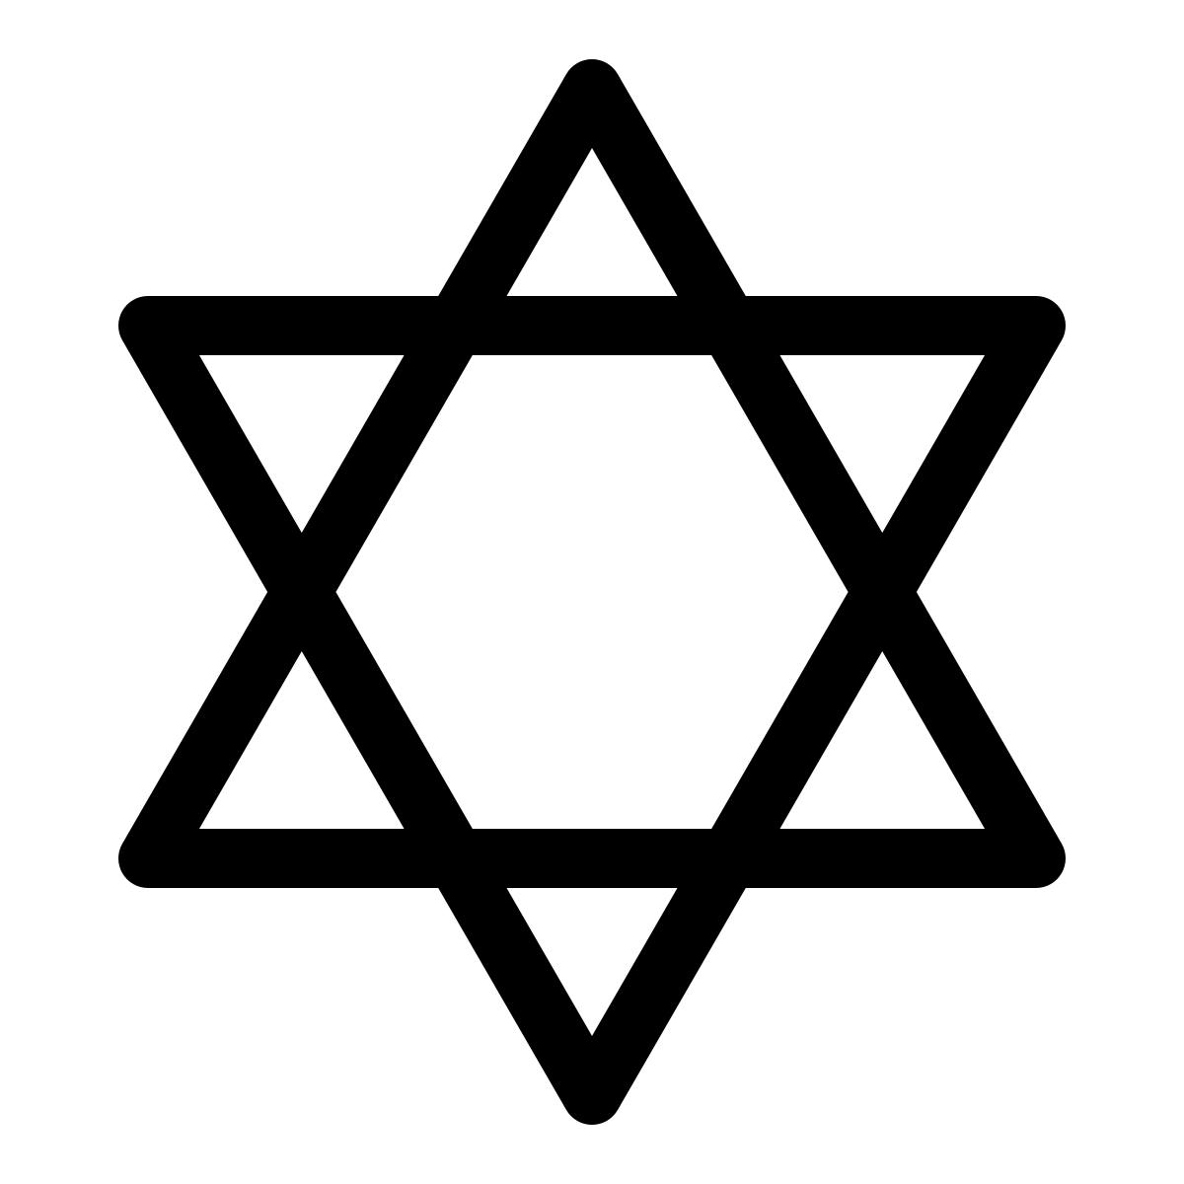

**Festivals and celebrations**

**Following the Jewish Faith**

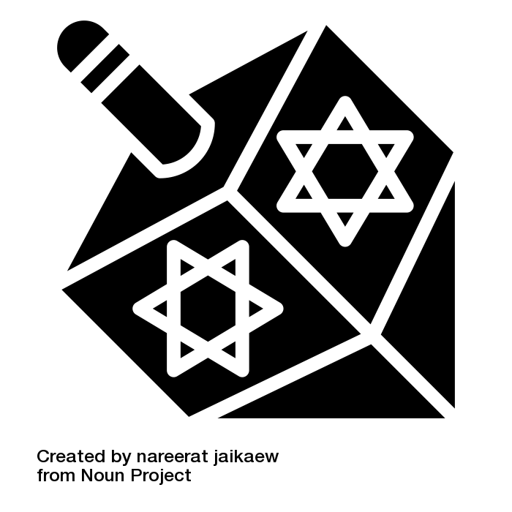

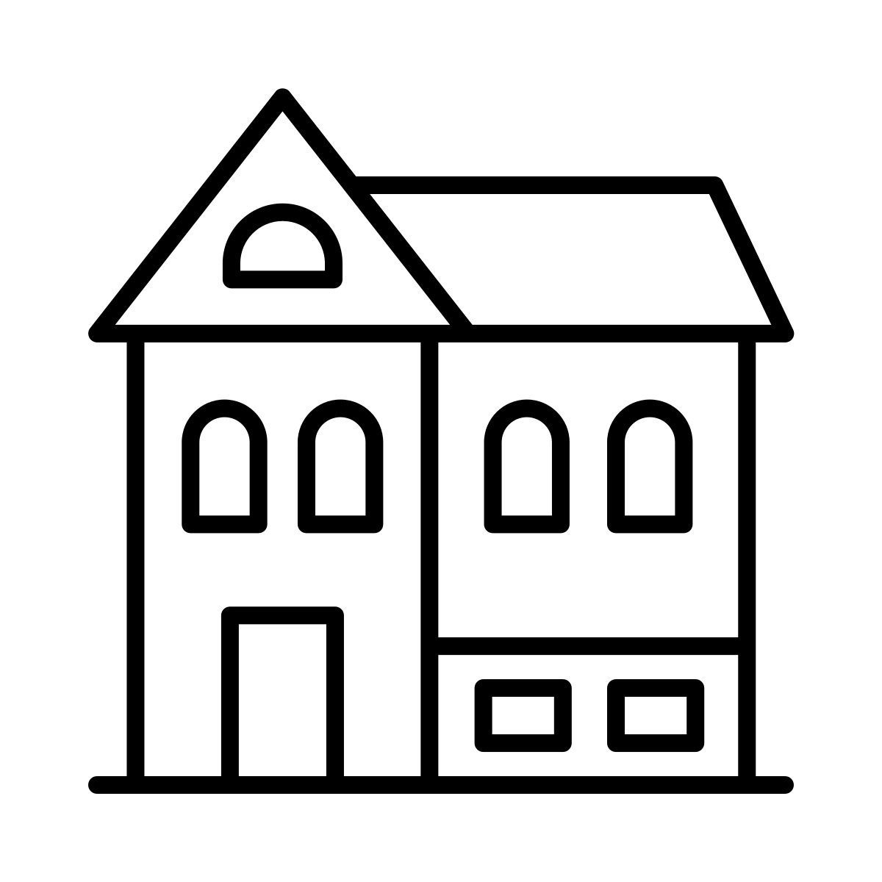

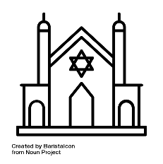

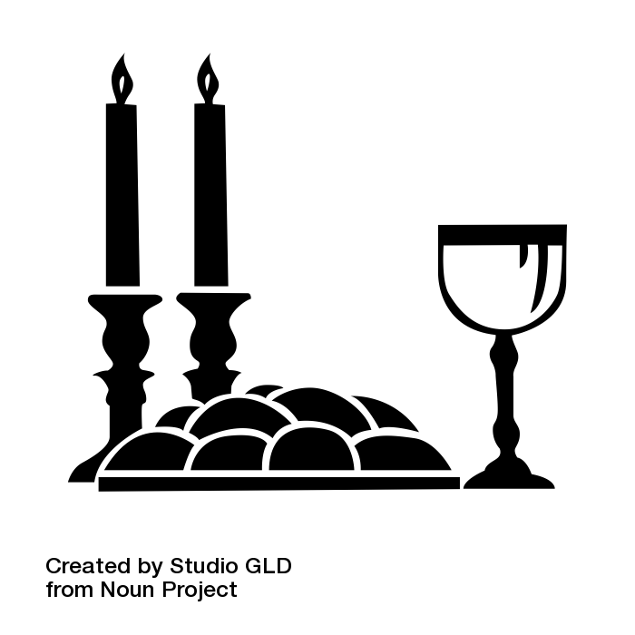

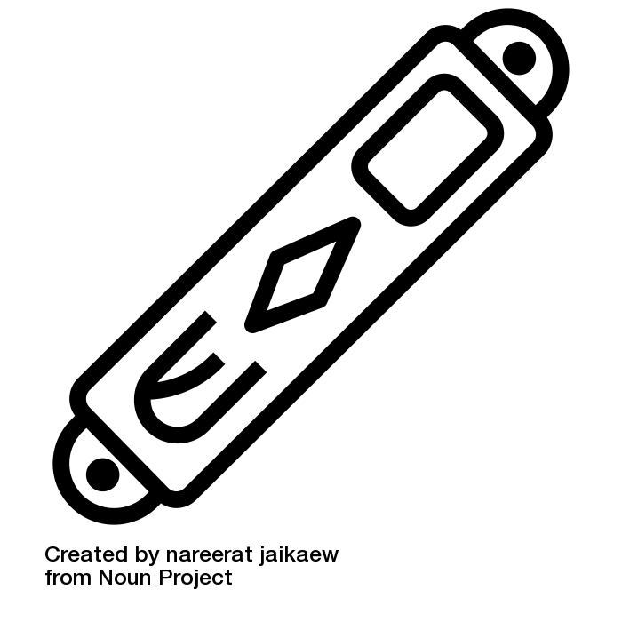



All icons are used free of charge from Noun Project.  
Individual artist credit is given on the following slide.

Year One – Knowledge Organiser

UNIT  
**9**

Year One  
**Knowledge  
Organiser**