
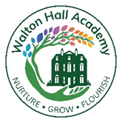

English
Achievement
2024-2025
Key Stage 4

GCSE English Language | 3 students were entered and the results gained were excellent (Grade 4, Grade 3 and Grade 2). All students achieved their target grade. 2 of these students are in year 10.
Level 2 Functional Skills | 1 student achieved Level 2 Functional Skills English – this exceeded their target.
Level 1 Functional Skills | 2 students achieved Level 1 Functional Skills English - both met their target.
Entry Level 3 Functional Skills | 5 students achieved Entry Level 3 Functional Skills English -1 below target, 4 met target grade.
Entry Level 2 Functional Skills | 8 students achieved Entry Level 2 Functional Skills English – all students met target
Entry Level 1 Functional Skills | 6 students achieved Entry Level 1 – 1 student below target. 5 student met target.
In summary 92% of students in Key Stage 4 met or exceeded their target level in English.

Key Stage 5

Level 1 Functional Skills | 2 students achieved Level 1 Functional Skills English - both met their target.
Entry Level 3 Functional Skills | 7 students achieved Entry Level 3 Functional Skills English All students met their target
Entry Level 2 Functional Skills | 3 students achieved Entry Level 2 Functional Skills English – all students met their target.
Entry Level 1 Functional Skills | 10 students achieved Entry Level 1 Functional Skills English All students met their target.
In summary 100% of students in Key Stage 5 met or exceeded their target level in English.
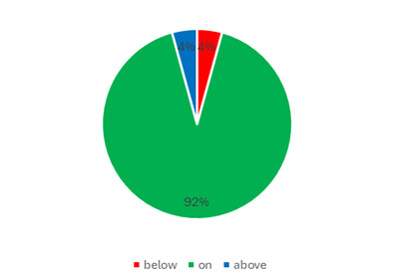

Mathematics
Key Stage 4

Level 1 Functional Skills | 3 students achieved Level 1 Functional Skills Maths - two students exceeded their target and 1 met
Entry Level 3 Functional Skills | 2 students achieved Entry Level 3 Functional Skills Maths -both were above their target grade.
Entry Level 2 Functional Skills | 21 students achieved Entry Level 2 Functional Skills Maths – all students met their target grade.
Entry Level 1 Functional Skills | 13 students achieved Entry Level 1 – 12 students met their target grade – 1 student was below.
In summary 97.5% of students in Key Stage 4 (year 10 and 11) met or exceeded their target level in Maths.

Key Stage 5

GCSE Mathematics | 1 student entered for GCSE Maths achieved a Grade 4 – met target grade
Level 1 Functional Skills | 3 students achieved Level 1 Functional Skills Maths – all met their expected target
Entry Level 3 Functional Skills | 3 students achieved Entry Level 3 Functional Skills Maths – all meeting their expected target.
Entry Level 1 Functional Skills | 1 student achieved Entry Level 1 Functional Skills Maths – expected target achieved.
In summary 100% of students in Key Stage 5 met their target level in Maths.

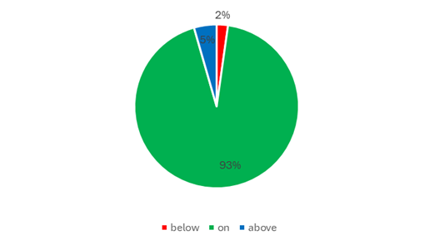

Science
Key Stage 4
BTEC Applied Science Certificate – Level 1 | 6 students achieved a pass grade – all met target  2 merits and 4 passes
WJEC Entry Level 3 Science | 10 students achieved a pass at Entry level 3 – All students met or exceeded their targets
WJEC Entry Level 2 Science | 10 students achieved a pass at Entry level 3 – All students met or exceeded their targets
In summary 100% of students in Key Stage 4 met their target level in Science

Key Stage 5

GCSE Combined Science: Trilogy | 1 Student entered and achieved 5 - 5
In summary 100% of students in Key Stage 4 met their target level in Science

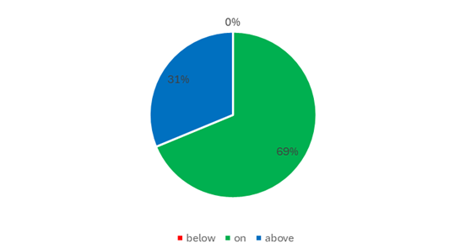

Other accreditations
Key Stage 4
Qualification | Number of students achieving the qualification
BTEC Home Cooking Skills Level 1 Award | 11 students gained a pass
BTEC Land Based Studies Level 1 Award | 9 students gained a pass
BTEC Introduction to Performing Arts Level 1 | 4 students gained a pass, 2 a merit and 2 a distinction
BTEC Art & Design Level 1 Award | 3 students gained a pass, 2 a merit and 1 a distinction
BTEC Sport & Active Life Level 1 Award | 16 students gained a pass
BTEC Caring for Children Level 1 Award | 7 students gained a pass
BTEC Introductory Pre-Vocational Studies Entry 2 | 13 students gained a pass
Entry Pathway Motor Vehicle Road Control Entry 2 | 3 students gained a pass
Entry Pathway Motor Vehicle Road Control Entry 3 | 3 students gained a pass
Entry Pathway Motor Vehicle Maintenance Entry 3 | 1 student gained a pass

Key Stage 5
Qualification | Number of students achieving the qualification
BTEC Digital Media Level 1 Certifícate | 1 merit, 3 distinctions
BTEC Land Based Studies Level 1 Certificate | 2 students gained a pass
BTEC Land Based Studies Level 1 Diploma | 4 students gained a pass
BTEC Introduction to Performing Arts Level 1 Certificate | 6students gained a pass, 1 a distinction
BTEC Art & Design Level 1 Award | 6 students gained a pass
BTEC Sport & Active Life Level 1 Award | 3 students gained a pass
BTEC Caring for Children Level 1 Award | 4 students gained a pass
BTEC Business Level 1 Award | 9 students gained a pass
BTEC Introductory Pre-Vocational Studies Entry 2 | 15 students gained a pass
BTEC Introductory Pre-Vocational Studies Entry 2 | 4 students gained a pass
Entry Pathway Motor Vehicle Maintenance Entry 3 | 1 student gained a pass

