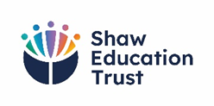
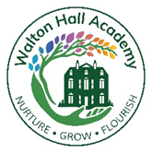
Achievement
2024-2025

Duke of Edinburgh
Bronze Award | 27 students across KS4 and KS5 achieved this award.

Tall Ship Expedition
Cirdan Trust Competent Crew Member | 3 students across the school
Cirdan Trust Start Yachting | 10 students across the school

Bikeability
Bikeability Level 1 and 2 | 12 Post 16 students passed.
Bikeability Learn to Ride | 6 Post 16 students passed

Active Life
Paddle Discover Award – British Canoeing | 12 key stage 3 students passed.

