 | Preparation for Adulthood  Independence  Overview | 

Intent
At Walton Hall Academy, we place Preparation for Adulthood (PfA) at the heart of everything we do by fulling embedding across the whole curriculum, residential provision, personal development, and daily school life. Staff also building strong relationships with students to understand their strengths, needs, challenges, and aspirations.

We aim for students to develop the knowledge, skills and confidence needed for adulthood through the following PfA pillars:

1. Employment
- Develop employability skills from KS3 onwards.
- Access meaningful work experience and employer encounters.
- Explore interests, strengths, and future career pathways.
- Build confidence, communication, and workplace readiness.

2. Independent Living
- Learn practical life skills such as cooking, budgeting, and home management.
- Increase independence in daily routines, self-care, and decision-making.
- Prepare for a range of future living options, including supported living.

3. Community Inclusion
- Access and participate in the local community safely and confidently.
- Build social communication skills, friendships, and positive relationships.
- Learn how to navigate public spaces, services, and community activities.

4. Health & Wellbeing
- Understand how to maintain physical, emotional, and mental health.
- Learn how to stay safe and maintain healthy relationships.
- Build resilience, self-esteem, and the ability to cope with new or challenging situations.

At Walton Hall Academy, PfA Independence is about giving students the everyday skills that help them feel capable and in control of their own lives. We build independence into daily routines, practical tasks and real experiences so students can learn by doing. Whether it’s making choices, managing personal tasks or navigating new situations, we support young people to grow in confidence and take on more for themselves. Our aim is for every student to leave us feeling ready, resilient and able to take their next steps into adulthood with increasing independence.
Progression through the pathways
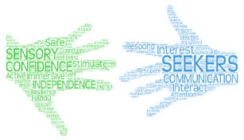 | Seekers Pathway  KS3  - PfA embedded through sensory, routine-based learning.  - Focus on early independence: communication, making choices, engagement, and simple self-care.  - Community inclusion through short, familiar, highly supported visits.  - Pre-vocational skills introduced through simple tasks, turn-taking, and following basic instructions.  KS4  - Build on KS3 with greater independence within routines.  - Develop functional skills such as simple food prep, tidying, and personal organisation.  - Community inclusion becomes more purposeful with slightly longer visits.  - Pre-vocational learning includes school-based jobs and simple enterprise tasks.  KS5  - Focus on maximising independence within each student’s capabilities.  - More emphasis on functional life skills, communication, and self-advocacy.  - Community inclusion becomes more regular and meaningful, always with high support.  - Pre-vocational learning includes structured, repetitive tasks that build confidence and routine.  - Preparation for adult services and transition planning is central.
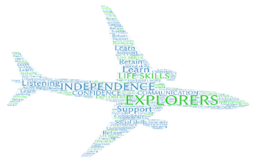 | Explorers Pathway  KS3  - PfA taught through practical, hands-on activities.  - Develop early functional skills: basic cooking, cleaning, money awareness, personal safety.  - Community inclusion through supported visits to local shops, cafés, and services.  - Employment learning includes classroom jobs and early enterprise.  KS4  - Increased focus on functional independence: planning meals, budgeting, using public transport with support.  - Community inclusion becomes more purposeful and frequent.  - Employment learning expands to structured work-related learning, enterprise projects, and employer encounters.  - Students begin exploring Post-16 pathways and personal aspirations.  KS5  - Strong emphasis on real-life independence: home management, shopping, travel training, and problem-solving.  - Community inclusion becomes regular and meaningful, with students practising skills in authentic settings.  - Employment learning includes internal work placements, enterprise, and supported external experiences.  - Students prepare for post-school destinations, supported living options, and adult social care pathways.
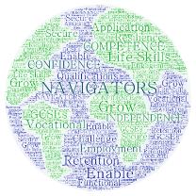 | Navigators Pathway  KS3  - PfA introduced through foundation skills in independence, communication, and problem-solving.  - Students learn practical skills such as basic cooking, money handling, and personal organisation.  - Community inclusion includes guided visits to build confidence and appropriate behaviour in public.  - Employment learning focuses on exploring interests and early employability skills.  KS4  - Strong focus on functional, real-world independence: travel training, budgeting, home management.  - Community inclusion becomes semi-independent, with students practising skills in real contexts.  - Employment is a major component: work experience placements, employer visits, and vocational learning.  - Students prepare for Post-16 destinations with personalised transition planning.  KS5  - PfA becomes the core of the curriculum, with independence and employability at the centre.  - Students engage in regular work experience, supported internships, or vocational pathways.  - Community inclusion includes independent or near independent travel, accessing services, and managing personal responsibilities.  - Independent living focuses on meal planning, budgeting, home routines, and self-management.  - Students work towards ambitious, realistic adult outcomes, including college, employment, or supported living.

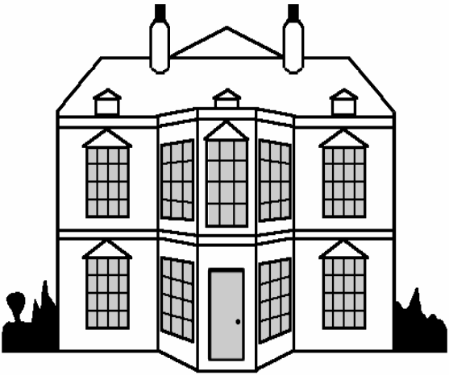
Walton Hall Academy PfA Independence Progression Plan
 | Explorers   | Navigators  
Year 1 | Autumn  Follow simple routines  Identify emotions with prompts  Use help to manage time and responsibilities  Spring  Practise polite greetings in informal and formal situations  Participate in group tasks with support  Recognise trusted adults in community  Summer  Explore school grounds using simple maps  Learn basic safety rules with modelling | Autumn  Manage timetable independently  Build emotional vocabulary  Learn to use planning tools (timetables, checklists) to stay organised  Spring  Lead small group tasks  Initiate conversation in school/community  Identify community roles and their purpose  Summer  Identify safe vs unsafe places (e.g., crossings, quiet areas)  Suggest solutions to real world scenarios (practice what to do if lost)
Year 2 | Autumn  Build consistent daily routines  Use visual aids to regulate emotions  Complete simple tasks with time prompts  Spring  Explore school grounds using simple maps and orienteering  Learn basic safety rules with modelling  Problem solve simple scenarios with adult cues  Summer  Follow adults on community walks  Practise safe behaviours (stopping, waiting)  Identify local landmarks | Autumn  Set personal goals (short term)  Apply strategies for frustration independently  Manage time with minimal reminders  Spring  Build structured conversations  Ask questions to gain information  Adapt communication for familiar/unfamiliar people  Summer  Lead small route sections  Apply problem solving when plans change  Interact politely in real environments (shop, library)
Year 3 | Autumn  Manage personal belongings with visuals  Take one responsibility role (tidy area, hand out resources)  Spring  Express likes/dislikes appropriately  Use supported decisionmaking  Take part in Votes for Schools discussions  Summer  Recognise safe vs unsafe spaces  Identify crossing points  Practise supervised crossing routines | Autumn  Independently organise learning materials  Take on class responsibilities (equipment, peer support)  Spring  Justify opinions respectfully  Lead small debates  Show resilience when opinions differ  Summer  Plan simple schoolbased routes  Identify risks & solutions  Model safe pedestrian behaviour
Year 4 | Autumn  Follow step by step organisation routines  Use visual schedules  Spring  Explore new environments with support  Identify emotions linked to change  Use coping strategies modelled by staff  Summer  Follow travel safety rules  Recognise symbols (bus, stop, ticket)  Participate in supervised travel sessions | Autumn  Create personal organisation systems  Track deadlines  Plan and evaluate weekly tasks  Spring  Reflect on personal reactions to new experiences  Choose from a range of coping strategies  Guide others in adapting to change  Summer  Read simple timetable  Plan short journeys  Handle unexpected changes with support
Year 4 | Pre-Vocational Study Unit 1: Adapting to New Situations (EL2) | A1 Mandatory BTEC Unit: Being Organised (Level 1)
Year 5 | Autumn  Prepare for visits using checklists  Practise expected behaviours  Handle small personal budgets with support  Spring  Practise greetings, ordering, thanking  Use scripts for customer interaction  Roleplay community scenarios  Summer  Identify key travel signs  Follow adults on short walk  Use simple maps and photos | Autumn  Lead parts of visit planning  Manage personal budget independently  Communicate with venue staff  Spring  Make real phone calls  Adapt tone to audience  Lead interactions in community settings  Summer  Plan and complete supervised bus journeys  Create backup plans  Reflect on travel confidence
Year 5 | Pre-Vocational Study Unit 5: Participating in a Visit (EL2) | A1 Mandatory BTEC Unit: Being Organised (Level 1)
Year 6 | Autumn  Practise buying tickets  Navigate familiar routes with fading support  Follow safety routines reliably  Spring  Take basic roles in events  Follow instructions in teams  Practise peer feedback with sentence starters  Summer  Use local services with prompts  Demonstrate expected behaviour  Complete basic community tasks | Autumn  Plan whole journeys  Compare routes  Travel semiindependently  Spring  Lead event planning  Assign roles and manage tasks  Evaluate group performance  Summer  Use services independently  Problem solve complex community issues  Make personal community plans
Year 6 | Pre-Vocational Study Unit 20: Using Public Transport (EL2) | A3 Mandatory BTEC Unit: Working with  Others (Level 1)
Year 7 | Autumn  Maintain hygiene routines reliably  Follow simple fitness activities  Choose healthier options with visuals  Spring  Prepare simple meals with supervision  Use cleaning routines  Sort and prepare clothing  Summer  Handle basic money tasks  Complete structured workplace activities  Follow supported routines | Autumn  Track weekly health habits  Set and review health goals  Evaluate lifestyle choices  Spring  Cook full meals independently  Manage weekly household jobs  Create shopping lists  Summer  Budget weekly amounts  Take on more complex work roles  Evaluate their own performance
Year 7 | Pre-Vocational Study Unit 6: Understanding Personal Health and Wellbeing (EL2) | A3 Mandatory BTEC Unit: Working with Others (Level 1)
Year 8 | Autumn  Make simple transactions with prompts  Identify correct change  Understand receipts in simple form  Spring  Use familiar routes with minimal prompting  Plan journeys using simple apps  Cope with minor unexpected events  Create simple products  Summer  Serve customers with scripts  Display independence in supported enterprise | Autumn  Perform multistep transactions  Handle money for others responsibly  Identify value for money  Spring  Regular independent travel  Complete risk assessments  Navigate unfamiliar routes  Summer  Lead enterprise activities  Manage stock, budgets, advertising  Engage in transition planning (college, care, work related)
 | Pre-Vocational Study Unit 3: Handling Money Transactions (EL2) | Travel Training

Personal Development in PfA Independence
Spiritual, Moral, social and cultural development/capital and Character  - Guided meditation  - Sensory room activities  - Sensory walks  - Forest school  - Library visits  - Lunchtime clubs e.g. radio club  - Friendship group, interventions  - School assemblies  - Religion through RE  - Religion through Science  - Church visits – Christmas  - Music sessions  - Performing arts and cultural week  - School concerts and shows  - Celebrating special/themed days  - Educational visits and trips  - Votes for schools’ sessions  - Circle time sessions  - Student council – democracy  - Emotion coaching | Preparation for next stage of life  Education, training and Employment/Careers Guidance:  - BTEC Mandatory Units  - Educational visits  - Work Experience  - Managing money units in PSHE  - Apprenticeships/supported internships  - CV Writing  - PFA evening  - EHCP reviews  - ILPs  - Record of achievement  - College Visits  - PSHE topics  - Post 16 Friday Café  - Vast range of Vocational Options  - Careers advisor  Independent living  - Transition days  - Residence provision  - Work Experience  - Managing money units in PSHE  - MyBnK - financial education sessions  - Travel Training  - Cookery  Community Inclusion  - Educational visits  - Reward visits  - Travel Training  - Post 16 Friday Café  - Duke of Edinburgh  - Active life sessions  - Shopping visits  Staying Healthy/Healthy Living  - Swimming  - Football club  - Gym sessions  - PSHE units  - School nurse sessions  - Encouragement to try new foods  - Cookery sessions  - PE lessons across the school  - Science units  - Sex Education  - Hygiene – PSHE, school nurse, residence  - PSHE/ICT – keeping yourself safe
Fundamental British Values and Citizenship
- History Lessons
- Decorating the church - Poppies, Christmas trees
- Votes for schools’ lessons
- Celebrating special days/themes
- Equal opportunities
- Charity fundraising
- Student council - democracy
- Community links
- Organised voting in class
- Duke of Edinburgh
- Assemblies
- Belonging to the school community
- Work Experience
- Volunteering
- 3 Rs – Be ready, be responsible and be respectful

Equality and Diversity
- Makaton and communication
- Oasis centre provision
- Transition days – moving between groups
- Interventions
- History lessons
- Assemblies
- Votes for schools

