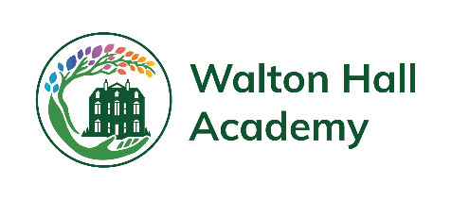 | Reading and Phonics  Overview | 

Intent
Reading is an essential skill that our students will use not only throughout the school but also throughout their lives. As well as teaching reading skills, we also hope to foster a love of reading for pleasure in our students. We promote and reward reading in a variety of ways and use reading skills throughout the curriculum. At Walton Hall, we want our students to:
- Grow in terms of their knowledge and understanding of the world around them.
- Work towards meeting their EHCP desired outcomes within RAP time
- To engage fully with the ‘Fresh Start’ phonics scheme
- Ask questions and be curious; to analyse at a deeper level
- To develop an appreciation of books and a love of reading
- Develop comprehension skills and to know how to find key information.
- To be solid in their phonetical knowledge and be exposed to new vocabulary
- Become intrinsically motivated, flourish and achieve their full unique potential.
- Understand how reading is an essential skill to achieve life-long success

Progression through the pathways
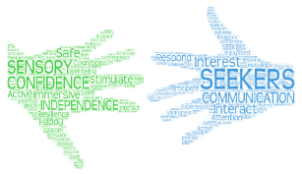 | 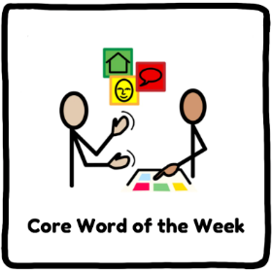  Reading in Seekers follows a more bespoke approach to adapt to the complex needs of the individual. Some pupils will follow the Fresh Start phonics scheme in school, learning to recognise graphemes and morphemes in systemic manner. All students will be given the opportunity to develop their reading skills through learning key words, high frequency words, and learning key phrases. Students will have the opportunity to read books and listen to stories as part of their literacy lessons. The Core Word AAC programme will underpin literacy lessons for Seeker’s students to help develop their understanding of common high frequency words, and to relate these words to concrete objects. As students’ progress into Key Stages 4 and 5, reading is focused on Preparation for Adulthood, where students will learn to recognise and use everyday signs in the community.
  Explorers  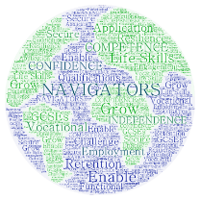  Navigators | Explorers and Navigators students all have a dedicated RAP (Reading and Phonics) lesson four days a week. All students are initially assessed using a combination of the fresh start phonics assessment, and the NGRT reading assessment. Students are then allocated a phonics or reading group to attend during RAP time based on these outcomes.    For students who require phonics, they follow the RWI: Fresh Start scheme. This incorporates the systemic teaching of explicit phonics knowledge, and age-appropriate comprehension materials to develop their reading abilities. Students are assessed each term and reallocated to the appropriate group. Staff delivering phonics follow the programme as directed in the RWI: Fresh Start Phonics handbook, and students’ progress through various modules as their reading abilities develop. Modules focus on learning to read different sounds, reading comprehension and spelling.  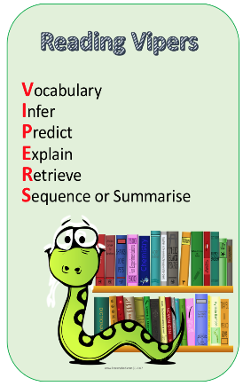  For students who have progressed on from phonics, they access a dedicated group reading lesson instead. Students will read a variety of class texts whilst developing essential reading and comprehension skills. These skills include the development of:  Vocabulary, Inference, Prediction, Explanation, Retrieval and Summary/Sequencing (VIPERS).  It is essential to note that while these students are able to read mostly fluently, they may still need to continue to develop the pace, intonation and clarity of their reading. RAP time also helps to expose students to new reading opportunities and help them to foster a love and appreciation of reading.

Personal Development in RAP
Spiritual, Moral, social and cultural development/capital and Character  - Guided meditation  - Sensory room activities  - Sensory walks  - Forest school  - Library visits  - Lunchtime clubs e.g. radio club  - Friendship group, interventions  - School assemblies  - Religion through RE  - Religion through Science  - Church visits – Christmas  - Music sessions  - Performing arts and cultural week  - School concerts and shows  - Celebrating special/themed days  - Educational visits and trips  - Votes for schools’ sessions  - Circle time sessions  - Student council – democracy  - Emotion coaching | Preparation for next stage of life  Education, training and Employment/Careers Guidance:  - BTEC Mandatory Units  - Educational visits  - Work Experience  - Managing money units in PSHE  - Apprenticeships/supported internships  - CV Writing  - PFA evening  - EHCP reviews  - ILPs  - Record of achievement  - College Visits  - PHSE topics  - Post 16 Friday Café  - Vast range of Vocational Options  - Careers advisor  Independent living  - Transition days  - Residence provision  - Work Experience  - Managing money units in PSHE  - MyBnK - financial education sessions  - Travel Training  - Cookery  - Reading for develoment of PFA  Community Inclusion  - Educational visits  - Reward visits  - Travel Training  - Post 16 Friday Café  - Duke of Edinburgh  - Active life sessions  - Shopping visits  - Learning about the wider community  Staying Healthy/Healthy Living  - Swimming  - Football club  - Gym sessions  - PSHE units  - School nurse sessions  - Encouragement to try new foods  - Cookery sessions  - PE lessons across the school  - Science – hazards and safety  - Sex Education  - Hygiene – PSHE, school nurse, residence  - Science units  - PSHE/ICT – keeping yourself safe
Fundamental British Values and Citizenship
- History Lessons
- Decorating the church - Poppies, Christmas trees
- Votes for schools’ lessons
- Celebrating special days/themes
- Equal opportunities
- Charity fundraising
- Student council - democracy
- Community links
- Organised voting in class
- Duke of Edinburgh
- Assemblies
- Belonging to the school community
- Work Experience
- Volunteering
- 3 R’s – Be ready, be responsible and be respectful

Equality and Diversity
- Makaton and communication
- Oasis centre provision
- Transition days – moving between groups
- Interventions
- History lessons
- Assemblies
- Votes for schools

