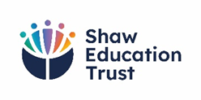
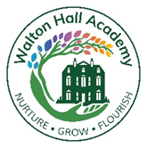
Sporting Achievement
2024-2025

Walton Hall is a member of the North Staffordshire Special School Sports Association (NSSSSA) alongside many other schools. Throughout the year there are many sporting events where students from different special schools across North Staffordshire come together to compete. This provides valuable experiences for our young people, supporting them to develop their teamwork and collaboration skills, communication and interaction skills, self-worth, self-confidence and resilience.

Achievements of Team Walton Hall in 2024 – 2025

Event | Result
Key Stage 3 Inter-cricket | Winners
Key Stage 4 Inter-Cricket | Winners
Key Stage 3/4 Girls Inter-cricket | Exhibition games only
Girls Netball | Runners-up
Key stage 3/4 Basketball | Runners-up
KS3 Indoor Cricket | Runners-up
KS3/4 Football | Winners
KS4 Uni-hockey | Winners

