Walton Hall Maths Curriculum – Teaching Approaches
Addition
Concrete | Pictorial | Abstract
Using Fingers  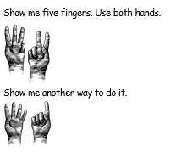  Number Lines  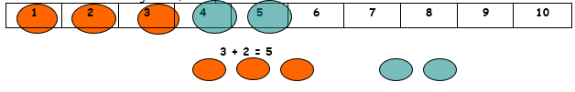  Using Blocks, Frame 10, Dienes and Numicon  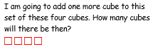 | Adding simple numbers by drawing own scaffolding to add.  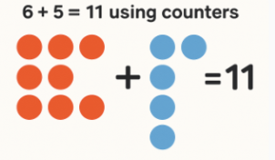  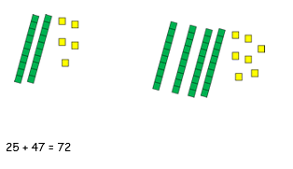  Place Value and Base 10 Images  Adding by drawing counters to support Column Method  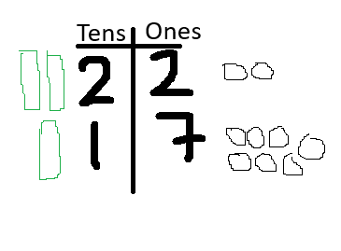 | Using Column Method  