Walton Hall Maths Curriculum – Teaching Approaches
Addition
Concrete | Pictorial | Abstract
Sharing Equally  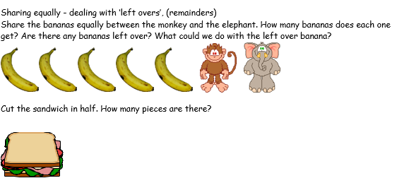  Making Equal Groups  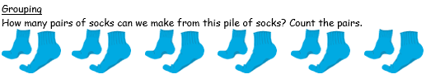   | Making Groups and Using Arrays  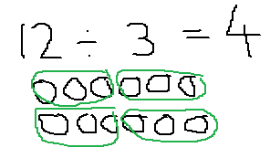  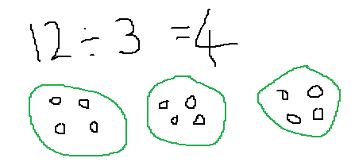  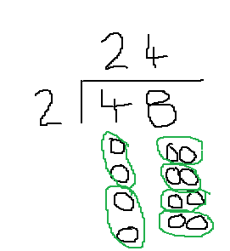  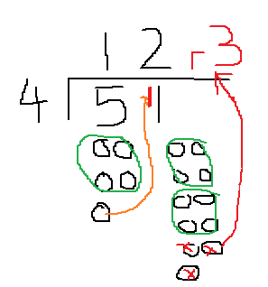  Using short Division with own drawings | Short Division (Bus Stop Method)  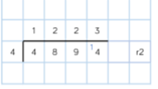  Long Division (Bus Stop)  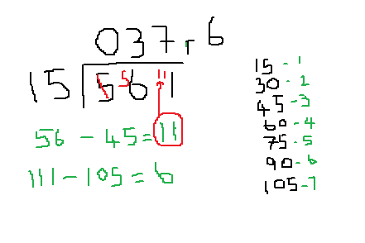  Division (Decimals)  