Walton Hall Maths Curriculum – Teaching Approaches
Multiplication
Concrete | Pictorial | Abstract
Use very simple items that can be reproduced    Sort real objects and pictures into sets of equal number while counting aloud    Use real world examples  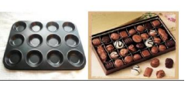 | Use Drawings of items    3 Vases of 4 flowers = 12 Flowers  Drawing Arrays in Groups  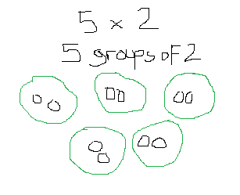  Drawing groups of counters in rows  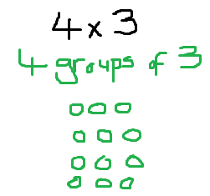 | Column Method (2 digit by 1 digit)  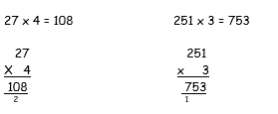  Column Method (2 digit by 2 digit)  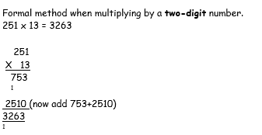  Column Multiplication of Decimals  