Walton Hall Maths Curriculum – Teaching Approaches
Subtraction
Concrete | Pictorial | Abstract
Using Concrete resources to remove items  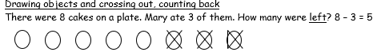  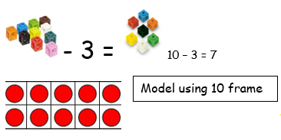  Matching and finding the difference  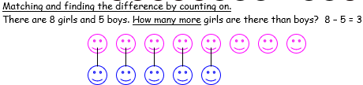  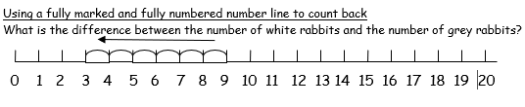  Using Number lines to count backwards | Using own pictorials to understand Subtraction  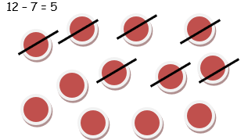  Using Place value to subtract.  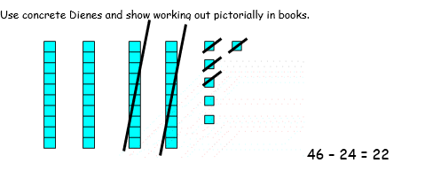  Using Column method using own drawing to support  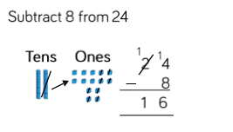 | Counting backwards  Understand when it is sensible (more efficient) to count back and when to count up e.g.  - 93 – 5 (count back)  - 93 - 88 (count up)  Using Column method to calculate subtraction  