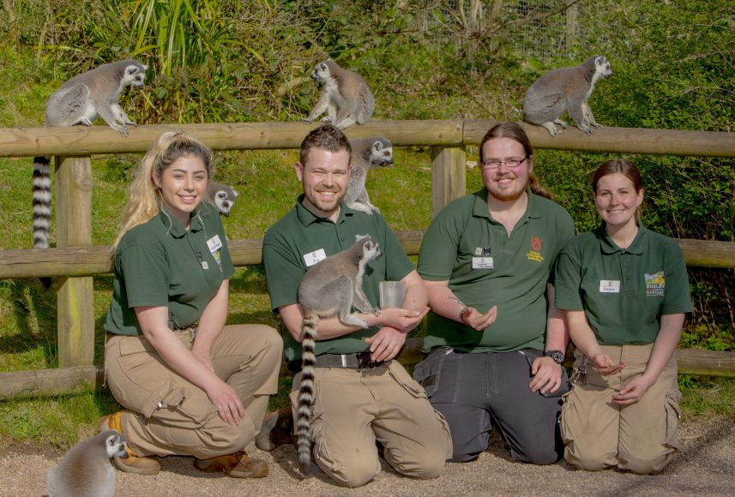
Job title: Zookeeper
Job title: Zookeeper | Zookeepers look after animals in zoos, safari parks and aquariums.
Entry requirements: | You can do a foundation degree, higher national diploma or degree in:  - animal or zoo management  - animal behaviour and welfare  - zoology or marine zoology  - animal conservation and biodiversity  - veterinary science  - biology  Zoos vary in what qualifications they ask for and it can depend on what their zookeepers are going to do.  Entry requirements  You'll usually need:  - 1 or 2 A levels for a foundation degree or higher national diploma  - 2 or 3 A levels, including a science, for a degree  You could do a course before applying to a zoo for a trainee zookeeper's job. Relevant courses include:  - Level 3 Extended Diploma in Animal Management  - Level 3 Diploma in Animal Care or Animal Science  - Biology A level  Entry requirements  You'll usually need:  - 5 GCSEs at grades 9 to 4 (A* to C), including English, maths and science  You could start by doing an intermediate or advanced apprenticeship in animal care, or an animal care and welfare assistant intermediate apprenticeship. This may help you to get a job as a trainee with a zoo. Your employer would then put you through more courses on the job.
Skills required: | You'll need:  - the ability to work well with others  - to be thorough and pay attention to detail  - excellent verbal communication skills  - the ability to use your initiative  - the ability to work well with your hands  - to be flexible and open to change  - patience and the ability to remain calm in stressful situations  - customer service skills  - to be able to carry out basic tasks on a computer or hand-held device  You'll need to:  - pass enhanced background checks, as you may be working with children and vulnerable adults
What you'll do: | In this role you could be:  - preparing food and feeding animals  - cleaning out pens and cages and changing bedding  - making sure animals live in as close to natural conditions as possible  - checking for signs of distress or disease and caring for sick animals  - checking enclosures and cages for signs of wear or damage  - monitoring conditions like temperature and humidity  - keeping daily healthcare records on paper and computer  - giving educational talks to children and adults
What you’ll earn: | - Starter: £12, 000  - Experienced: £25, 000  These figures are a guide.
Working hours, patterns and environment: | - You could work at a zoo.  - Your working environment may be outdoors in all weathers and physically demanding.  - You may need to wear a uniform and protective clothing.  - 37 to 40 hours, evenings, weekends and bank holidays
Career path and progression: | - In larger zoos, you could progress from keeper to team leader or head keeper. With experience and a degree, you could become a curator.  - You could also move into education or conservation research.

