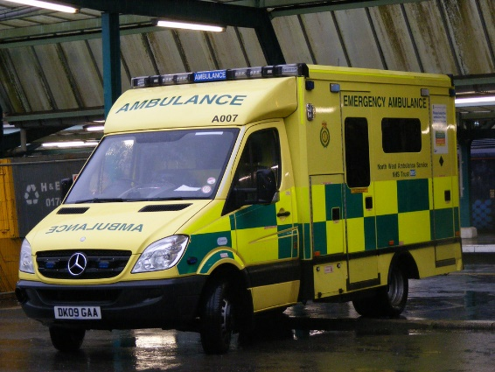
Job title: Paramedic

Job title: Paramedic | Paramedics deal with emergencies, giving people life-saving medical help.
Entry requirements: | - You'll need a foundation degree, diploma of higher education (DipHE) or degree in paramedic science or paramedic practice.  - You could start as a student paramedic, a trainee technician or an emergency care assistant for an ambulance service.  - Working as a volunteer community first responder with an organisation like St John Ambulance or an NHS ambulance trust, may help you to get onto a training course.  - Your local ambulance trust has information about the services in your area.  - To become a paramedic you'll need:  - to register with the Health and Care Professions Council (HCPC)  - a driving licence, including C1 category entitlement  - to pass a medical check  - an enhanced background check which your employer will arrange for you  - The College of Paramedics has more information about becoming a paramedic.
Skills required: | You'll need:  - excellent driving skills  - the ability to think and act quickly under pressure  - practical skills and the ability to follow procedures  - excellent communication skills
What you'll do: | - Most paramedics work for NHS ambulance services. You'll deal with a range of situations, from minor wounds and substance misuse to serious injuries from fires and major road, rail and industrial accidents.  Your day-to-day tasks could include:  - checking a patient's condition to decide what action to take  - using electric shock equipment (a defibrillator) to resuscitate patients  - carrying out surgical procedures like inserting a breathing tube  - giving medicines and injections  - dressing wounds and applying supports for broken bones  - delivering babies  - working closely with the police and fire services  - keeping accurate records and checking equipment
What you’ll earn: | - Starter: £23,023 (qualified paramedic)  - Experienced: Up to £28,500  - Highly Experienced: £36,644 (specialist paramedics and team leaders)  These figures are a guide.
Working hours, patterns and environment: | - You'll usually work 37.5 hours a week on shifts, including nights, weekends and bank holidays.  - You'll wear a uniform including protective clothing.  - You'll work on an ambulance, or as a specialist you may work on your own, using a car, motorbike or bicycle.  - The job is physically and emotionally demanding.
Career path and progression: | With around 3 years’ experience, you could become a team leader or a specialist paramedic or emergency care practitioner.  You could also move into operations management, education and training, research or human resources.

