WLD Teaching and Learning Digest – w/c 3rd December 2018
COMMUNICATION FOCUSES  Use the alphabet game – ask students to list words connected with a topic, starting with each letter of the alphabet | INCLUSION FOR ALL  Cue in using names

Click here for an advent treat!

This week:
- The thought for the week this week is ‘Advent’ in preparation for the start of advent next week. Hopefully, kindness calendars are ready to go. Please talk about the meaning of ‘advent’.
- Teaching and Learning Advent calendar – starts today! Click on the date on the website (link on the present above) and try to use the teaching approach offered. If your name is drawn on any given day, you will receive a chocolate from our staff calendar.
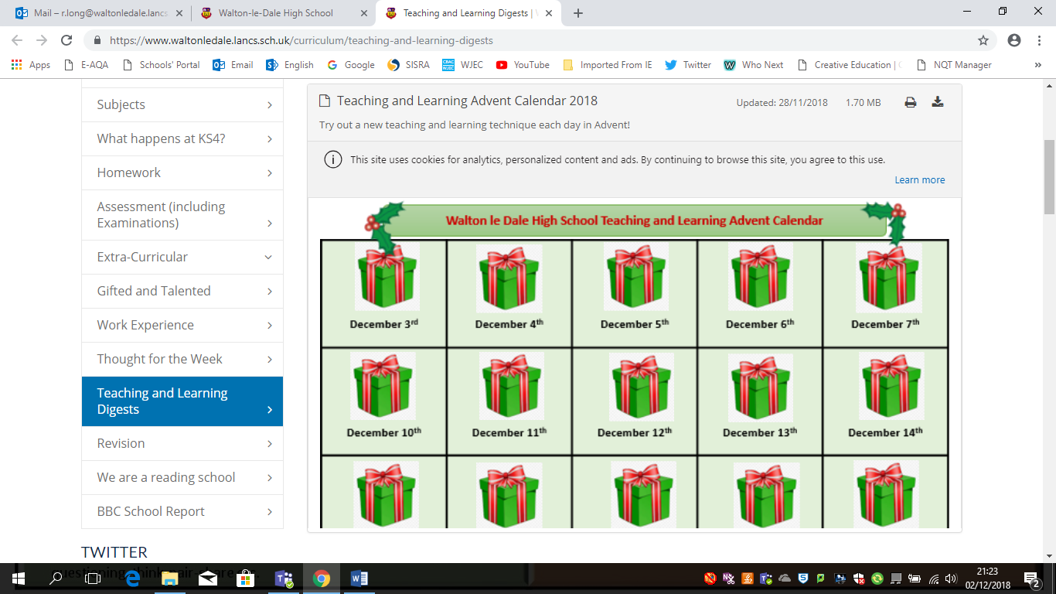

- NQTs – CPD session this week will explore career routes. Friday lunch time in D10.
- NQTs Reminder – scheduled meetings with LG this week (LG’s office) to discuss progress against standards. Exemplars emailed out last week and format discussed.
- 10th December – Walton le Dale Staff Christmas market @3.15. Bring some money, enjoy a festive treat and finish your Christmas shopping. Usborne books will be there as well as the crafts and works of art from our talented staff body.
- 19th December – ‘Pastries and Progress’ – bring a marked exercise/process work (rather than a one-off assessment), sit with a colleague and discuss the student’s work, evidence of progress, feedback, presentation etc – and enjoy a pastry!
Think about this…comparative marking!
As many of us turn our attention towards mock exam marking that will hit our desks this week, this approach may be of interest. It is called ‘comparative marking’ and is thought to reduce marking time and therefore workload, whilst being more reliable.
I must admit, I have tried it and it does seem to work. Read more here:
https://schoolsweek.co.uk/new-method-of-exams-marking-could-transform-teachers-workload/
Grading exam essays using comparative judgment is “significantly” quicker and still as reliable as double-marking them, Ofqual has found.
On Tuesday the exams watchdog published findings from research it conducted over the past five years into improving the quality of examiner marking at GCSE, AS and A-levels.
It found paired comparison, also known as comparative judgment, in which examiners judge pairs of essays against one another until all are ranked and then graded, is as reliable and takes as long as traditional marking and another method called “rank ordering”.
Rank ordering is simply where examiners use example essays provided by the exam board as “anchors” for the grade a paper should get, and is not the same as comparative judgment.
As well as being as reliable as traditional marking and rank ordering, Ofqual also found paired comparison is “significantly quicker” than double marking, without losing any reliability.
“Paired comparison can match the predictive accuracy of double marking or two examiners rank ordering with significantly less time invested,” said the Marking reliability studies 2017 report…

Talk-Talk! Structure of the Week: Timed – Pair - Share
MFL: try using to demonstrate different menu options for a restaurant. As students to look for a specific menu choice first. Then share possible items with a partner, using conversation structures offered.

Science: Ask students to think about the importance of braking distance. They could compare three different speeds and then discuss their ideas with a partner.

Mathematics: put a problem on the board. Ask students to solve with working out. Share this with a partner. Discuss the method used.

All of these ideas are basic and happen daily. However it is the final stage (SHARE) that really consolidates learning. Remember to ask students to share their partner’s answers/method etc – NOT their own.

Top Tips in Two this Term (HoDs please organise who will share and let me know)

CPD Cascade
Thanks to those who have signed up for the PTSA twilight courses. You should all now have received email confirmations.

Thanks for reading. ‘Like’ or reply to this email if you found anything useful.

