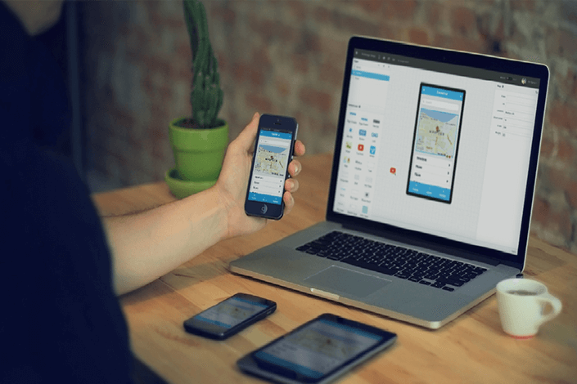
Job title: App Developer

Job title: App Developer | App developers design and build mobile applications for PCs, mobile phones and tablets.
Entry requirements: | At University you could do a foundation degree, higher national diploma or degree in:  - computer science  - software engineering  - computer applications development  - mathematics  Entry requirements  You'll usually need:  - 1 or 2 A levels for a foundation degree or higher national diploma  - 2 to 3 A levels for a degree  You can complete a software developer higher apprenticeship.  Entry requirements  To get onto an apprenticeship, you'll find it useful to have:  - 4 or 5 GCSEs at grades 9 to 4 (A* to C) and college qualifications like A levels for a higher or a degree apprenticeship
Skills required: | You'll need:  - maths knowledge for understanding programming  - the ability to write computer programs  - analytical thinking skills  - to be thorough and pay attention to detail  - the ability to come up with new ways of doing things  - knowledge of systems analysis and development  - complex problem-solving skills  - persistence and determination  - to have a thorough understanding of computer systems and applications
What you'll do: | Your day-to-day tasks may include:  - developing new apps or creating 'mobile-friendly' versions of websites  - working with other developers, designers and copywriters  - designing prototypes to suit client needs  - writing or amending computer code  - testing software, finding faults and fixing problems  - writing accurate notes about the development process  - keeping up to date with new technology trends and tools
What you’ll earn: | - Starter: £21,000  - Experienced: £55,000  These figures are a guide.
Working hours, patterns and environment: | - You could work in an office or at a client's business.  - You will work 37 to 40 hours usually Monday to Friday
Career path and progression: | - You could move into systems analysis, or be promoted to a senior app developer or applications project manager.  - You could also become self-employed, offering your services through contracting.  - You can build up your skills and knowledge using free online learning resources for programming languages and apps development.  - You'll also find it useful to have an understanding of Agile project development methods.

