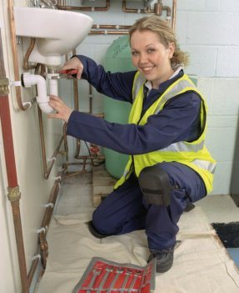
Job title: Plumber
Job title: Plumber | Plumbers fit and service hot and cold water systems, heating systems and drainage networks.
Entry requirements: | You could do a Level 2 and 3 Diploma in Plumbing and Domestic Heating.  This would teach you some of the skills needed for the job and will help you when applying for a trainee position with a plumbing company.  Entry requirements  You'll usually need:  - 2 or more GCSEs at grades 9 to 3 (A* to D) for a level 2 course  - 4 or 5 GCSEs at grades 9 to 4 (A* to C) for a level 3 course  You can do an intermediate and advanced apprenticeship in plumbing and domestic heating. This can take up to 4 years.  Entry requirements  You'll usually need:  - some GCSEs, usually including English and maths, for an intermediate apprenticeship  - 5 GCSEs at grades 9 to 4 (A* to C), usually including English and maths, for an advanced apprenticeship
Skills required: | You'll need:  - the ability to use, repair and maintain machines and tools  - knowledge of building and construction  - to be thorough and pay attention to detail  - knowledge of maths  - the ability to work well with others  - the ability to use your initiative  - the ability to work well with your hands  - physical skills like movement, coordination, dexterity and grace  - to be able to carry out basic tasks on a computer or hand-held device
What you'll do: | In this role you could be  - measuring and planning to give cost and time estimates  - cutting, bending and joining pipes and fittings  - installing water, drainage and heating systems  - finding and fixing faults  - servicing gas and oil-fired central heating systems and radiators  - installing and fixing domestic appliances like showers and washing machines  - dealing with emergency call-outs like boiler breakdowns or blocked drains  - fitting weather-proof materials, joints and flashings to roofs, chimneys and walls
What you’ll earn: | - Starter: £15,000  - Experienced: £40,000  These figures are a guide.
Working hours, patterns and environment: | - You could work at a client's home or at a client's business.  - Your working environment may be cramped, at height and outdoors some of the time.  - 37 to 40 hours, including evenings and weekends
Career path and progression: | You can develop your skills by taking further training in areas such as heating, ventilation and air-conditioning, and renewable energy technologies like solar powered heating.  You can also join the Gas Safe Register or get certified with the Oil Firing Technical Association (OFTEC). These would show you're qualified to work on gas or oil-fired appliances.  You could go on to take an HND or degree and become an engineer. This would give you career options in building services engineering, estimating and contract management.

