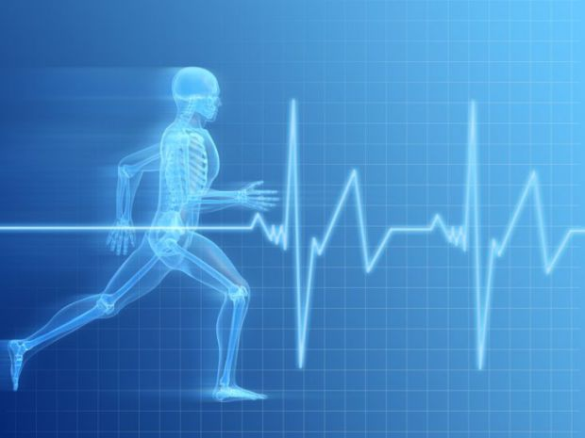
Job title: Sports Scientist

Job title: Sports Scientist | Sports scientists use knowledge of how the body works to help people improve their health or sporting ability.
Entry requirements: | You'll need  - a degree in sport science, or a degree in a related subject like physical education, physiology or psychology, followed by a postgraduate qualification.  It's becoming common for sports scientists to already have or be working towards postgraduate qualifications like MRes, MSc or PhD.  Experience may improve your career prospects. You could get it as a fitness instructor, lifeguard, sports coach or by volunteering.
Skills required: | You'll need:  - the ability to analyse physical and sporting performance  - the ability to apply scientific ideas and principles
What you'll do: | You'll typically:  - work with sports coaches and sports therapists to improve the performance of individuals and teams  - work with doctors to help people improve their health through exercise  - work with hospitals and other health organisations in areas such as cardiac rehabilitation  - take part in research projects  - offer advice on the design and manufacture of sports equipment
What you’ll earn: | - Starter: £18,000  - Experienced: £35,000  - Highly Experienced: £60,000 or more  These figures are a guide.
Working hours, patterns and environment: | You'll typically work around 38 hours a week. This may include weekends and evenings to cover appointments with clients. You may have to work extra hours to complete research.  You may be based in a consultation room with occasional work in other locations. In health promotion you'll usually work in an office and travel to visit partner organisations.
Career path and progression: | You could join the British Association of Sport and Exercise Sciences (BASES) and work towards accreditation. You could also apply for Chartered Scientist status.  You could find work with universities, schools and colleges, large sporting organisations, public and private enterprises and local authorities. It's also possible to become self-employed or to work as a consultant.  You could also move into a related career area, like sports development or performance testing and research.

