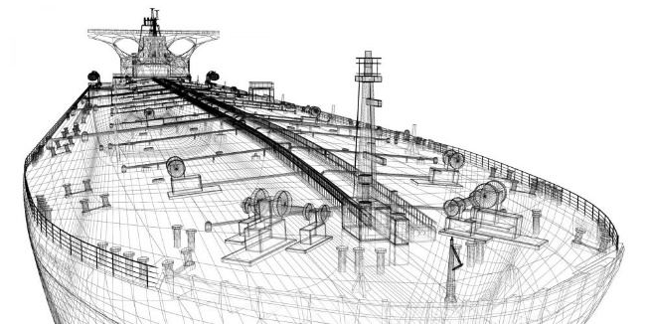
Job title: Naval Architect
Job title: Naval Architect | Naval architects design, construct, refit and repair marine vessels and offshore structures.
Entry requirements: | Most naval architects have a degree or postgraduate qualification that is recognised by the Royal Institution of Naval Architects. This would usually be an engineering subject like:  - naval architecture  - ocean, offshore or marine engineering  - ship science  - You may be able to get onto a degree course if you've got qualifications from working as an engineering technician.  Entry requirements  You'll usually need:  - 3 A levels, including maths and physics  Registration  - a fully qualified naval architect is a member of the Royal Institution of Naval Architects, who is registered with the UK Engineering Council as a Chartered Engineer, Incorporated Engineer or Engineering Technician.
Skills required: | You'll need:  - maths knowledge  - knowledge of engineering science and technology  - design skills and knowledge  - knowledge of physics  - analytical thinking skills  - excellent verbal communication skills  - the ability to read English  - knowledge of computer operating systems, hardware and software  - to be able to carry out basic tasks on a computer or hand-held device
What you'll do: | Your day-to-day duties could include:  - coordinating the work of engineering design teams  - making sure that designs are safe, seaworthy and cost-effective  - preparing design plans using computer software  - checking and testing specifications using computer simulations and 3D models  - making sure that designs meet operational requirements  - coordinating manufacturing or repair work
What you’ll earn: | - Starter: £25,000  - Experienced: £65,000  These figures are a guide.
Working hours, patterns and environment: | - You could work in an office, at a shipyard, on a rig, on a ship or in a laboratory.  - Your working environment may be at height and outdoors some of the time.  - You may need to wear protective clothing.  - 39 to 41 hours a week with occasional evenings and weekends
Career path and progression: | With experience, you could progress to senior positions. You could become a consultant, providing technical and commercial guidance, support and project management for research, design, construction, refits or conversions.  You could also move into other areas like procurement, sales and marketing.

