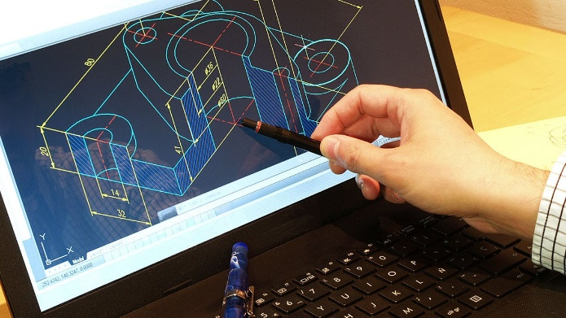
Job title: CAD Technician
Job title: CAD Technician | Computer-aided design (CAD) technicians use software to design buildings, machinery, goods and components.
Entry requirements: | You could start by doing a higher national diploma or degree that includes computer-aided design work. For example:  - construction  - architectural technology  - product design  - design engineering  Entry requirements  You'll usually need:  - 2 to 3 A levels for a degree  You could train in computer-aided design by taking a college course like:  - Level 2 Certificate in Engineering Technology  - Level 2 Certificate in Computer-Aided Design and Manufacturing  - Level 3 Diploma in Design and Draughting  Entry requirements  You'll usually need:  - GCSEs at grades 9 to 4 (A* to C) in English, maths and ICT  You could complete an intermediate or advanced apprenticeship in engineering, manufacturing or construction. The exact apprenticeship you take will depend on your job role but there are several that include computer-aided design work.  Entry requirements  You'll usually need:  - some GCSEs, usually including English and maths, for an intermediate apprenticeship  - 5 GCSEs at grades 9 to 4 (A* to C), usually including English and maths, for an advanced apprenticeship
Skills required: | You'll need:  - design skills and knowledge  - maths skills  - to be thorough and pay attention to detail  - excellent verbal communication skills  - knowledge of engineering science and technology  - thinking and reasoning skills  - the ability to work well with others  - the ability to use your initiative  - to be able to use a computer and the main software packages confidently
What you'll do: | Your day-to-day tasks could include:  - use software to draw 2D or 3D images of products or parts of a product  - work with engineers to design parts for machinery  - help engineers estimate the cost of a product
What you’ll earn: | - Starter: £15,000  - Experienced: £35,000  These figures are a guide.
Working hours, patterns and environment: | - You could work on a construction site or in an office.  - 38 to 41 hours a week usually between 8am and 6pm
Career path and progression: | - With experience, you could register with the Engineering Council to get Engineering Technician (EngTech) status.  - You could become a team or section leader, project manager or site manager. With further training, you could become a design or software engineer.  - You could work freelance.

