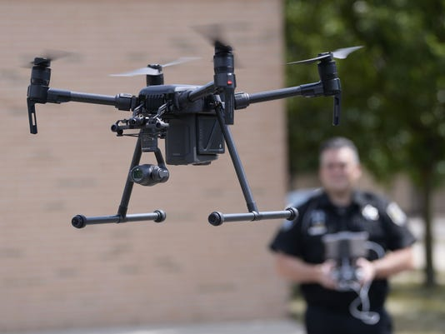
Job title: Drone Pilot
Job title: Drone Pilot | Drone pilots remotely operate aircraft used in work like surveying, filmmaking and aerial photography.
Entry requirements: | You can get into this job through:  - applying directly  - specialist courses run by private training organisations  You can apply for jobs directly. Most employers will expect you to have experience of flying drones, with at least 40 hours of recorded flying time.  You could complete training approved by the Civil Aviation Authority. This lasts between 2 and 4 days and includes:  - UK air regulations  - flight safety  - flight planning  - theory test and practical flight skills assessment  You'll also have to write an operations manual describing how you are going to use your drone commercially.  After successfully completing training, you can apply for the Permission for Commercial Operations certificate, which you need to fly drones for commercial purposes.  You must renew the certificate every 12 months.  Career tips  You'll have to join the armed forces or the police and train as an aerial vehicle pilot to operate drones for military or security purposes.
Skills required: | You'll need:  - knowledge of media production and communication  - to be thorough and pay attention to detail  - to be flexible and open to change  - the ability to accept criticism and work well under pressure  - leadership skills  - the ability to use your initiative  - patience and the ability to remain calm in stressful situations  - the ability to monitor your own performance and that of your colleagues  - to be able to carry out basic tasks on a computer or hand-held device  You'll need to:  - hold a Permission for Commercial Operations certificate
What you'll do: | As a commercial drone pilot, you'll:  - plan flight paths  - test flight equipment  - carry out aerial surveys  - gather digital images and data  - maintain and repair drones  - produce maps based on flight data  - work with other professionals to interpret data
What you’ll earn: | - Starter: £13,000  - Experienced: £65, 520  These figures are a guide.
Working hours, patterns and environment: | - You could work on a film set, on a construction site, in the countryside or in a control room.  - Your working environment may be outdoors in all weathers and you may spend nights away from home.  - Freelance/self-employed 39 to 41 hours a week
Career path and progression: | You may be able to complete a qualification like the Level 3 Certificate and Level 4 Diploma in the Remote Piloting of Unmanned Aircraft Systems.  Examples of work you might do includes:  - filmmaking, TV and marketing  - weather forecasting  - mapping land use for farming or archaeological work  - inspecting infrastructure like bridges and tall buildings  If you have engineering qualifications, you could move into drone design and development work.

